Welcome to class 2

I hope you had a wonderful summer and are now set for the busy term ahead in year 2.

This term we are dancing back in time to the 1950’s to discover the dawn of the fridge freezer and LEGO! This topic which will most certainly wow and shock many year 2’s with the horror of no colour TV or shops not opening on a Sunday! It will certainly be an eye opening term for us all. Especially learning about some of the changes that have happened to Keyworth since 1950 too.

Literacy: During literacy we will begin the year by exploring the fantastic world of Enid Blyton’s Faraway Tree. Travelling with many mythical characters up the tree to new lands. We will then turn to look at more traditional tales before ending the topic writing our very own retelling of the Coronation of the Queen.
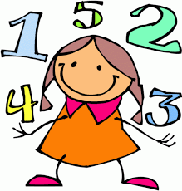
Phonics/ Spelling: Daily phonics/ spelling will continue throughout year 2. We will be learning each week a new spelling pattern or revisiting previous week’s work. I will be setting spelling homework each week on a Monday to be tested on the following Monday.

Maths: We start the term looking at numbers to 100 and ordering these before moving on to work on addition and subtraction before exploring units of measure.
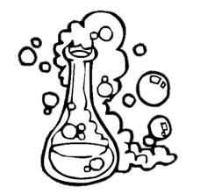
Science: During science we will look at materials and their everyday uses, how their properties determine their use.

Art/ DT: This term we will be looking at the work of Kandinsky and his beautiful abstract art before moving on to DT. Here we will look at how food was rationed and come up with our own meal from rationed products.

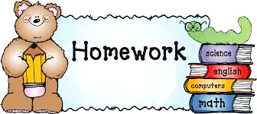
PE: Weather permitting we will try and get outside as much possible therefore it is important for all children to have sensible PE kit for the autumn term. During PE sessions we will be working on our co-ordination and multi skills on Tuesday afternoons. On Monday afternoons we are lucky to have Excel teaching us some super dance routines.
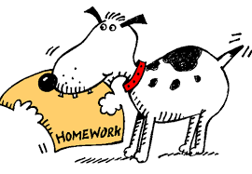

Homework: Each week your child will bring home their homework book. A short task will be set on a Friday to be handed in by Thursday. This task will be set on the week’s teaching in either Maths or Literacy and on occasion a task will be set on our topic theme.
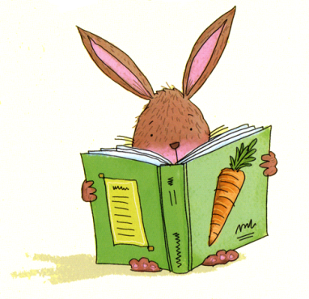
Reading: Monkey books will continue to be used during year 2. This is an excellent way to keep a running record of both your child’s reading and a way of keeping in regular contact with me. Your child should try and read every night where possible and even if they have finished the book it is important for them to reread, discuss and explore the text more than once. Your child’s reading book will not be changed daily but at least twice a week. Reading beyond and outside of their book is strongly recommended too.

Spelling: As previously stated weekly spelling homework will be set, either learning a new rule or recapping preciously learnt rules. These will then be tested the following Monday morning.

As you can see it’s going to be a very busy and hopefully thoroughly enjoyable first half term.
Best Wishes
Miss Weston

