Class 5 Learning Letter

*November – December 2016*

Dear parents,

It was great to see you all at parents evening at the end of the last term and to share with you some of the fantastic work your children have been doing so far in year 5! They really have embraced everything we have tackled and I know their hard work will continue this half term too. As you all know this half term is when we start our Christmas Play rehearsals, I know many of the children are already very excited by this. As you will see from this learning letter, our time spent practising will not affect the learning taking place in the classroom, we will continue to have our daily Maths and English sessions and afternoon activities will be combined to form more of a project for our superhero topic. We had lots of exciting things happening last half term so I have included a few photos of the different activities we have been doing.

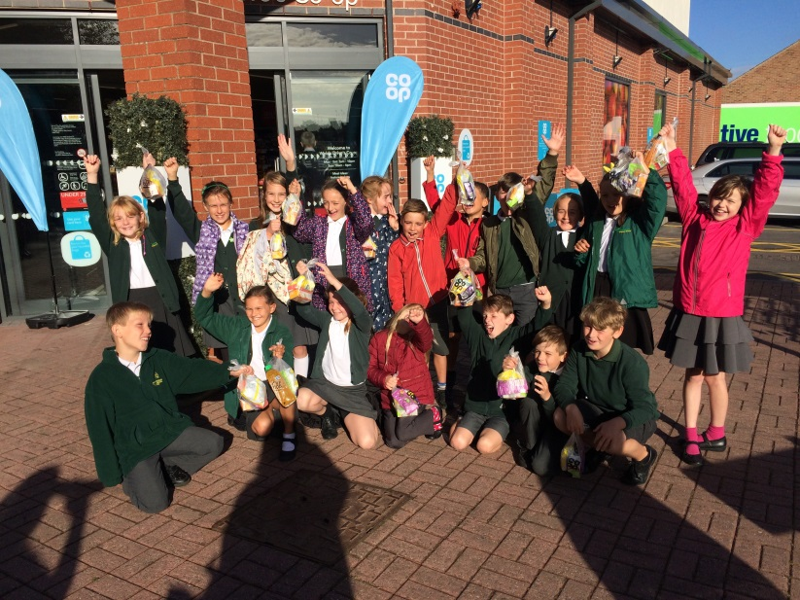

Guided reading has become part of the children’s routine in Class 5 and it is wonderful to see how much they are enjoying the stories they are reading. Home tasks are being completed to a high standard and I always look forward to hearing their ideas each week. A reminder however, that this doesn’t have to be the extent of children’s reading. I know many children at this age lose interest in reading their own books independently but the more this can be encouraged the better! Similarly with children’s spelling tasks, I have been equally delighted to see the improving scores they are achieving each week. Keeping a log of their scores and having some activities to complete seems to be helping and everyone is tackling the mixed spelling tests well too. Spellings will continue as normal this half term, we will have a test on the first day back and then children will be on week 7-8.

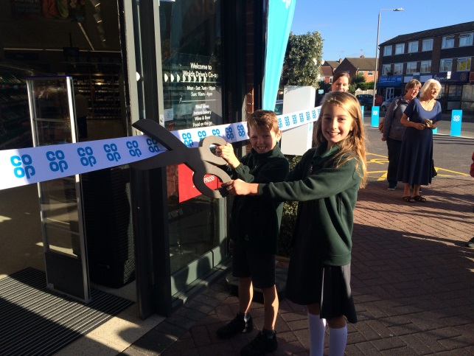

Our English lessons will be focused around a story that is being used throughout the whole school for this half term. In line with the superhero theme for our school play we will be looking at *Traction Man* by Mini Grey. This is a wonderful book for all ages and we will be having a lot of fun with the work we are going to be doing based on the story. As always, our grammar lessons fit into the pieces of writing that we are focusing on and we will be doing some more practise of grammar terminology and questions during the first half an hour in the morning.

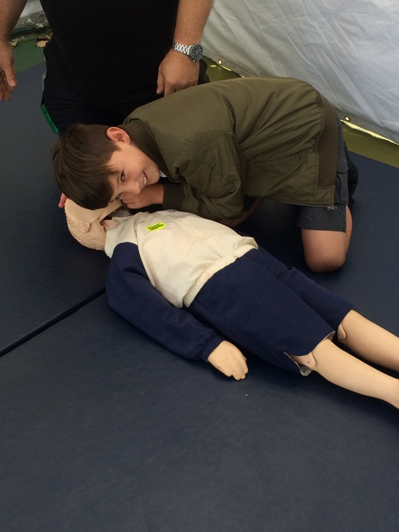

Topic/Computing/Art

Our lessons for these subject areas will all be closely linked with our English work on Traction Man and superheroes this half term. We will be creating a plan of Traction Man’s house to plot his adventures and be creating some pop art inspired artwork to fit with our topic. We will be using the computers for research and we will be starting some sessions on Scratch.

Science

I, along with the children, have loved our science lessons so far this year. Class 5 are very enthusiastic about science and it makes experimenting so exciting. We will be continuing with our work on materials and their properties this half term. We have an ongoing experiment looking at evaporation to conclude in our first week back. We will then be moving on to planning and conducting more investigations looking at reversible and irreversible changes!

This half term in maths we are going to be tackling fractions, decimals and percentages as well as touching on measurement and shape. We are going to continue to work on lots of reasoning and problem solving questions during our maths lessons to build children’s confidence in tackling those trickier questions. We are also taking time in the week to build in times tables and mental arithmetic practise that children will be doing with Mrs Hallsworth when she teaches on a Monday afternoon. Again, the more tables practise that can be done at home the better!

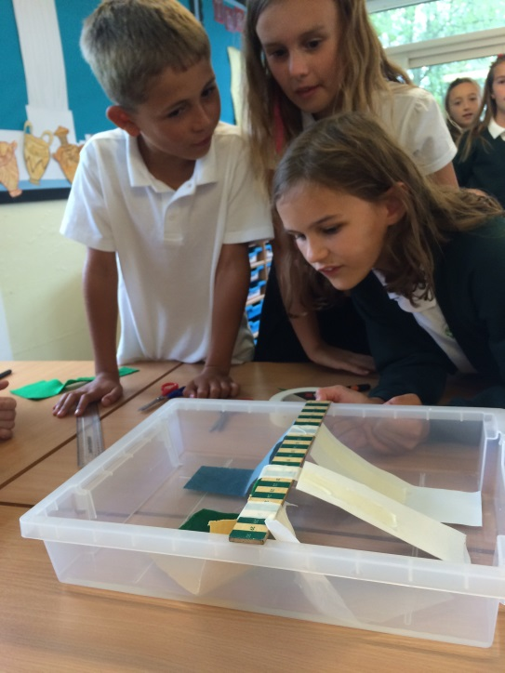

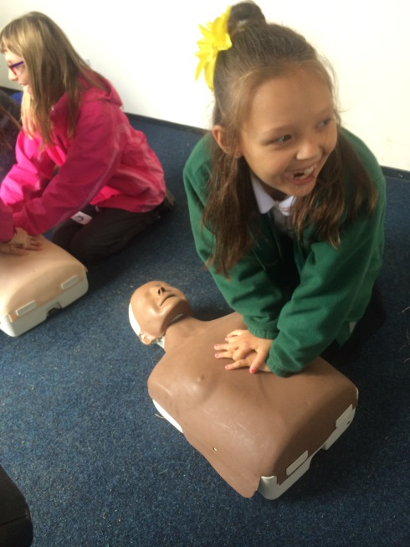

This half term our P.E sessions will be on a Monday and Friday as we have dance with Excel as one of our sessions. Homework will continue to be set on a Friday to be handed in the following Wednesday.

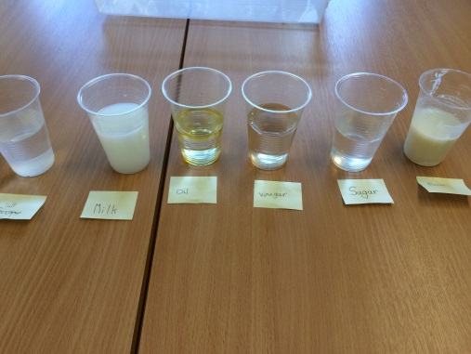

As always, please do not hesitate to contact me if you have any questions.

Kind regards,

Emma Hackett.