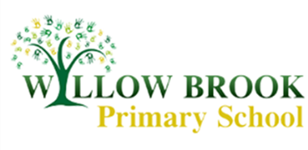
Year 1 Learning Letter
February 2017
Roald Dahl
We have a very exciting whole school topic this half term. Roald Dahl has always been one of my favourite authors and I can’t wait to share some of the stories and characters with the children. We will be focusing our English lessons around the story of ‘The Giraffe, and the Pelly and Me’ as it is aimed towards younger readers. We will be learning about the story and characters, using our imaginations to create some special animal characters of our own. We will be using the text as a running theme in our English lessons but also dipping in and out of other stories through our topic work. We will be completing some Quentin Blake art work as well as focusing on the Roly Poly Bird character.
Maths
After covering all of the basics within our Curriculum we will start to move onto some of our more complex topics over the half term. We will be looking more closely at number bonds and the relationships between numbers to make our mental calculations more efficient and quick. We will then be moving onto multiplication and division and the relationships between the two. We will be using lots of practical methods to learn different skills before applying this to other mathematical concepts after Easter.
Human Body and the 5 Senses
Over the next few weeks we are going to be learning all about the human body and how to take care of ourselves. We will be looking at the main body parts and the bones in the human skeleton. We will also be learning all about the 5 senses and what we use each sense for. We will be going on a sound hunt around school, listening carefully to find out what is making the sounds. We will also be exploring objects in a mystery box to work out what objects are hidden inside.
Physical Education
This half term our PE lessons will take place on Mondays and Tuesdays. Please make sure your child has suitable PE kit in school so that they can take part in our lessons. This should include an indoor kit and an outdoor kit suitable to keep warm in the cooler weather. We will also be having a couple of visits from some of the students at South Wolds who will be coming to complete some fun games and activities with us.
Other Information
Friday High Frequency Words have stopped for the time being. We will review the children’s progress over this half term and continue with spelling after Easter.
The school website it updated on a regular basis with photos of what we have been getting up to. Please pop into school to see me if you have any questions,
Miss Sarah Johnston

