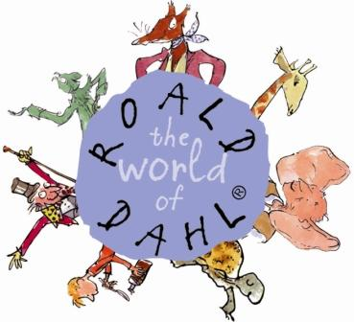

**Class 5 Learning Letter**

*Spring 2, February – March 2017*

Key dates:

2nd March : World Book Day

15th March: Year 5 and 6 to BGS science trip

15th / 16th March: Parents evening

22nd March: Year 5 to South Wolds dance festival

24th March: Red Nose Day

Dear parents,

Our last half term, although short, seemed a very busy one and I hope you have all enjoyed the break. We had lots of fun with our topic work last half term on Europe; we explored different countries and produced some fabulous artwork on landmarks. We worked equally hard in English and I was really impressed with the amount of effort that went into the homework task on researching a country to write about in our class version of around the world in 80 days. Hopefully you have had a chance to look at the piece of writing that the children produced for this as they all had a copy to bring home!

We are very excited about our whole school topic for this half term already in school as we are coming together to explore the world of Roald Dahl. Our whole school topics are a brilliant way for promoting the Willow Brook community magic as we will be carrying out competitions and incentives across year groups, which really motivates and engages children in the learning they do in classrooms on the topic. The topic of Roald Dahl lends itself wonderfully to English work, as we will be studying one of Dahl’s stories as well as producing some exciting art projects inspired by Dahl’s creations. Similarly we will be exploring some fun science activities, linking to the many formulas and potions made in his stories.

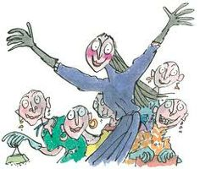

Our book study for this half term is The Witches! We will be carrying out lots of pieces of writing to develop all of the skills we are learning in our grammar and comprehension work. We will begin with a biography of Dahl before then moving on to think about the rather gruesome description of a witch, creating our own magic formula and writing the story of Grandma. Roald Dahl is the perfect opportunity to make an effort to do some extra reading at home, I will be encouraging the children (as always) to read as much as possible and we will be having an in class challenge to see who can read the most Dahl books over this half term. There is no better task to do at home than reading a brilliant story!

I endeavour to keep our P.E lessons on a Wednesday and Friday this half term but children really do need to have their kit in school all week as this is likely to change!

Just a little reminder of the expectations of P.E kit in school…children are expected to have both an indoor (shorts, t-shirt, bare foot) kit and an outdoor (joggers, t-shirt, jacket/fleece, socks, trainers) kit at all times. Please also ensure that girls come equipped to tie their hair up and be able to take earrings out on the days of our P.E sessions.

On a final note, it is becoming an increasing trend in class 5 to wear bracelets/bands which are not part of our uniform and therefore should be left at home. Similarly there seems to be a lot of homemade stress balls appearing in school and I will be asking the children this week to no longer bring these into school as there have been a few problems with storing them in pockets and becoming a distraction in lessons. I would really appreciate your cooperation in reminding children to leave these at home!

As always, please email or pop in if you have any queries. I look forward to seeing you all at parents evening in a couple of weeks.

Kind regards, Emma Hackett

In science this half term we will be carrying out some experiments linked to our work on Roald Dahl, as previously mentioned. We will also be looking at the changes as humans develop to old age. To do this we will be making a timeline from birth to death and studying the changes in animals through this time. We have also been invited to attend a science trip to the BGS this half term which we will be attending with year 6.

Mrs Graham continues to carry out some wonderful DT projects when she teaches the children every other Tuesday morning. Their latest project has been looking at pulleys and levers, in which the designed a way to transport heavy items up a treehouse.

This half term Mrs Hallsworth will be looking at teaching, wisdoms and authority through moral codes in her R.E work with class 5 on Monday afternoons, as well as carrying out our weekly spelling test and some arithmetic practice.

In maths, we are continuing to work hard on learning skills that we can then use and apply in problem solving and reasoning style questions. The children are really getting hooked on these thinking lessons and they particularly enjoyed figuring out the donut challenge we looked at when exploring our learning on fractions. As always, we work hard on revisiting and re-capping on all learning we have covered on a regular basis. This is done through a weekly mental maths or arithmetic test and through varying short activities every morning. In an attempt to highlight the importance of regularly practising times tables all children now have booklets which they will be carrying out in an out of school to try and improve their times.