Spring Term in Class 4
Welcome back.
Halfway through the year already! Where did the time go? Well you know what they say – time flies when you’re having fun. Or is it time flies when you’ve got spellings, homework and times tables to learn before dance club, after football training, during the journey to chess club and on the way back from the latest birthday party? Either way, time is flying!

Onto the matter at hand - this half term. If you’ve not heard the latest news about Wonka Bars, golden tickets, Enormous Crocodiles and Big Friendly Giants then quite frankly – where have you been? That’s right – we’re learning all about Roald Dahl! He just so happens to be my favourite children’s author and over the years I’ve come to trust his books as being the perfect tool for extracting some of the best work of the year from the children in my class. With my different classes, we’ve made giant plaster of plaster of Paris insects from James and the Giant Peach, created thirty upside down living rooms from the Twits, collaged a four foot long Enormous Crocodile and even staged the mechanical digger race from Fanstastic Mr Fox. This year we’re working on a completely new book for me, we will be studying arguably his most celebrated masterpiece, Charlie and the Chocolate Factory! We’ll be so busy reading, writing and having fun that the children won’t even notice that I’ve somehow managed to teach them the difference between a subordinating and a coordinating conjunction or a verb in the present progressive or the present perfect form. Wish me luck!

Our maths work will be focusing on time. So far we’ve just looked at units of time and got a little carried away working out how many seconds are in a millennium (31,536,000,000) but have also managed to make other more useful conversions It is an important skill to learn and requires as much practice as possible. Wherever you can, try to ask your child questions about the time. For example you could ask them what the current time is, how long their favourite tv programme lasts or how many minutes they took to find their school shoes. You could even add this up over the course of a week to show them that they spend nearly a whole school day per week just trying to leave the house!
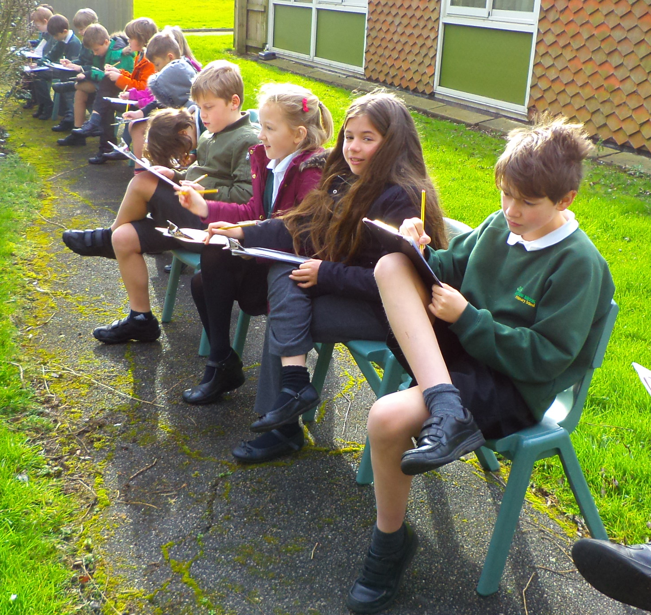
The children will continue to learn science on alternate Tuesday mornings with Mrs Graham. Taking advantage of this recent bout of mild weather, the children worked outside, carefully studying the environments here at Willow Brook. After this project is finished, they will learn all about how they, as human beings, fit into the mighty animal kingdom. Digestion, skeletons, muscles and brains. Time to be amazed!

Homework continues to be set on Friday and to be handed in by the following Thursday. The sooner it is completed, the more time I have to mark it. I can’t promise to get homework marked if I receive it late! If it’s all getting a bit much please do come and see me – I’m here to help!

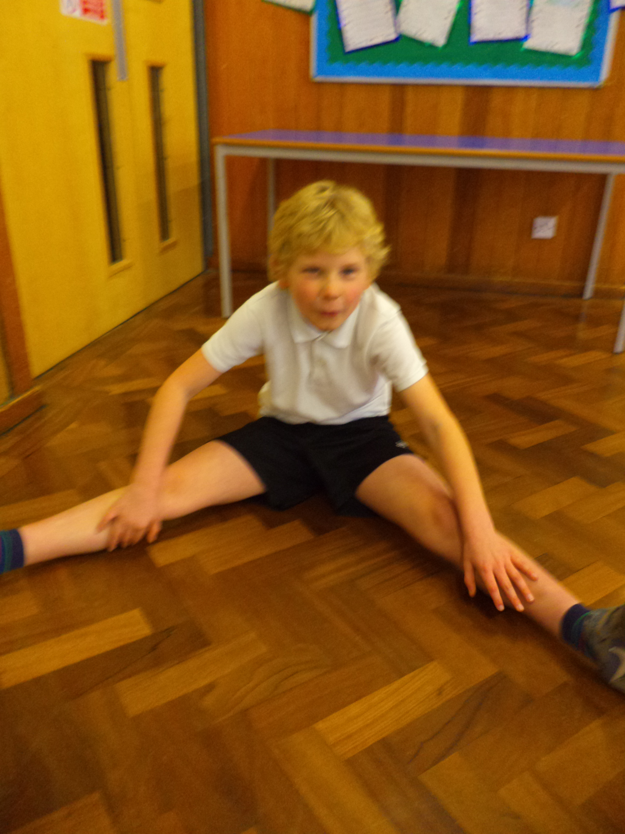
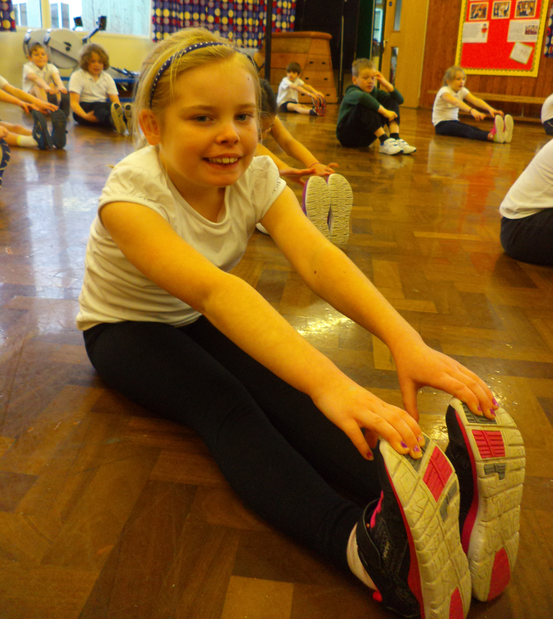
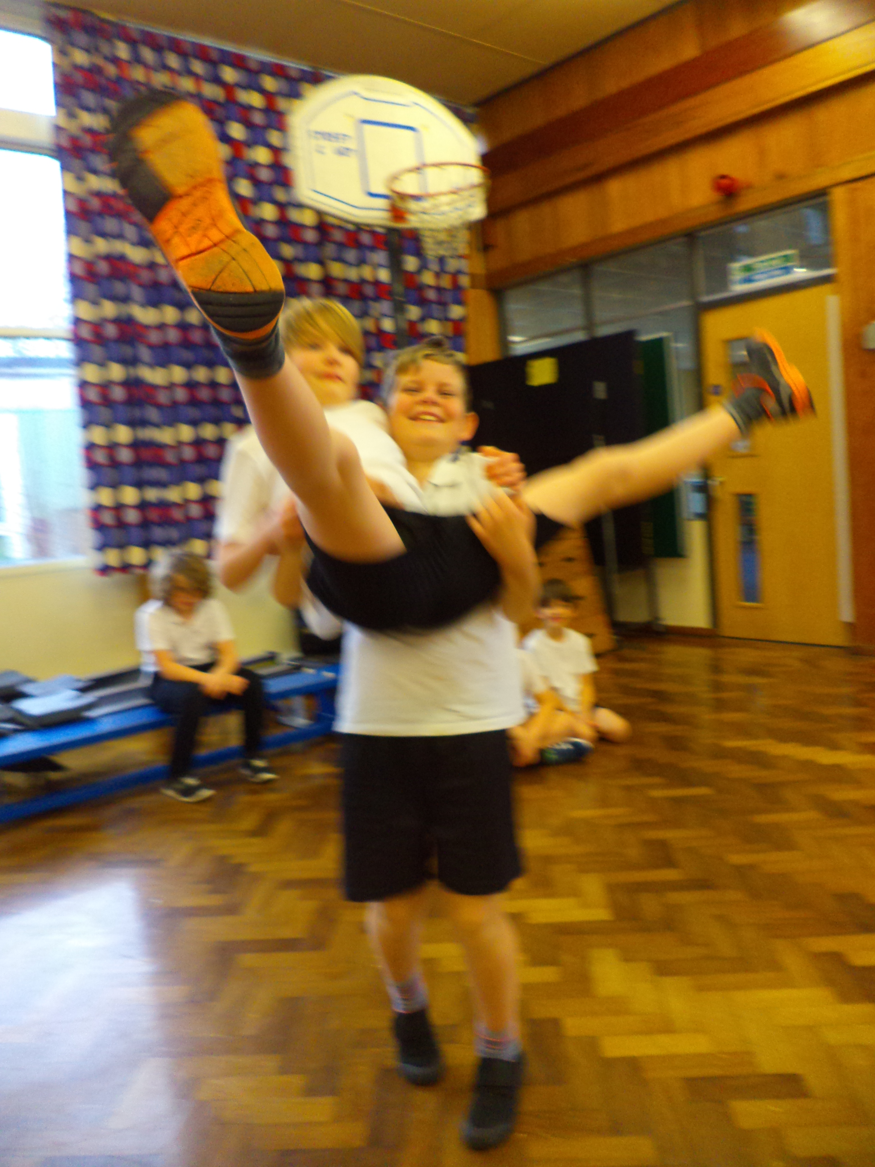
After a fantastic series of lessons with Fisa the street dance teacher (which I thoroughly enjoyed!), we will start to really get stuck into improving our techniques on the rowing machines. I’ve already started to record the children’s performances and they are really enjoying seeing themselves improve on the big screen in the hall. There is fierce competition at the top and the bottom of the table. I am planning to use the data at the end of the year to help us learn about plotting graphs – but don’t tell the children that – they think PE is just about fun!

Just a reminder, there are times, due to timetabling and the busy nature of school that PE lessons can happen at quite short notice – this means that PE kit needs to be in school every day. The children will need kit for both indoors (black shorts, white t-shirt) and outdoors (tracksuit bottoms, top and trainers). We have had a discussion about this in class this week.

I think somebody’s half term project deserves a special mention – I’ve never been so enthusiastic about marking a piece of homework. Eating a chocolate cake is much more appealing than checking page of calculations!

Please do come and see me if you have any concerns or queries. I do love a good chat!
Mr Jones

