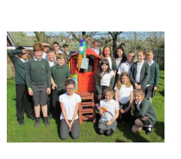
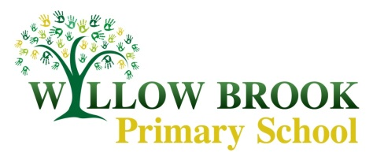

Class 6 Learning Letter

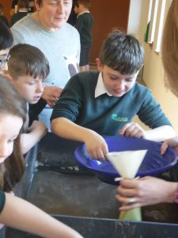
Summer Term 2017

Welcome back! I hope you all had a lovely Easter break and enjoyed some family time and chocolate eggs. The Spring Term was crammed full of wonderful experiences, such as the trip to BGS, sporting fun at South Wolds and the fantastic caravan and roly-poly bird project (which I hope lots of you got to see in the final couple of days).

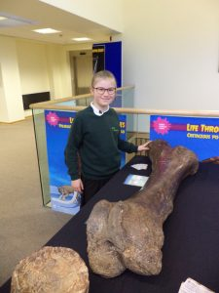
Onto the summer term… It probably just seems like yesterday that your children put on their primary school uniform for the first time and it is, therefore, quite a shock to think that this is their last term at Willow Brook! For some families it is the end of an era with this being the last sibling with us; whilst others will experience the move to pastures new for the first time. Whatever the situation we will do everything we can to make sure that this term is a happy, successful and memorable one.

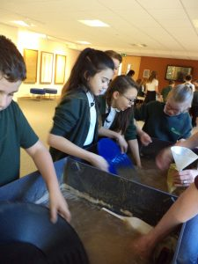
First things first…you will probably realise that Year 6 will sit their tests this half term. They begin on Monday 8th May and there are tests every morning from Monday to Thursday. Whilst we work extremely hard to make sure that the children are well prepared and achieve their potential, we also make sure that the week is calm and without worry. We appreciate your support in making sure this week runs smoothly. (Plenty of sleep, being at school on time and a good breakfast always helps.)

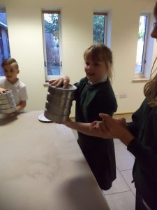
There are many exciting adventures planned for the post tests weeks. Three adventurous days away at Dukes Barn, sports day, the plant sale, visits to new schools and a DARE graduation. Over the next couple of weeks the children will be preparing an assembly to share what they learned from Mr Oakes and the DARE programme. You are welcome to come to their special assembly on Thursday 18th May at 9.30am as they are presented with their graduation certificates.

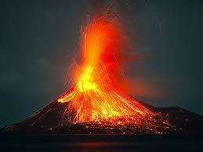

As well as all of this, we are still managing to jam pack our days with exciting curriculum topics. Our geography focus for the term takes us on a journey to the centre of the earth. We will learn all about the structure of our planet, the phenomena of tectonics and volcanoes as well as travelling back in time to the dramatic eruption that destroyed Pompeii back in 79AD. We will be getting practical in science, learning about light and shadows and making electrical circuits. In art we will be getting to grips with perspective and, hopefully, producing some pictures and paintings that show our advanced skills with vanishing points and horizons.

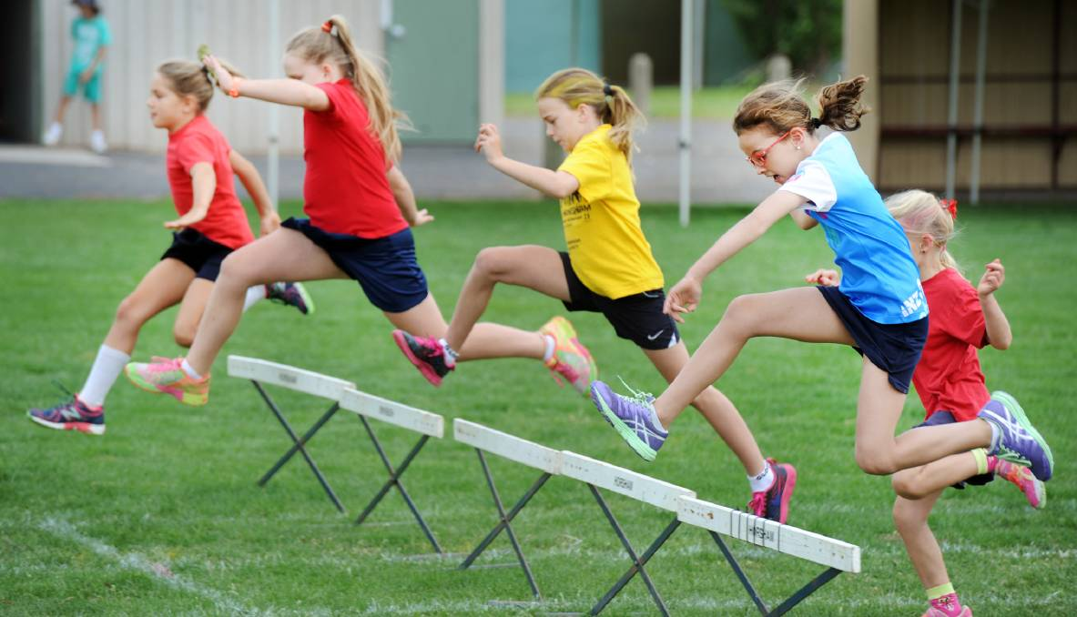
Whilst P.E. is timetabled for a Monday (with the Excel sports coach) and Wednesday this half term, please make sure kits are kept in school all week. We will seize any chance that the summer weather offers once the field is dry to get out and get active.

We are looking forward to a busy and exciting summer term and we hope you and your children are too. If you do have any questions or concerns about any of the events over the next term, you are welcome to come into school to discuss them with either myself, Mrs Graham or Mrs Ballard. We are always happy to see you.

Enjoy the term!

Hanna Myring

