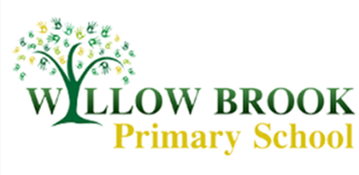
Year 1 Learning Letter
June 2017
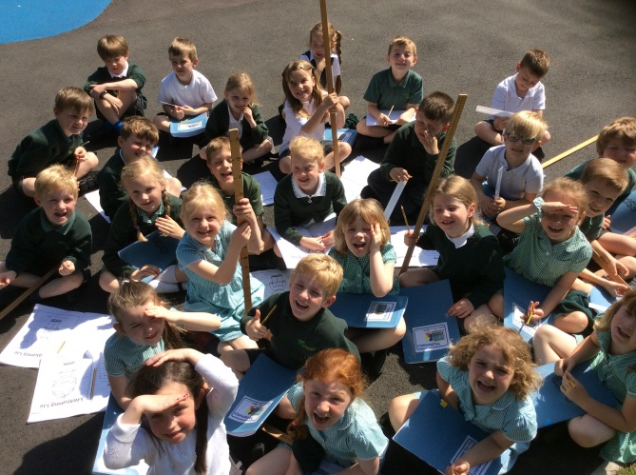
Wow! Last half term went by so quickly. We had lots of fun playing and learning outside making the most of the sunny days. We were so busy in Year 1 that every day seemed to fly by and the bell was ringing for the end of the day before we knew it. I am sure this half term is going to go by even quicker with our preparations ready for Year 2.

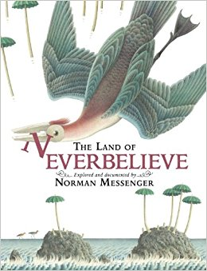
The Land of Neverbelieve
As always, our last topic of the year is one for the whole school to enjoy. We will be going on an exciting a journey to the magical land of Neverbelieve. If you haven’t had the opportunity to explore the land for yourself I highly recommend getting your hands on a copy of the book. So not to spoil the topic for the children, now that many of them can always be found reading the learning letter before it makes its way out onto the playground at half past 3, I won’t be giving too many clues as to what we will be discovering but it’s safe to say I have had a lot of fun planning the adventures this half term!
For one of our first adventures we will be discovering the inhabitants on the island and finding out a little bit about where they live. The pictures of their houses are beautiful and it felt only right that we should have a whole school technology and art task to recreate their village. For this we will require some small box modelling items eg. small cardboard boxes of all shapes, tiny bottles, milk cartons, yoghurt pots. If you could save any suitable materials and send them into school with your child before Wednesday 14th June that would be really helpful.

Phonics Screening
Next week, the children will be taking part in the Phonics Screening Check. The children are so used to this process that they won’t see it as being any different to their usual phonics lessons. The children are actually quite excited at meeting some of the brand new ‘monsters’ in the new booklet and are always discussing which monster is their favourite. The outcomes of the screening will be reported to parents along with your child’s end of year report and will outline whether they have ‘met the expected standard’ or are ‘working towards the expected standard’. If your child achieves ‘working towards the expected standard’ they will continue with their phonics lessons in Year 2 and will retake the screening at the end year 2.
Maths
This half term is full of recapping anything that as a class we have found a little more challenging or that we need to deepen our understanding of ready for the move up into Year 2. We will be revisiting telling the time, money and shape as these are all topics that require a little more time. We will also be having another look at missing number problems and finding creative calculations to solve problems.
Science
Our science this half term moves on from plants and mini-beasts to finding out a little more information about the different types of animals. We will be discovering more about mammals, birds, fish, reptiles and amphibians as well as thinking about what animals eat. We will be sorting animals into carnivores, herbivores and omnivores before thinking about their positions in a food chain.
PE
In our PE lessons we will be learning how to play simple versions of rounders as well as starting to get the hang of playing tennis. We will also be practising ready for sports day which the children are already looking forward to. Please ensure your child has a PE kit in school all week so that we can make the most of the warmer weather and take out PE lessons outside.
If you have any questions about the half term ahead please pop into school to see me or email the school office.
Thank you for your continued support,
Miss Sarah Johnston.

