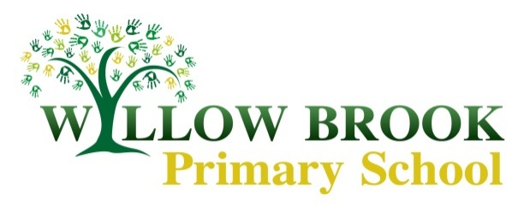
Class 5 Learning Letter
June- July 2017
Dear parents,
It is the start of our final term already, where has this year gone!? I hope you enjoyed the bank holiday weekend and if you were lucky enough to also have the half term off, you enjoyed yourselves in the sun.
Last half term’s topic, as you all know, was space. The children did various activities on space including a debate on ‘is there life on other planets?’- which turned into a very heated, but educational discussion- we also worked on planets, the sun, moon and earth, shadows and to showcase all their new knowledge on space the class created their own non-fiction book. This has been put together and I am looking forward for class 5 to see the finish product! In English, the children have had a very busy half term and produced brilliant pieces of work, some of which have been put onto our class display ‘class 5’s galaxy’. The work class 5 have produced just shows how much they have learned and how they have grown this year, well done class 5 you are all stars!
This half term, our final term, we will be doing various activities with the whole of Willow Brook through our school topic based on the book, ‘The Land of Never Believe’ by Norman Messenger. This is an interesting and unique book of a make-believe island. If you get a chance to purchase a copy or to have a quick read through, please do, it is a fantastic book for all ages. The illustrations and language in the book are fascinating. I think the children will thoroughly enjoy studying this book further and will be doing lots of different activities connecting to the book. As always, in Willow Brook style, there will be opportunities for each class to show off their creative skills in different school projects such as creating their own house in the style of those in the hamlet on this island.
In English this half term, class 5 will have numerous writing opportunities to show off their creativity and all the year 5 techniques they have learnt. All the English work will be connected to the topic book ‘the Land of Never Believe’. The children will be planning their trip to the Never Believe, writing descriptions on the people in the book, the places on the island and writing their own stories to add to our very own book mountain. Through these writing opportunities the children can use their imaginations and bring the book to life, which I for one am very excited about reading and being a part of.
Our maths lessons will be focusing on different objectives, all with a link to the half term topic, where appropriate. The first week back we will be focusing on coordinates, translations and reflections which will result in the children making their own map of the island Never Believe. In the following weeks, the children will be focusing on measurement and recapping objectives such as fractions and problem solving. The children have done extremely well this half term in maths. Certain objectives such as fractions, decimals and percentages, showed the classes determination and focus on learning new skills and developing their maths knowledge. I was very proud of class 5 after focusing on this objective, as not everyone found this easy at first; through their hard work the children are all much more confident in the area and can tackle questions with more ease. Well done class 5, keep up the determination and hard work this half term.
Science this half term will be focusing on forces. The children will have lots of opportunities to turn into scientists through doing investigations and experiments. In the first week back the children will be learning about air resistance and will be making their own parachutes to see who can make the most successful flight. In following weeks, the children will be studying different scientists who helped develop the theory of gravity. I am sure these lessons will engage all class 5 and bring out some budding, young scientists.
I’m sure class 5 will be happy to hear that, this half term our DT will be focusing on cooking. There will be plenty of opportunities for the children to make delicious food and hopefully the children will let you, at home, have a taste! Class 5 will be making vegetable muffins and other delicious treats throughout the half term.
Class 5 will have the usual two P.E sessions a week. As the weather is getting much warmer we will be able to do more P.E outside. This half term we will be focusing on athletics and rounders.
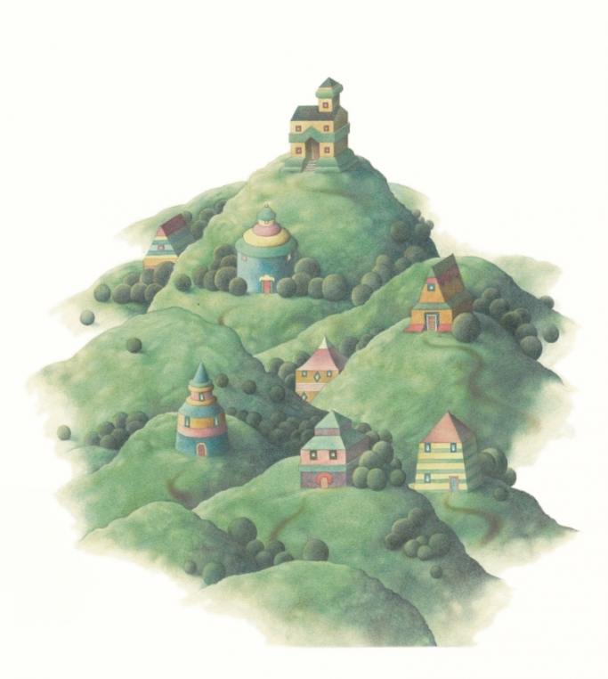
A final message from me (Miss Clifton), with only three weeks left, my PGCE placement at Willow Brook is now coming to an end. I would like to thank all the children in class 5 and all of you for your involvement in my teacher training. It has been a pleasure to teach all the children in class 5 and to meet those of you that I have met. I have thoroughly enjoyed taking over class 5 and I will miss the class a lot. Although I know Miss Hackett is looking forward to having class 5 back for the last few weeks of term!
Key dates: June 9th – Class photographs. June 16th- School disco. June 21st – 6pm meeting re Year 5/6 residential. July 3rd – School closed for inset day. July 5th- School reports out. July 10th- 12th - Year 5/6 residential trip. July 18th- Sports day. July 25th- Last day of term.

I hope this gives you an insight into the half term ahead of us.
If you have any questions or queries myself and Miss Hackett are always happy to arrange a time to discuss them.
Kind regards, Grace Clifton

