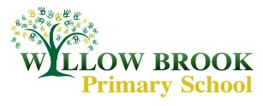

Class 5 Learning Letter

*Autumn 1 September – October 2017*

Dear parents of Class 5,

Welcome back! I hope you’ve all had enjoyable summers, I’m sure I will hear lots of stories about them as we return to school this week. As marvellous as the six weeks are, there is always a buzz of excitement in returning to school for a new academic year, especially after two inset days of preparing classrooms.

Year 5 is a big and exciting year as we step up in preparation for this time next year when children will be facing their final year at Willow Brook. There are a few changes in terms of expectations of work completed at home and hopefully these will be explained throughout this letter. I feel that I have a sneaky advantage this year in having already taught this class so the getting to know each other phase will be more of a catch up, although I was very impressed to see and hear about the progress being made throughout year 4 during class swap morning and in speaking to Mr Jones about last year.

Dear parents of Class 5,

Welcome back! I hope you’ve all had enjoyable summers, I’m sure I will hear lots of stories about them as we return to school this week. As marvellous as the six weeks are, there is always a buzz of excitement in returning to school for a new academic year, especially after two inset days of preparing classrooms.

Year 5 is a big and exciting year as we step up in preparation for this time next year when children will be facing their final year at Willow Brook. There are a few changes in terms of expectations of work completed at home and hopefully these will be explained throughout this letter. I feel that I have a sneaky advantage this year in having already taught this class so the getting to know each other phase will be more of a catch up, although I was very impressed to see and hear about the progress being made throughout year 4 during class swap morning and in speaking to Mr Jones about last year.

History - The Vikings

What a topic to start our year off with! I am very excited to get stuck into our learning about The Vikings this half term and hopefully the children will be too. I know before Summer when a couple of eager children asked what their topic would be they seemed rather elated to hear that we would be studying The Vikings. The aim of our history project will be to create interactive Viking settlements / scenes in groups, which we will aim to then share with you at the end of the half term. All of the history work we will be completing in lessons will lead up to this and influence the designing of it. A large factor helping with this will be our trip to the Viking Jorvik Centre in York! An additional letter will be sent home with the details of this.

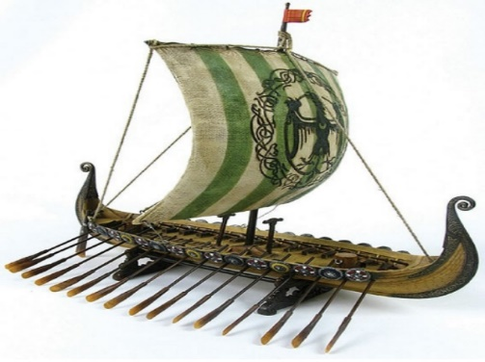

English

Our English work this half term will link with our topic of the Vikings as we begin by exploring Norse mythology. We will be finding out about what and who the Vikings believed in and this will lead us to creating some pieces of descriptive writing as well as some adventure stories. As always we will be studying parts of a text for this and whilst not a children’s book, we will be looking at parts of stories from Neil Gaiman’s depictions of Norse Mythology. Each week we will have a focused grammar lesson that links in with the style of writing we are working on. One of our focuses for this half term will be re-visiting the basics and mastering relative clauses.



Maths

To begin with this half term our focus in maths will be on number and place value. As I am sure you will have noticed throughout year 4 the focus on reasoning and problem solving tasks continues to rise and on a weekly basis we will be facing questions and task that develop these skills. In addition to this we’re also recognising the importance of solidifying the basics which is why we are re-introducing the counting sticks to classrooms! Each week we will have a counting focus, whether that be a particular times table, decimal numbers or fractions, that we will start every maths lesson with and which will be displayed around the classroom. With Mrs Hallsworth every week children will continue to develop their mental maths and arithmetic skills as they will complete an informal paper, which they will mark themselves to help see how improvements can be made.

It is so beneficial for children to learn their times tables at home. I’m sure Mr Jones stated this same message throughout year 4 so I am only reiterating that any practice that can be done at home is very valuable. We’re up to learning all of the times tables now, as children were already doing by the end of year 4, so starting by refreshing some of those trickier tables is a good idea.

Reading

As part of our English lessons we cover aspects of the reading curriculum and develop comprehension skills however many of these are consolidated during **Guided Reading** sessions. Guided reading has a bigger focus in year 5 as children no longer spend their mornings writing in fish books. Children will be placed into guided reading groups and will have a guided reading book that is only written in for guided reading sessions. Each week we will read and discuss a section of the text that the group is working on in school and this will be followed up with a **home task to be completed every week**. Typically, this will be to read 1-2 chapters at home and to complete a task that develops comprehension skills, often answering a question or analysing a particular part of the story. When children get into the swing of this, guided reading sessions become a brilliant part of the week, especially when children are enjoying the book they are reading! This step up in guided reading is aimed to help promote continuing to read at home as often children seem to begin to lose interest in reading, which we cannot let happen. Despite not having fish books to write in we still thoroughly recommend that children are encouraged to read at home, whether that be independently or with someone else as the value of this is irreplaceable.

Spelling

As in year 3, children will have a spelling book with their spellings in for the year. Their learning of spellings at home will be consolidated with spelling lessons in school every week as well ask tasks to complete to help practice their spellings in home. More details of this will be explained in a separate spelling letter that will be sent home next week when the children receive their spelling books.



Important class info

Guided reading homework will be set on the day of the guided reading session (stated in front of book) and will be due in for the same day on the following week.

Spellings will be set and tested every Friday.

Homework will be set every Friday and is due on the following Wednesday…however it is completed before this it is very welcome.

P.E kits should be in school all week as timetables do change meaning our P.E sessions can fall on any day of the week.

R.E / P.E

In R.E lessons Mrs Hallsworth will be looking at beliefs in action on Monday afternoons.

In P.E we have a very exciting opportunity as we will be taking part in Drumba sessions! This will be every Thursday afternoon up until Christmas and I am told it is a lot of fun!

The Arts

Our art projects will be linked with our history work on Vikings as we re-create the head of a Viking God in the style of a Bhupen Khakhar who tells stories through his portrait work. We will also be studying Norse artwork and will design our own dragon heads for the bow of a ship, working in fine liner. Every other Tuesday afternoon Class 5 will be completing a DT project with Mrs Graham. This half term they will be designing and making Viking longboats!

If you have any queries or questions before parents evening at the end of the half term please feel free to arrange a time to discuss these, I am pretty much guaranteed to read any email sent before 8:30am so please use this as a means of communication in the morning if needed.

[ehackett@willowbrook.notts.sch.uk](mailto:ehackett@willowbrook.notts.sch.uk)

Kind regards, Emma Hackett

Computing / PSHE

Our computing and PSHE lessons will be spent completing a series of lessons on e-safety following the NSPCC resources for share aware. We will be discussing what children do online and what apps they use before looking at Net Aware to see how much children know about the sites they are using. We will also complete some work to help children understand how the internet actually works so they know what they are doing when they are online. Towards the second half of the half term we will be looking at the case studies designed to be used in KS2 classrooms by the NSPCC and will discuss what we can learn from there. There is lots of advice and resources for this campaign on the NSPCC website if you would like to discuss any of it with children at home whilst we are covering it in school.

Science

Our science theme for the half term is materials which lends itself nicely to lots of science experiments that we will be carrying out. Including testing materials for their solubility, conductivity as well as looking at irreversible changes and separating materials.