Class 1 Learning Letter
January 2018
Happy New Year!
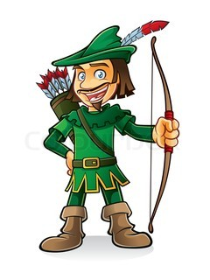
Thank you so much for all of your generous cards and gifts over Christmas. I hope you all had a wonderful Christmas surrounded by friends and family and are looking forward to the year ahead. Here is a quick learning letter to let you know what the next 6 weeks have in store.
Robin Hood
We will be working alongside Year 2 for our topic lessons this half term as our geography objectives link nicely to that of Year 2. We will be leaning all about the city of Nottingham and the key features of towns and cities. We will be comparing countries outside of Europe and talking about similarities and differences with the city of Nottingham. Towards the end of our unit will be looking in detail at the legend of Robin Hood and how the city of Nottingham has changed and developed over time. We will be using all of our geographical knowledge to design and build his perfect forest hideout.
English
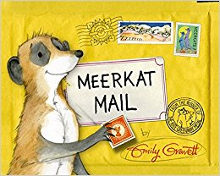
We will be starting off our English work by improving our understanding of capital letters. We will be using the story Meerkat Mail to help our understanding as well as learning all about letter writing. We will then be moving on to familiar tales to link with our topic of Robin Hood. We will be retelling the story as well as focusing on the different characters; deciding on whether they are a hero or villain. There will also be time for a spot of drama to act out the story of Robin Hood.
We are very lucky this half term as we have the Nottingham Playhouse coming into school to perform the story of The Town Mouse and Country Mouse. Before their arrival we will spend a little time getting to know the story ready for when we watch the play.
Maths
Maths lessons this half term begin with building on our understanding of number so far. We will be looking closely at 2digit numbers and really getting the hang of what each digit represents. We will be working with them more, adding and subtracting, as well as figuring out how to find missing numbers in calculations. We will then be moving on to telling the time and finding fractions of shapes and quantities. Telling the time is always a tricky topic so any additional work you can do at home will really help your child’s understanding.
Science
We will be learning all about the weather this half term in Year 1. As well as observing what weather is happening outside the classroom window we will be investigating and creating different types of weather in the classroom. We will be observing a variety of different classroom experiments to try and create different types of weather in the classroom. We will also be investigating the best material for a Lego house roof to keep our characters dry as well as trying to melt ice in the quickest way.
PE
Our PE lessons this half term are going to be split between indoor and outdoor sessions. Our indoor sessions are going to be based on the small, low level apparatus improving our balancing, jumping and rolling skills. Our outdoor lessons are going to build upon our throwing and catching skills as well as some work on skipping. Please make sure your child has a suitable PE kit in school so that they can take part in both indoor and outdoor sessions comfortably. PE will normally take place on Wednesday afternoon and Friday morning but could change depending on the hall availability and the outside weather.
Please let me know if you have any additional questions or queries. If you can’t catch me on the playground my email address is sjohnston@willowbrook.notts.sch.uk
Thank you for your continued support with learning at home.
Miss Sarah Johnston

