Spring Term in Class 4
Welcome back,
It sounds like everyone had a fun filled Christmas break. From what I have heard, the children have been treated to a wonderful holiday indeed. We have wasted no time however and in just two days we have already learned some mathematical vocabulary concerning fractions, how to add adverbs to sentences and lots of facts about the home nations and how they make up the country in which we live. Before we move onto this half term, I’d like to share with you some of the beautiful artwork we produced before the Christmas break.
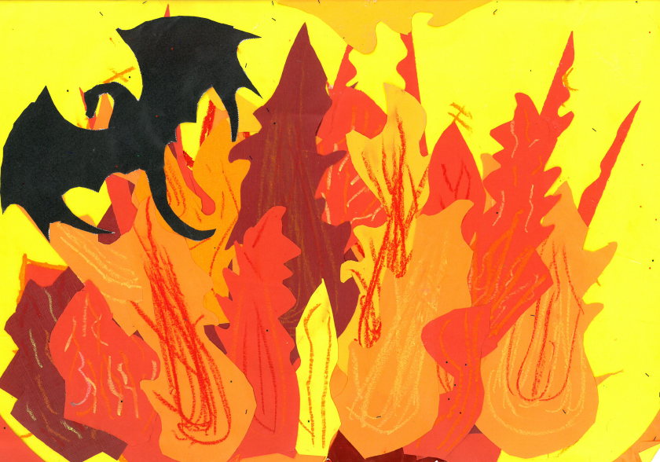
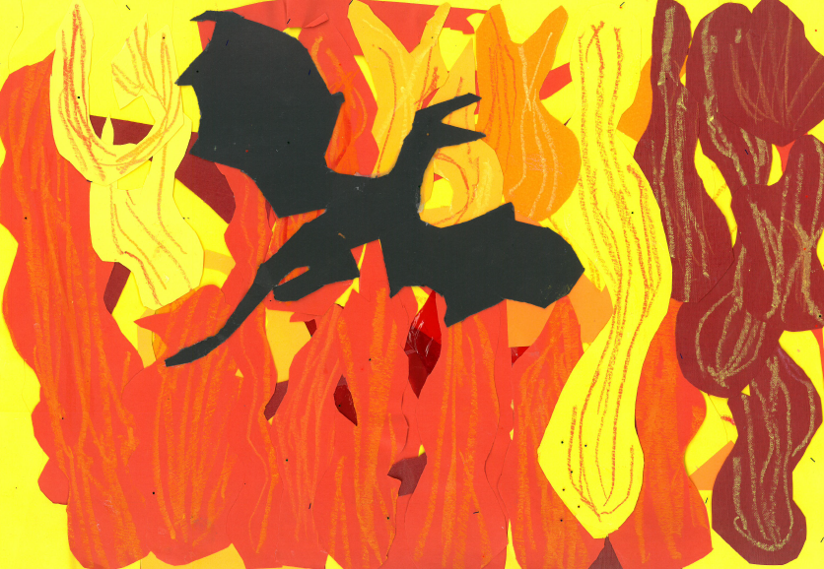
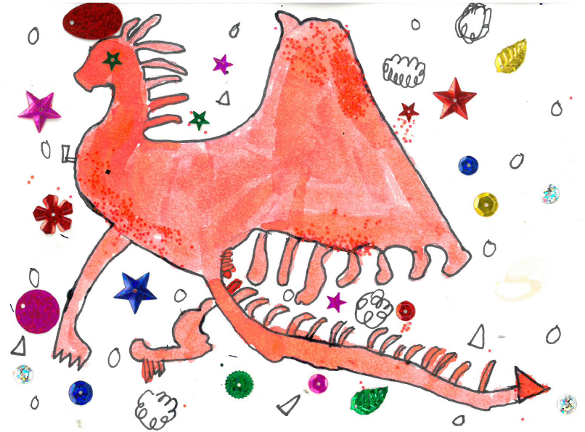
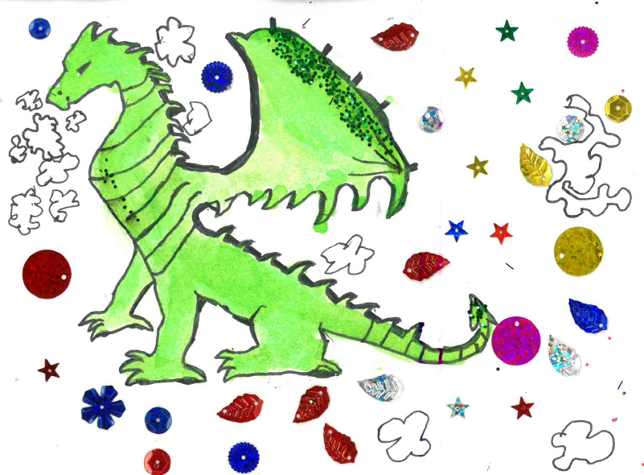
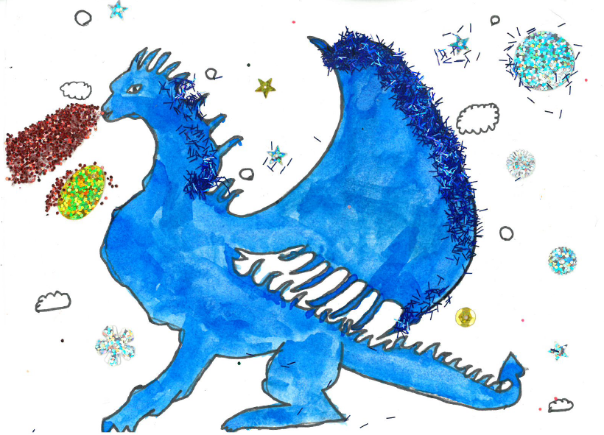
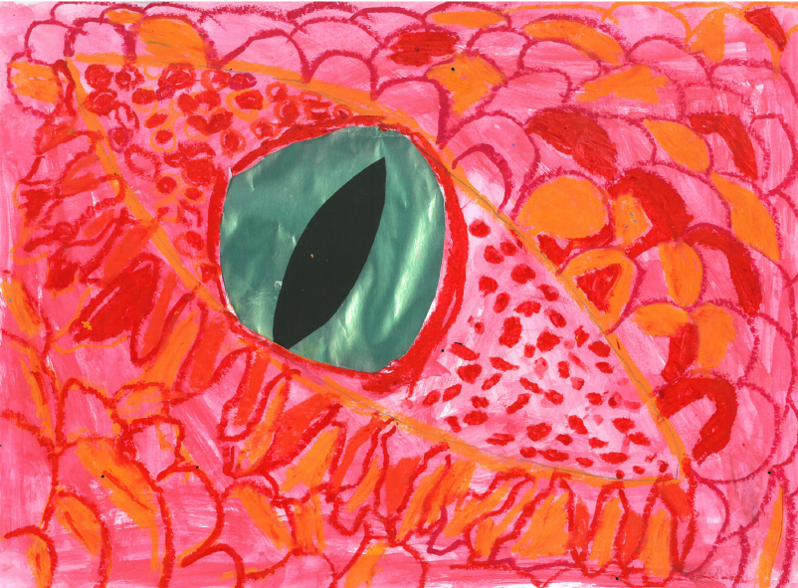
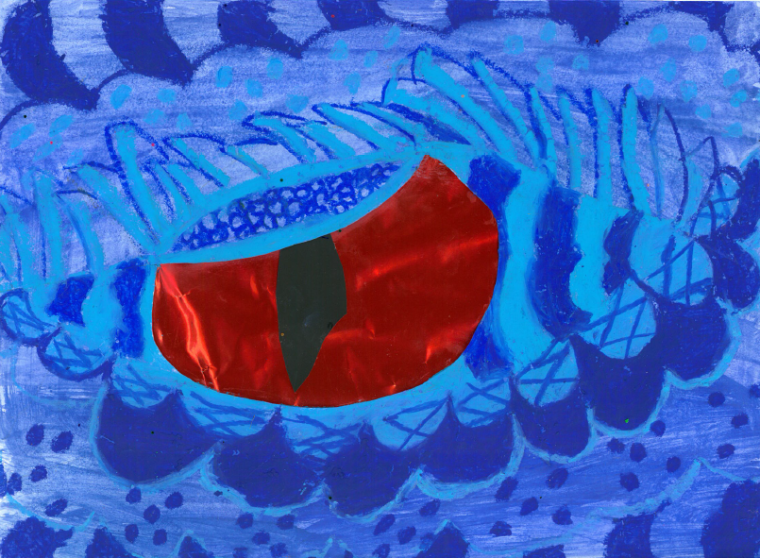

Our maths work this half term will mostly be learning how to use fractions. Since maths is just a different language to learn, it is vital that the children start to use terms like denominator and numerator. That’s right, simply cutting up pizzas doesn’t make the grade anymore! By the end of this half term your children will be able to solve all sorts of tricky problems using fractions. But don’t forget to keep practicing those times tables – the world of fractions is much easier to navigate if you have your times tables map in your hand!

This half term we will be going on a journey ‘Around the World’ learning all about the geography of our planet. We will learn about the world’s major countries, their populations and some key facts. Once we’ve got the basics out of the way it will be time to start working with some of mankind’s most amazing creations – Ordnance Survey maps! I’ll be dusting off my collection for the children to learn from and before long we’ll be taking grid references, measuring contours and heading off on an imaginary treasure hunt.

The children will continue to learn science on alternate Tuesday mornings with Mrs Graham. After having learned about solids, liquids and gasses, we will move our attention to the varied world of the animal kingdom and the habitats in which they live. The children really are very lucky – I’ve seen all of the interesting lessons that Mrs Graham has planned for them!

In our English lessons we will be looking at how masterful writing techniques such as a the ‘fronted adverbial’ can have an impact on the reader. Inspired by the writing of the Beast Quest series we will then get to work writing our own action packed battle scenes. Following on from this we will revisit non-fiction writing, this time creating fact files on some of the world’s most populous countries. This will probably involve a touch of research at home, time to dig out those atlases or pay Google a visit.

We will be benefitting from the tuition of EXCEL sports coaching this half term. Every Monday afternoon the children will learn racket sports skills. This means the children will need a PE kit in school each Monday. In addition to this the children will be benefitting from drumba lessons on Thursday afternoons. For those of you who don’t know, drumba is an activity like Zumba, but with drums. For those of you who don’t know what Zumba is (I didn’t), it’s an aerobic fitness programme featuring movements inspired by various styles of Latin American dance and performed primarily to Latin American dance music.

During all the excitement and fun activities that took place during the Christmas term we lost our regular pattern of homework. Fear not – in 2018 homework will once again go out on a Friday to be returned on the following Thursday. As ever, homework tasks need not be onerous. They are designed to take up as much or as little time as is convenient.
Please do come and see me if you have any concerns or queries. I do love a good chat!
Mr Jones

