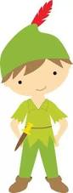
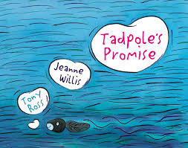
A happy new year to you all! I hope you have all had an enjoyable Christmas break and are feeling refreshed for the New Year ahead?
Our Local Town and Country: Robin Hood

This term we are staying at home to explore our local surroundings, looking at why Nottingham is here today and the bustling city it has become. We will be exploring its past and present landscape as well as linking this to our science topics of animals and humans and how they develop linked to their surroundings.

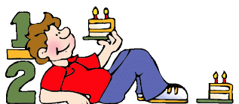
Literacy: We will begin the term looking at the beautiful picture book Tadpole’s Promise which links very well with both our topic, the local environment along with our science topic about the growth and survival of animals and humans. This book also offers some wonderful descriptions making good use of adverbs, verbs and adjectives, which will be our initial focus. As you are aware, the Roundabout Theatre Group is coming into school performing The Town and Country Mouse. We will therefore, during the term, be exploring the traditional tale based upon this performance, writing some of our stories in this style along with linking this to the differences between town and country animals and their survival. We will then complete the term by turning to Robin Hood and traditional tales to explore different types of sentences in particular those tricky exclamations. We will also identify and consider questions and statements in our sentence work as well as writing some past tense descriptive pieces utilizing adjectives and noun phrases.

Spelling: Spelling will continue daily. I will continue to set spellings on a Monday to be tested the following week. It has been wonderful to see the children recognize the spelling rules during reading too.

Maths: We start by looking at statistics and the use of tables, tally tables and simple pictorial representations of data. We will then recap number facts, understanding the opposite of subtraction is addition before moving on to identifying the relationship facts between multiplication (2,3,5 and 10) and division before finally working on fraction work towards the end of this half term.

Science: We are now looking at humans and other animals, understanding that animals and humans have offspring, how we develop and grow along with our basic needs, as living things, to develop successfully.

PE: we will be continuing to swim on a Monday afternoon (bring hats and scarves it maybe a cold walk back!)
As you can see it’s going to be a busy, fun start to 2018.

Best Wishes
Miss Weston

