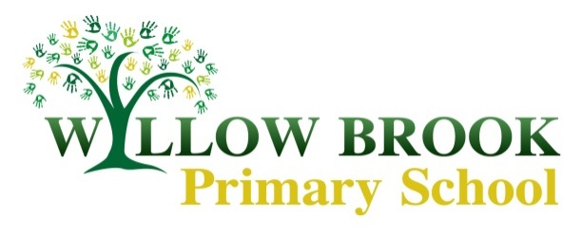Class 5 Learning Letter – Spring 2

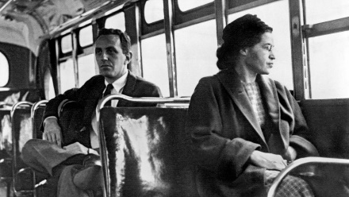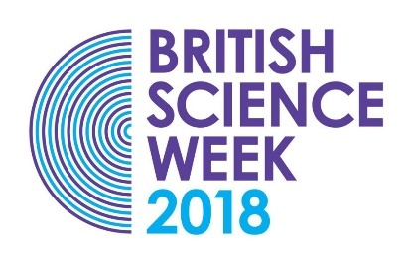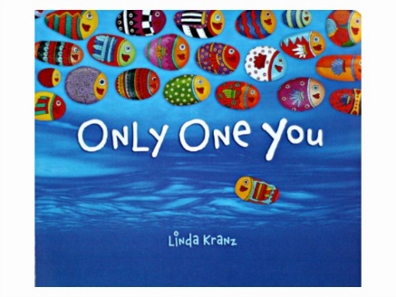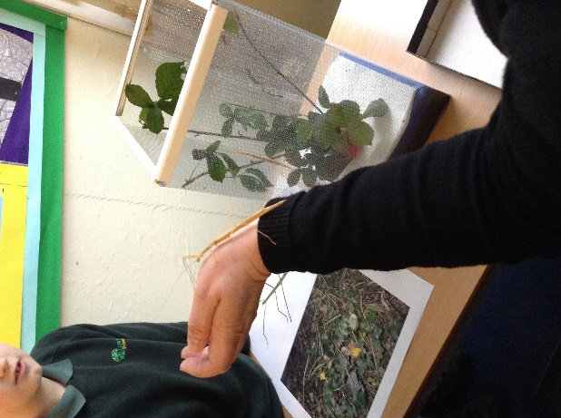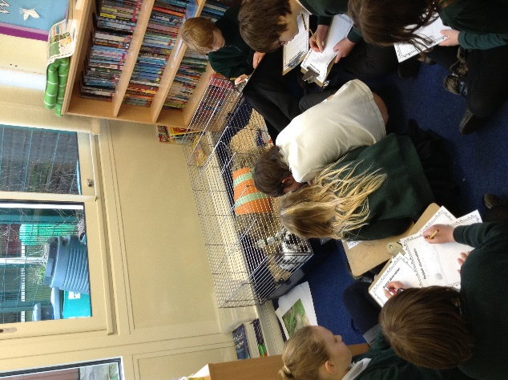February – March 2018

Theme 1: World Book Day As I’m writing this letter I’ve had the sudden realisation that I need to click purchase for my costume order! Hopefully you’re more prepared than I am for our Suess filled day. Throughout the week we’ll be exploring the world of Dr Seuss and books with the aim of completing a whole school take on There’s a Wocket in my Pocket.

As always, if you have any queries please arrange a time to see me or email me ehackett@willowbrook.notts.sch.uk.

And more… In addition to our themed work, we will be continuing with our daily maths lessons, this half term focusing on geometry. We will be getting to grips with shapes and angles, as well as keeping up with our regular counting and arithmetic practice. P.E sessions will continue like the previous half term, with Class 5 enjoying Excel sessions and some time for gymnastics too.

Theme 4: Lives that changed the World For our final theme, every class in school will be focusing on a different individual who changed the world. Year 5 will be studying Rosa Parks. As well as finding out about her individual impact we will be looking at the wider subject of the Civil Rights movement both in America and the UK. This will be a really powerful time for children to learn and discuss about this period.

Theme 3: Science Week Not only do year 5 get to join in with the science activities in school…we get a trip to the BGS too! Please look out for a further letter with more details. During the week we will be working scientifically on a number of investigations including swapping classrooms to work with another teacher on an experiment.

Theme 2: Only One You Our second week takes us into a PSHE theme, we will be exploring the text Only One you and focusing on a particular message each day. This will be introduced in assemblies and then worked on in the classroom where we will be producing written pieces of work including poetry and prose. We’ll also get creative with some mixed media artwork!

Dear parents,

Our first half term has flown by! Our geography topic proved a great success. Before the holidays we had the chance to enjoy playing our Great Games of Britain, combing all of our knowledge and hard work of the topic. In science, our learning came to an exciting close with our final lesson where we mimicked the footsteps of Jane Goodall and her observational skills. You will have seen from Mrs Ballard’s newsletter that our whole school topic for this half term takes a rather different twist. Our themed weeks will allow us to cover a range of broad and balanced projects over the next half term.