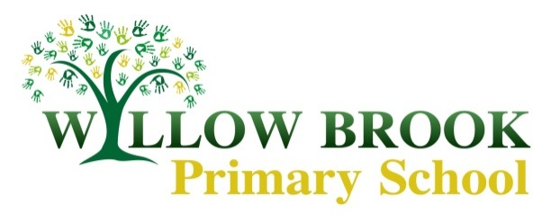

Willow Brook Primary School Class 3 Curriculum Newsletter

*Summer 1 April-May 2018*

**Dear parents and carers**,

I can’t believe we’re in the summer term already! The children worked incredibly hard last term and amidst the battles against coughs and colds, we had a super 5 weeks culminating in our whole school showcase. Thank you so much to those of you that came, I know how proud the children were of all the work they had done and how keen they were to share it with you! I was so impressed with how maturely and sensitively the children wrote about Malala Yousafzai and I know it was a topic they got very engrossed in which made for some superb work.

On **Thursday 3rd May**, Class 3 will be picking up their paints and travelling down to Wollaton Hall to use the beautiful gardens there as their muse for an artist’s afternoon out. Letters will be out shortly detailing the cost of the coach to and from Wollaton.

Homework

**Tuesday**: spelling test, scores are recorded on the **Wednesday** in spelling booklets or fish books and sent home ready for the following week.

**Friday**: set a literacy or numeracy task in their homework books, due in the following **Wednesday**.

**Friday**: children are given an informal times table test and the associated division facts to track progress- these scores will not be shared with parents or pupils but are used to track progress

**Every day:** reading with fish books being used to make comments and to be signed by a parent/guardian at the end of each week. **Children are responsible for changing their own books** but are not allowed to change a book **unless they have read all/part of it with an adult.** Please keep ensuring that children have their **fish books in school every day**.

**Some children only had comments in their reading books from Mrs Hallsworth or myself each week last term so please try to hear your child read at home and record it in their fish book.**

**Topic/Literacy**

Our class topic this term is the aptly summery title of “Sunflowers”! This will largely revolve around the artist Vincent Van Gogh but will also incorporate other artists from the era. Our literacy work will use Van Gogh as a subject for research and biographical work into his life as well as using arguably his most famous subject matter of sunflowers as a starting point for poetry.

**Numeracy**

This term we will be continuing our work on fractions, looking at equivalent fractions, adding and subtracting fractions, finding fractions of a number and ordering fractions. Towards the end of the term, we will be recapping what the children have learnt about time so far, which has been covered by Mrs Graham.

**The requirement for year 3 is to know the 2, 3, 4, 5, 8 and 10 times tables and related division facts.** The current year 3s will be the first year group to be tested, at a national level, on their times tables up to 12 at the end of Year 4. Even if not explicitly stated in a homework task, it is expected that children are continuing to practice these at home to ensure they are confident.

**PE**

In our **Wednesday** PE lessons, we will be continuing to have PE inside, with a focus on dance!

Drumba on a **Thursday** afternoon will continue until Easter. Please make sure PE kits are kept in school all week as these timings are subject to change depending on what’s going on in school.

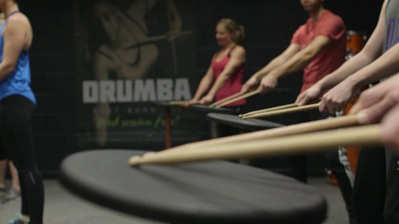

[](https://www.google.co.uk/url?sa=i&rct=j&q=&esrc=s&source=images&cd=&cad=rja&uact=8&ved=2ahUKEwjioYyJ6rbaAhXE7xQKHROeBtEQjRx6BAgAEAU&url=https://clipartpng.com/?193,sunflower-png-clipart-image&psig=AOvVaw1nDJiLdA37UntNdYvexJjn&ust=1523694373948989)

**Science**

Science this term will be a big focus as it links perfectly to our class topic of “Sunflowers”, the children will be doing investigative work into how plants grow and the names for each part. We will also look at how water travels in plants and the flower/pollination cycle.

**Computing**

This term, we will be continuing to look at algorithms and using them in a variety of contexts. We will do this using <https://www.draw.io/> website so if the children wish to create their own extra algorithms at home and share what we are doing, they can! As well as this, we will be using the computers to write up some of our Literacy/Topic work on Van Gogh to help develop those basic, but important word processing skills.

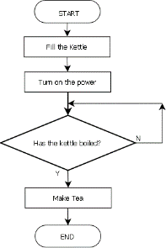

[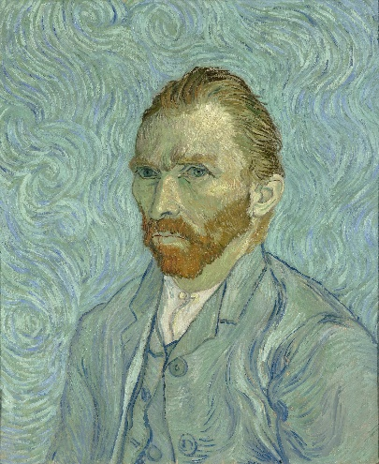](https://www.google.co.uk/url?sa=i&rct=j&q=&esrc=s&source=images&cd=&cad=rja&uact=8&ved=2ahUKEwiUl9C-6LbaAhXBPRQKHe5xCp8QjRx6BAgAEAU&url=https://en.wikipedia.org/wiki/Vincent_van_Gogh&psig=AOvVaw1SBgSM3PprjcXap6u4ultK&ust=1523693935516196)

**Art and Design**

As mentioned, our focus for this term will be on Vincent Van Gogh and his famous paintings. However, to understand his technique, style and subject matter, we will be looking in turn at other artists from the same era and looking at where he got his inspiration from, as well as who he later influenced. There are so many interesting artists and art movements that happened around this time and I’m looking forward to seeing the children’s interpretation of the range of techniques used by these artists.

[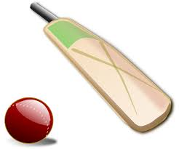](https://www.google.co.uk/url?sa=i&rct=j&q=&esrc=s&source=images&cd=&cad=rja&uact=8&ved=2ahUKEwiqnK_96LbaAhUOnRQKHdPPCtcQjRx6BAgAEAU&url=https://openclipart.org/tags/cricket&psig=AOvVaw2sqgerxLIQWYoD4e2swYUA&ust=1523694091850167)

**PE**

We will be continuing our Drumba lessons on a Thursday afternoon with Adam for the first 2 weeks of term as we missed 2 sessions last term!

In our Wednesday afternoon PE sessions, we will (hopefully!) be enjoying the start of the summer by working on our cricket skills out on the field. At first, we will be fine-tuning our fielding and batting skills in isolation before moving onto team games.

Please ensure that **children have their PE kit in every week**, our PE time slots may change so it’s best for them to bring it in on a Monday and take it home on a Friday if needed.

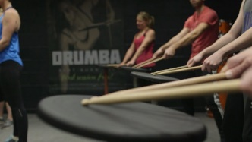

As always, if you have any questions or queries please ask me on the playground or I am always happy to arrange a time to meet after school.

Kind regards, Miss Brearey.