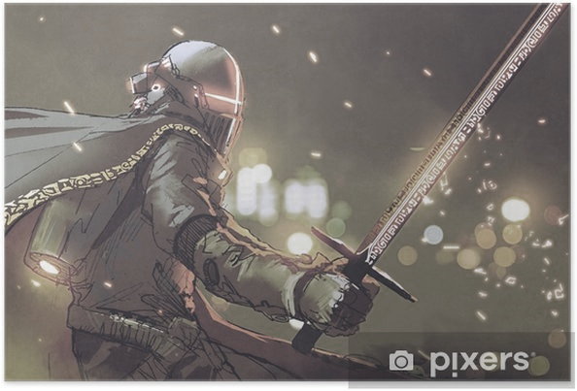

As mathematicians we will…

accept the challenges of Sir Cumference whose story-based challenges will help us explore key aspects of each year group’s curriculum. Our maths focus week will bring reasoning and problem solving to the fore as mathematical skills combine in practical and written investigations.

In each year group, specific skills will be taught. We aim to develop challenges that move from the concrete to the pictorial to the abstract to develop thinking and engagement.

As language specialists…

Scripts, myths and drama will be at the heart of our half term. Arthurian Legends bring to life key characters and kingdoms and pupils will become experts when it comes to comprehending and constructing narratives in this genre. To inspire a love of reading the class will study extracts and stories from new and familiar authors that are appropriate and challenging. These will be different for each year group and will reflect National Curriculum aims. Writing skills will be developed through cross curricular learning and will include both fiction and historical work. Pupils will all continue to work on age related grammar and techniques to improve all elements of the English Primary Curriculum. Drama and scripts will be a key part of the half term as we bring to life a story of the legendary King Arthur.

***‘Take heart, for when Albion’s need is greatest, Arthur will rise again!’***

**As our school performance brings the legend to life once more, we marvel in the magic of Merlin, journey to discover the Holy Grail, take our places around the Round Table and sword in hand, embark on a quest to Camelot! Our theme will touch every aspect of our curriculum and shed light on the Dark Ages in more ways than one… Not to mention a school production that we hope will be equally as legendary!**

**Knowledge of the World**

What was dark about the Dark Ages? What were its key features and how did they impact on what came before and after. How did different time periods get their names…and what will our current time period be known as in the future?

**Citizenship**

King Arthur reportedly designed his round table to give every member of his community an ‘equal place’. How do we work as a school to make sure that we are all equal, irrespective of our differences?

**Ambitious thinking**

Reality and myth combine to show us loyalty, love, camaraderie and quest. What are the key themes of a strong historical tale and can you write one that captures your learning?

Across the curriculum

**As expressive artists**

We will be working together to create a Willow Brook production. Alongside drama, our creative skills in music and dance will progress as we work cooperatively towards a quality performance. Celtic Art, illuminated manuscripts and Arthurian illustration will help to develop our artwork and castle construction will help us to get to grips with 3 dimensional structures.

**As French speakers**

Years 2 and 4 will learn new conversational French vocabulary and aspects of European history to complement our topic theme.

**As musicians**

We will work towards our main production, singing a range of songs from ‘What a Knight’ and our nativity. The Junior choir will be working towards Young Voices. Other extra-curricular opportunities will provide a wealth of instrument tuition on both one to one and group levels.

**As computer specialists**

We will word process and publish online articles. Pupils will use the internet to consider historical sources and improve knowledge.

**As theologians and thinkers**

We will explore the traditional stories that form the basis of different faiths. We will understand how stories with morals underpin and strengthen human understanding.

**As fitness experts**

We will dedicate curriculum and extra-curricular time to promoting fitness and healthy lifestyles. Together with professional coaches and input from our South Wolds Alliance, we will participate in team sports and individual coaching. Miss Phillips will add yoga and specialist fitness throughout both key stages and works to promote active play at break times.

**What a Knight!**

Autumn 2019

As geographers we will

*‘name and locate counties and cities of the United Kingdom, geographical regions and their identifying human and physical characteristics, key topographical features (including hills, mountains, coasts and rivers), and land-use patterns; and understand how some of these aspects have changed over time’*

As historians we will

Understand The Dark Ages and how this period fits in Britain’s historical timeline. Castles, courts and conquests will stand alongside Arthurian legend as we consider how to separate fact from fiction and historical sources. From our existing knowledge of Roman and Viking invasion, we will see how the fall of Rome led to the Peasant’s Revolt and England’s Middle Ages.

*‘know and understand our history as a coherent, chronological narrative, from the earliest times to the present day: how people’s lives have shaped this nation and how Britain has influenced and been influenced by the wider world’… ‘a study of an aspect or theme in British history that extends pupils’ chronological knowledge…’*

As scientists

Each year group will complete individual studies according to their curriculum. Practical investigations will take on Arthurian themes as Merlin’s Potion Room provides opportunities to observe, test and record our thinking.

Building and laying siege to a medieval castle required knowledge of forces and mechanisms. Our STEM studies will enable us to explore and construct!