Dear parents/guardians of Class 3,
I hope that you all feel fully refreshed and rested after a glorious 2 weeks of half term break and are excited about the term ahead! As I’m sure you’ll remember from years past, this Christmas term is always jam packed with Children in Need, carol singing, rehearsals for our wonderful Key Stage 2 production and of course an exciting topic to keep us busy as ever. We’ll be delving into the world of myths and legends by following the life and times of King Arthur and the knights of Camelot this term, following the theme of our production. This lends itself wonderfully to lots of research, reading and learning both at school and at home. If children do any additional learning at home around our subject and are keen to share, we’d love to hear about it in the classroom! An overview of what we’ll be getting up to this half term are overleaf.

PE
Our main PE day this term will continue to be on a Monday although please ensure children have their kit in for the full week as this is subject to change due to weather and especially due to upcoming production rehearsals…! Visiting coaches often add to our provision and having the correct kit is essential to make the most of both outdoor and indoor activities.
Reading
I was so impressed by the amount of enthusiasm Class 3 had for reading last term and I loved discussing their reading books with them throughout the day! They are all very excited to now have the responsibility of writing in their fish books themselves during the school day, although some of them still need reminding to write in the correct week…!

As became the routine last term, each week, children will read with myself as part of a guided reading group to enjoy a book together as well as developing important comprehension skills. Knowing that there are often merits for enthusiastic reading at home should make your children keen to share a book with you at home! This may be their class reading book, a chapter book from home or a festive tale…any reading is good reading! Please ensure that children have their Dinosaur book and reading book in school every day so that our reading sessions can be recorded.

Homework
Homework, consisting of an English or Maths based task, will be set each week on a Wednesday to be completed and handed in on the following Monday. Spellings will also continue be set each week on a Wednesday, to be tested on the following Monday. Please ensure homework/spelling books are in school on the Monday as the children use these to complete their spelling test, allowing you to see how they’ve got on each week!

In year 3 (and especially the next 2 half terms), there is a focus on times tables, with the expectation that, by the end of the year, children are confident and fluent in the 2,3,4,5,8,10 multiplication and division facts up to 12. Having a secure knowledge of these helps in so many aspects of mathematics and the more fluent they are in the recall of these facts, the better! We will be practicing these in class on a regular basis, and some homework tasks will be based around these, but practicing at home is incredibly valuable…you can never know your times tables well enough! One particular game the children have already had a taster of at school is “Hit the Button” which can be found on the top marks website. It can also be downloaded as an app onto tablets etc and is perfect for quick practice to see how many questions they can answer in a minute.

If you have any concerns or queries regarding anything on here or otherwise, please don’t hesitate to catch me on the playground or arrange a meeting with me afterschool.
Miss Brearey
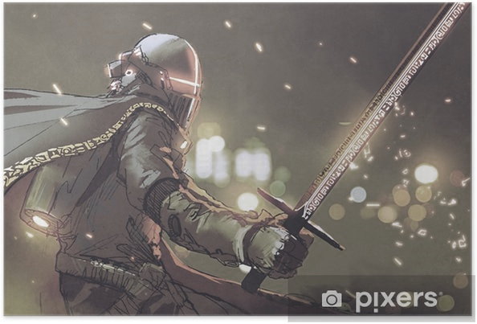
As language specialists…
Scripts, myths and drama will be at the heart of our half term. Arthurian Legends bring to life key characters and kingdoms and pupils will become experts when it comes to comprehending and constructing narratives in this genre. To inspire a love of reading the class will study extracts and stories from new and familiar authors. King Arthur and the Knights of the Round Table by Marcia Williams and Usborne’s retelling of the King Arthur legend will get us fully immersed in the world of knights, camaraderie and bravery. We will use media such as Disney’s “Sword in the Stone”, “Jackanory Junior’s Crazy Camelot Capers” and the Fantastia clip of “Sorceror’s Apprentice” to look at a more light hearted version of events whilst allowing us to use this as a stimulus for our writing. We will also use extracts from the novels “Harry Potter and the philosopher’s stone” and our class novel “Narnia: The lion, the witch and the wardrobe” to explore how authors describe magical settings and narratives. We will look at prose such as “King Arthur” by Joe Denle as well as the silly rhyming “Sir Scallywag and the Golden Underpants” series to allow us to practice being wandering minstrels...

As mathematicians we will…
accept the challenges of Sir Cumference whose story-based challenges will help us explore key aspect of each year group’s curriculum. Our maths focus week will bring reasoning and problem solving to the fore as mathematical skills combine in practical and written investigations. In Class 3, we will be focussing on mastering those times table facts! We will look at strategies and different representations of the 2,3,4,5,8,10 times tables and look at how these facts can be used in problem solving. We will also learn the formal method of calculation for short multiplication.
Across the curriculum
As expressive artists
We will be working together to create a Willow Brook production. Alongside drama, our creative skills in music and dance will progress as we work cooperatively towards a quality performance. Celtic Art, illuminated manuscripts and Arthurian illustration will help to develop our artwork and castle construction will help us to get to grips with 3 dimentional structures.
As musicians
We will work towards our main production, singing a range of songs from ‘What a Knight’ and our nativity. The Junior choir will be working towards Young Voices. We will use music such as Fantasia’s “Sorceror’s Apprentice” to discover how musicians and composers bring magic to life!
As computer specialists
We will word process and publish online articles. Pupils will use the internet to consider historical sources and improve knowledge.
As theologians and thinkers
We will explore the traditional stories that form the basis of different faiths. We will understand how stories with morals underpin and strengthen human understanding.
As fitness experts
We will dedicate curriculum and extra-curricular time to promoting fitness and healthy lifestyles. Together with professional coaches and input from our South Wolds Alliance, we will participate in team sports and individual coaching. Miss Phillps will add yoga and specialist fitness throughout both key stages and works to promote active play at break times.

As scientists
Each year group will complete individual studies according to their curriculum. Practical investigations will take on Arthurian themes as Merlin’s Potion Room provides opportunities to observe, test and record our thinking. Building and laying seige to a medieval castle required knowledge of forces and mechanisms. Our STEM studies will enable us to explore and construct!
As historians we will
Understand The Dark Ages and how this period fits in Britain’s historical timeline. Castles, courts and conquests will stand alongside Arthurian legend as we consider how to separate fact from fiction and historical sources. From our existing knowledge of Roman and Viking invasion, we will see how the fall of Rome led to the Peasant’s Revolt and England’s Middle Ages.
‘know and understand our history as a coherent, chronological narrative, from the earliest times to the present day: how people’s lives have shaped this nation and how Britain has influenced and been influenced by the wider world’… ‘a study of an aspect or theme in British history that extends pupils’ chronological knowledge…’

As geographers we will

‘name and locate counties and cities of the United Kingdom, geographical regions and their identifying human and physical characteristics, key topographical features (including hills, mountains, coasts and rivers), and land-use patterns; and understand how some of these aspects have changed over time’

‘Take heart, for when Albion’s need is greatest, Arthur will rise again!’

As our school performance brings the legend to life once more, we marvel in the magic of Merlin, journey to discover the Holy Grail, take our places around the Round Table and sword in hand, embark on a quest to Camelot! Our theme will touch every aspect of our curriculum and shed light on the Dark Ages in more ways than one… Not to mention a school production that we hope will be equally as legendary!

Knowledge of the World
What was dark about the Dark Ages? What were its key features and how did they impact on what came before and after? How did different time periods get their names…and what will our current time period be known as in the future?
Citizenship
King Arthur reportedly designed his round table to give every member of his community an ‘equal place’. How do we work as a school to make sure that we are all equal, irrespective of our differences?
Ambitious thinking
Reality and myth combine to show us loyalty, love, cameraderie and quest. What are the key themes of a strong historical tale and can you write one that captures your learning?
What a Knight!
Autumn 2019

