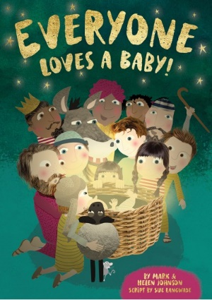

Reception Class
Welcome back to our new half term! It has been wonderful to see how easily and quickly the children have settled back into class, ready to embrace the term ahead.
Over the coming weeks we will be preparing for our Nativity play called Everybody Loves a Baby! There will be songs and actions to learn and for some children, lines to remember. I am sure that all the children will rise to the occasion and that you will thoroughly enjoy the performance.
During this half term, along with the rest of the school, we will be learning about the adventures of King Arthur and the Knights of the Round Table. In Literacy we will look at a range of books to find out about life long ago. We will read non- fiction texts about castles and knights and use our increasing phonic knowledge to label pictures and write facts about them. We will also read fiction books with a castle theme, including George and the Dragon, The Princess and the Pea and The Paper Bag Princess. The children are welcome to bring in their own books related to the theme to share with the class. In Phonics, we will continue with Phase 3 of our Letters and Sounds programme.
In Maths, we will recognise and write numbers to 20 and we will get better at counting forwards and backwards from any given number within 20. We will learn to find one more and one less from a number and solve problems
involving adding and taking away. We will describe the shapes of everyday objects and use names for 2D shapes.

To develop our personal and social skills we will know how to play cooperatively, share and take turns. We will continue to build positive relationships with our friends in class and we will learn ways of resolving conflicts. As part of our Anti-Bullying programme we will understand what it means to be a good friend and what we should do if some-one is not being kind to us. Through this, we will learn how to describe ourselves in positive terms and celebrate our achievements.

We will continue to have PE lessons on a Wednesday morning. Sometimes we go outside, so it would be useful to provide your child with tracksuit bottoms.

If you have any further questions, please do not hesitate to speak with me.

Thank you for your support,
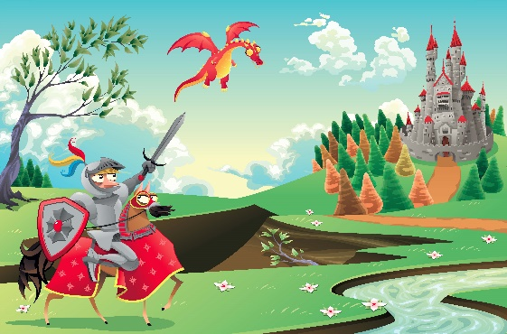
Anna Jones

