Congratulations on becoming a pirate.

You have shown your courage and bravery. Now it is time to cast off and set sail on your first pirate adventure.

First thing you will need to do is pick somewhere to travel.

I have given you a world map to look at.

I want you to put a big X on the country you would like to travel to.

Next, I would like you to find out anything you can about that country, starting with its flag. Flags are very important to pirates so knowing that countries flag is a must.

After that see what else you can find out.

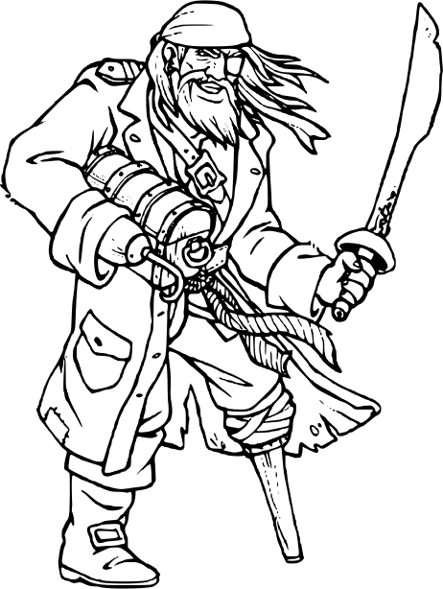

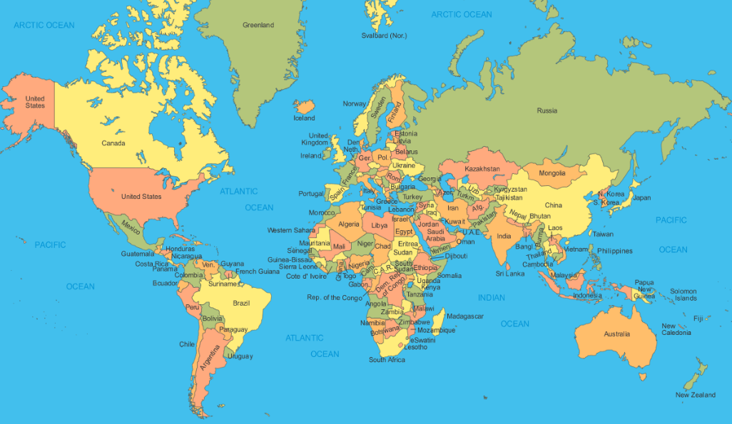

**World Map**

v

Facts about country:

______________________________________________________________________________________________________________________________________________________________________________________________________________________________________________________________________________________________________________________________________________________________________________________________________________________________________________________________________________________________________________________________________________________________________________________________________________________________________________________

I chose _________________________________________

Because____________________________________________________________________________________________________________________________________________________________________________________________________

**Flag**

[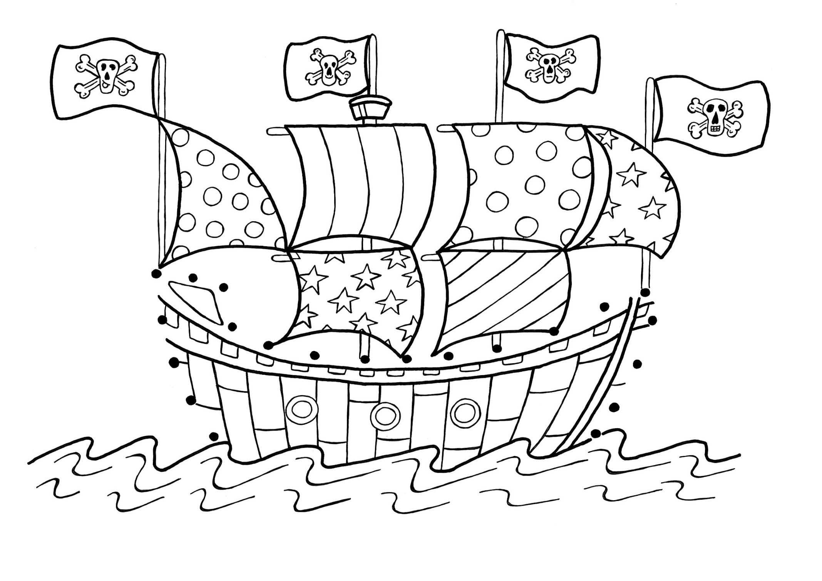](https://www.google.com/url?sa=i&url=https%3A%2F%2Fwww.bestcoloringpagesforkids.com%2Fpirate-coloring-pages.html&psig=AOvVaw3ekKsosilQP7ReTSXDtjwq&ust=1587894624706000&source=images&cd=vfe&ved=0CAIQjRxqFwoTCIijg6eng-kCFQAAAAAdAAAAABAK)