Set W/C 27th April 2020
‘Light’ – Art

Following on from your ‘crumpled paper’ task last week where you used shading to show lighter and darker sections of a piece of paper, I thought we’d progress this week onto using blending techniques to draw a real-life still object, showing a lighter side and a darker side, blended together. Your finished product should look something like this:

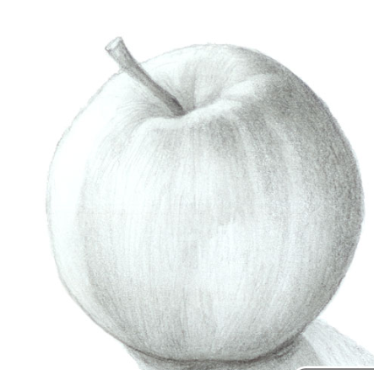

1) Get an apple. Either a red or a green one will be fine. If you don’t have an apple, any fruit or vegetable with a ‘shiny’ skin will work – a tomato, a pepper, a nectarine or a plum will also work. You will be drawing YOUR apple/fruit/vegetable – don’t just copy the one on here – copy the one in front of you. These photos of drawings are just what MY apple looks like. You draw YOURS.

2) Shine a light source on to it from one side. A torch is ideal for this. If you look carefully, you’ll see that one side of the apple is light and shiny, and the other side is cast into shade and appears darker.
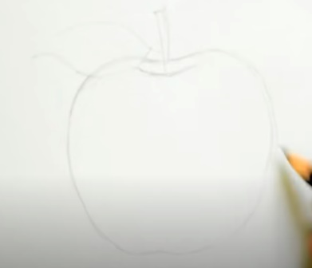

3) Draw your basic shape of your apple. Don’t be tempted to draw around anything circular – apples are NOT perfectly round and therefore will look very unrealistic if you draw it as such. Instead, try to copy the actual shape of YOUR apple in front of you. If it’s more rounded on one side and flatter on the other side, then draw it like that.
Hayes’ Handy Hint: Press lightly with your pencil so that you can rub out any mistakes.

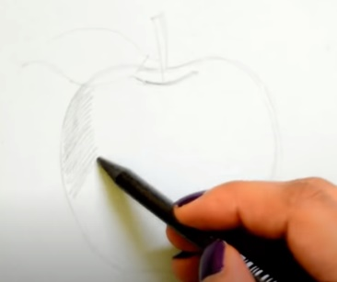

4) Next, start to shade the DARKER side of the apple. If your torch is on the right of your apple, then the left side will be darker. If your torch is on the left of your apple, the right side will be darker.

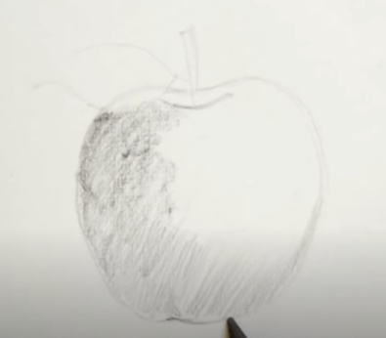
5) Start to put in the MUCH darker parts. This is likely to be underneath the apple and right around the edge of the apple on the darkest side. Press harder with your pencil for this; the harder the press, the darker the shading will be.

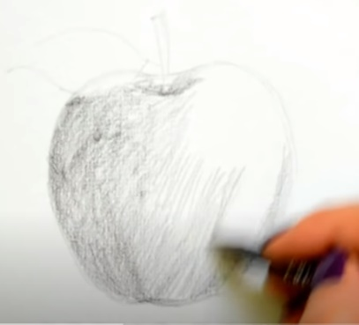
6) Give the ‘light’ side of the apple a little shading too (but much lighter than the ‘dark side). Don’t be tempted to leave the ‘light’ side completely white. If there is a particular ‘shine’ on your apple (that looks like a white, shiny ‘spot’ on the skin of your apple, created by the torch) then this is the only part that should be left white (I’ll give more instructions on this in a moment).

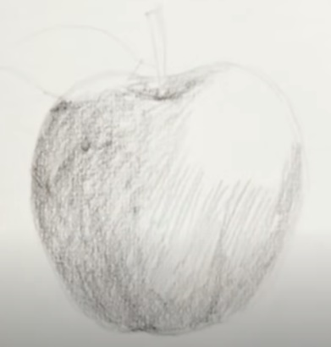

7) Ensure all of the apple has been shaded except for the ‘shiny’ patch where the light hits your apple. Keep this part white.

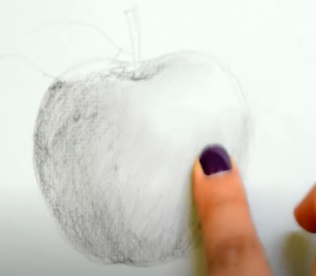
8) Use your finger to ‘blend’ the pencil lines together. You are aiming to make your apple so that you can’t see where the darker pencil lines meet the lighter pencil lines. Like last week when you did this when drawing the crumpled paper, don’t press TOO hard or smudge it TOO much, otherwise it looks like you have gone wrong.

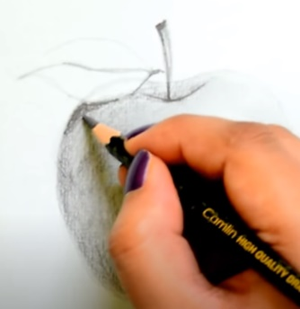
9) Continue to add shading, a bit at a time. Start with the darkest parts of the apple. This will take some keen observation skills. Really LOOK at your apple – where are the parts that are more in shade, and therefore darker? Where are the darkest bits? It’s likely to be around the dip where the stalk (if your apple has one) is, at the very bottom of the apple and along the darkest side, away from the light.

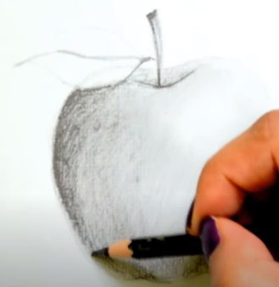

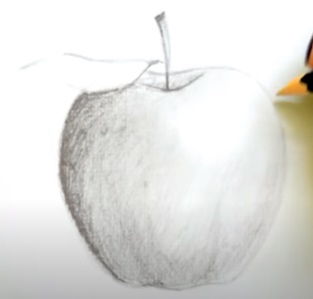

10) Add more definition to the lines on the outside of your apple by going over them slightly to show the edge of the pple more clearly.

11) Now, add more and more detail to the apple using shading and blending with your finger. This is the part that takes patience; you will need to do bits at a time, looking at your apple and trying to copy its darker and lighter parts exactly. Notice how the ‘shine’ of the light is shown by the white patch.

