‘Light’ – Art/Design
Set W/C 20th April 2020

1) Linking the theme of light/shadow with drawing, here is a challenge for you;

- Lightly crumple a piece of paper so that it looks a little like this:

It should clearly show more light and more shaded areas. (Hayes’ handy hint: The more ‘crumples’ or creases your paper has, the harder it will be to draw and shade).

- Make your best attempts at drawing it. Don’t forget, this is NOT a ‘finished’ piece of beautiful artwork for the classroom wall; if you go wrong or aren’t happy with it or think that you can improve it, you don’t have to start a whole new piece of paper – just try again next to it (a bit like we did when we were drawing the eyes, noses and mouths in class).

- You should only need a piece of paper to draw on and a normal pencil for this activity. To show the darker areas, use shading techniques like we learnt in class when drawing facial features.

- Below is a series of pictures that might help you with a step-by-step approach to this. Alternatively, you can watch this tutorial on YouTube (please do get parents’ permission before you watch this though). https://www.youtube.com/watch?v=IQ3BLK2vLgU

Start with the basic outline of the paper.

Add lines to divide the paper into the parts that are in shadow and the parts that are light.

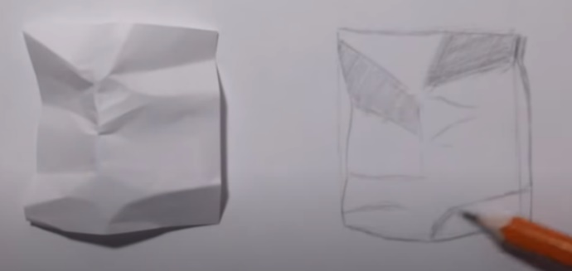
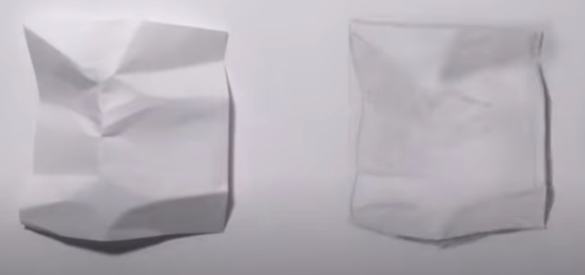
Shade the darker parts with your pencil. Make sure that you show the amount of shadow by shading the darker parts darker, and the lighter parts lighter.

Once shaded, gently use a rubber or your finger to lightly smudge your shading so that the individual pencil lines blend together. Don’t OVER smudge, or it will look like you went wrong.

Add in the shadows around the edge of the paper.

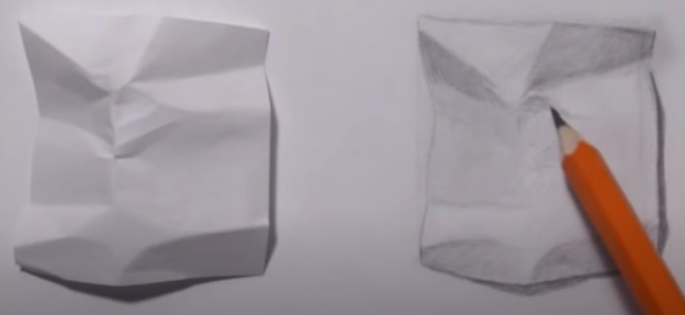
Continue shading with your pencil and blending lightly with your finger/rubber. It won’t be a quick process and will take a little time and patience, adding a bit more shading at a time. If you watch the YouTube video, you will see how much time the artist takes when fine-tuning their drawing. If you do this with the required time and care, it will probably take you an hour, or maybe longer.
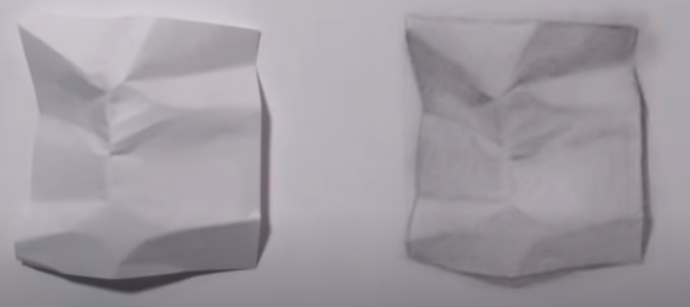

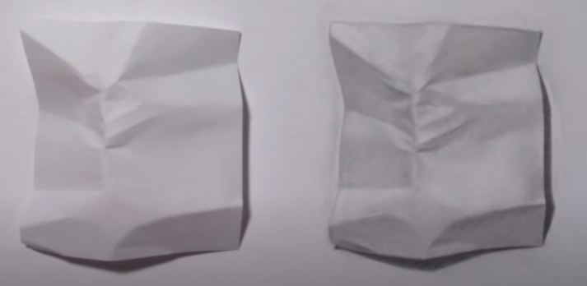

Use a small/precise rubber to add any white parts back into your drawing (like the ones in the middle of the paper).

