Set w/c 20th April 2020
English/History

Read the information about sundials below and answer the questions.

Sundials

A sundial is a device that indicates time by using a light spot or shadow cast by the position of the Sun. As the Earth turns on its polar axis, the sun appears to cross the sky from east to west, rising at sun-rise from beneath the horizon to a zenith at mid-day and falling again behind the horizon at sunset. Sundials are the oldest known instruments for telling time.
The surface of a sundial has markings for each hour of daylight. As the Sun moves across the sky, another part of the sundial casts a shadow on these markings. The position of the shadow shows what time it is.
The flat surface of a sundial is called a dial plate. It may be made of metal, wood, stone, or other materials. Numbered lines on the dial plate, called hour lines, show the hours of the day.
Some sundials use a stick which points directly upwards from the earth. On these sundials, the length of units of time varied according to the time of year, a "solar hour" being anywhere from 40 to 80 minutes depending on whether it was summer or winter. In modern times when we make this type of sundial, we will see that the distances between the hour lines are not equal so that the amount of minutes in an hour still remains at 60.
Other sundials use a part called a gnomon which sticks up at an angle from the dial plate. The sloping edge of the gnomon is called the style. As the day passes, the gnomon’s shadow moves around the dial. Every hour it falls on a new hour line. The idea of the angled gnoman is that the sloped top of it runs parallel to the Earth’s axis (which is at a slight tilt) and therefore hours are equal and the hour lines on the sundial are also equal. This type of sundial was invented by Abu'l-Hasan Ibn al-Shatir in 1371.
The ancient Egyptians made the earliest known sundial in about 3500 bc. In roughly 700 BC, the Old Testament describes a sundial (possibly the earliest written account of a sundial that is anywhere to be found in history). Sundials are believed to have existed in China since ancient times, but very little is known of their history. This sundial was simply a stick or a pillar that cast a shadow on the ground. The ancient Greeks made a sundial with a bowl-shaped opening cut into a block of stone or wood. A pointer in the centre cast shadows inside the bowl. Muslims later invented the modern sundial—the type with the angled gnomon. Clocks began to replace sundials in the 1300s, although sundials were still used for centuries after this. Before the invention of the clock, the sundial was the only source of time; after the invention, the sundial was still important as the clock needed to be reset regularly from a sundial, as its accuracy was poor.

Q1) a) What does the word ‘Zenith’ mean? (paragraph 1). Try to use the clues in the rest of the sentence to work out what it COULD mean and what it is LIKELY to mean and write your prediction here:

________________________________________________________________________________________________________________________________________________________________________

b) Now, find out what the word ACTUALLY means by asking and adult, using a dictionary or the Internet.
________________________________________________________________________________________________________________________________________________________________________

Q2) What celestial object does a sundial rely on to help it to be useful in telling the time?
________________________________________________________

Q3) a) What direction does the sun appear on the horizon of the Earth as it rises?
________________________________________________________

b) In which direction does the sun disappear on the horizon of the Earth as it sets?
________________________________________________________

Q4) What problems can you think of with using a sundial as a way to tell the time? Explain your answer fully, using evidence from the text to back up your thoughts. (3 marks)
________________________________________________________________________________________________________________________________________________________________________________________________________________________________________________________________________________________________________________________________________________

Q5) Circle the gnoman on the diagram below.

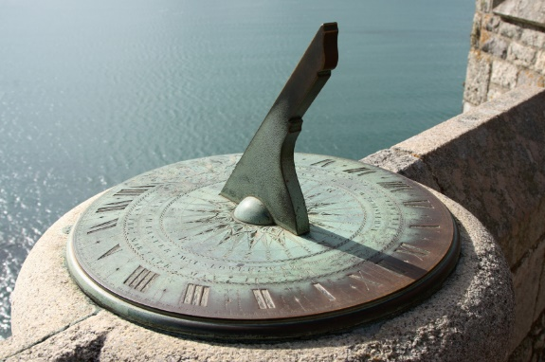

Q6) Where is the first record of a sundial thought to be found?
________________________________________________________
Q7) In the past, why was the newer invention of a sundial with an angled gnoman better than a sundial with a vertical stick as people had previously used?
________________________________________________________________________________________________________________________________________________________________________

Q8) Who was thought to have made the earliest known sundial?
________________________________________________________

Q9) What impression do you get of sundials? Use evidence from the text. (3 marks)

________________________________________________________________________________________________________________________________________________________________________________________________________________________________________________________________________________________________________________________________________________

