Set w/c 20th April 2020
‘Light’ – English/Craft

This activity links our topic of ‘light’ with a fun craft idea which will go alongside a short story that you will create. “YESSSS, CRAFTS!!” I hear you all shout with delight.

The idea here is that you will make a shadow puppet show and write a short story to accompany the characters so that you can put on a puppet show for your family! Popcorn and snacks at the ready!
I got some ideas from YouTube, specifically https://www.youtube.com/watch?v=-hL28SkHf1g
and I’ve summarised them below BUT YOU DO NOT HAVE TO FOLLOW THESE EXACTLY – BE CREATIVE AND INDIVIDUAL.
Please do, as always, check with an adult before searching YouTube for ideas, though.

1) Start by making your ‘theatre stage’. Probably one of the most simple and effective ways to do this will be out of a cardboard box. Cut off the back of the box (this will be where your puppets go).
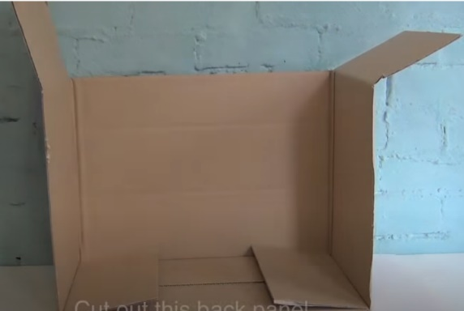

2) Decorate the front. Think pillars, curtains, statues, lions, crowns etc.
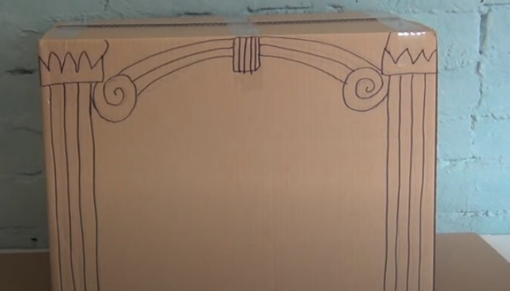

3) Cut out the front so that you have a ‘stage’.
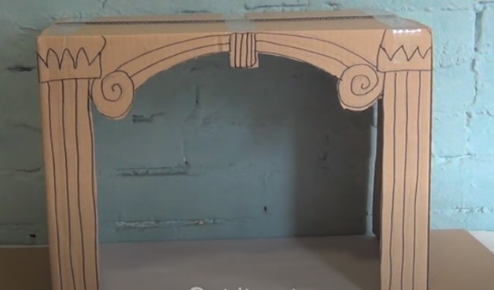

4) Add an opaque (not entirely transparent but not solid) screen. Flattened tissues, tracing paper and very thin/sheer fabric would work well for this. You’ll need to fix it at the back with glue/tape.
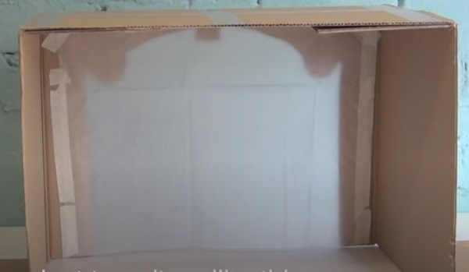
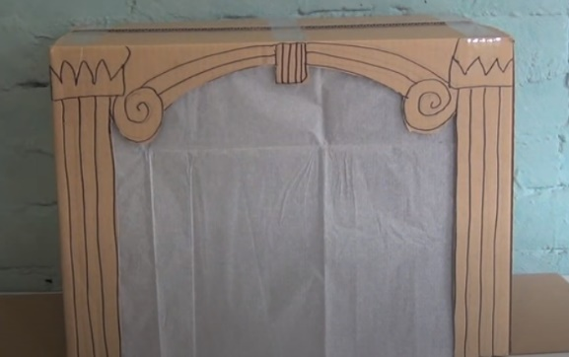

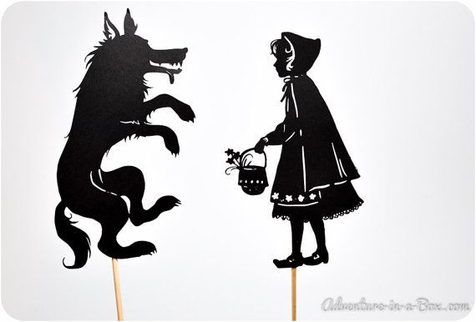
5) Make your characters and be thinking about your short story in your head. Here are some examples that I found:
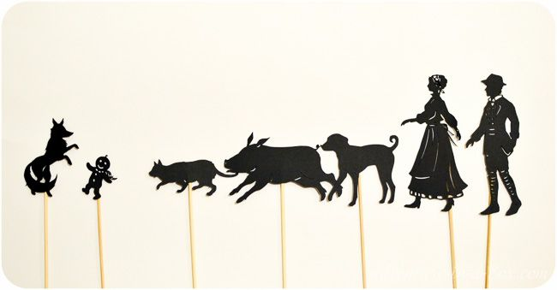
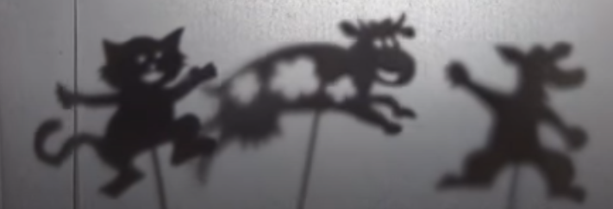
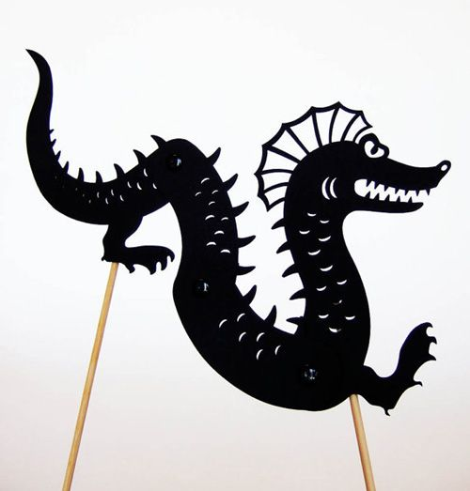
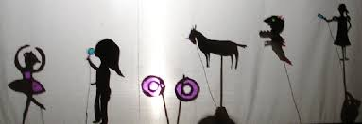

A good way to make your characters is to draw them on paper (not too detailed – you don’t really need faces etc, more just an outline), cut them out and then stick them to a stick (a lolly pop stick, a blunted skewer, a drinking straw etc). Alternatively, you could print off your characters rather than draw them, cut them out and stick them on your stick.

6) Write your story involving your characters. You can be as creative as you like. You can create a story from scratch. You could re-tell a fairytale. You could re-tell a fairytale, but with a plot twist (imagine if grandma eats the wolf!). You could make up or re-tell a myth or a legend.
Hayes’ Handy Hints (use these as a tick-list so you know you’ve completed the task to the best of your ability):
- The best type of stories for this purpose will be something fun, lighthearted, fairytale-ish and probably involving some animal characters. A simple plot such as that of the 3 little pigs works well. It will keep your audience captivated and interested.
- You could try to involve a small bit of humour (e.g. the pigs blow the farmer’s house down etc the end; puns; plot twists). Don’t go overboard by trying to make the whole thing a comedy show, though! Everything in moderation.
- I’d like you to use speech between your characters and use correct speech punctuation (see the bullet points below for a reminder of speech rules).
- Ensure your puppet show (and therefore, story) will last for around 7-8 minutes.

7) REHEARSE! Once you have your stage, your characters and your story prepared, you can rehearse your performance. Try different voices and different actions for different characters. Have a ‘narrating’ voice to help tell the story as you go along. Maybe enlist the help of a sibling to put on your performance to your audience.

8) Light up your stage area from behind with a lamp or a powerful torch. Face your stage towards your audience and you stand behind it with your characters and your written story so that you remember it as you go along. Invite your audience in to the theatre, provide them with the refreshments of their choice and let the performance begin! You could even ask your adults at home if they can film it so you can share it with grandparents and other family members.
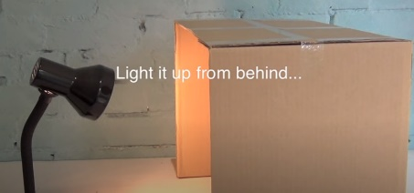

Speech punctuation rules:
- Put inverted commas (aka speech marks) around the exact words spoken by your characters.
- Include punctuation BEFORE your closing speech mark.
- Start speech with a capital letter.
- If you have the reporting clause before the speech (e.g. Mum said, “Lets’s go!”) introduce your speech with a comma.
- New speaker = new line.

