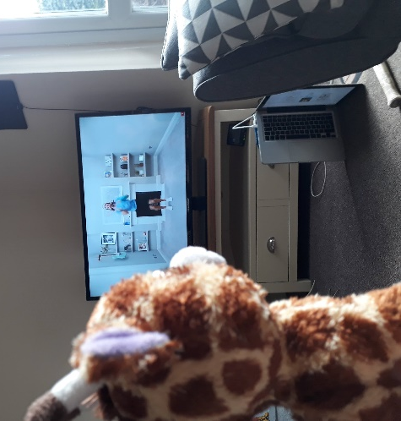
Top Secret! Gillian’s Self Isolation Diary
Monday
Today, we started with Nutella and banana porridge! YUM! Breakfast was followed by Joe Wicks workout on YouTube. Miss Brearey said we’re going to do this every day to keep us fit and healthy!
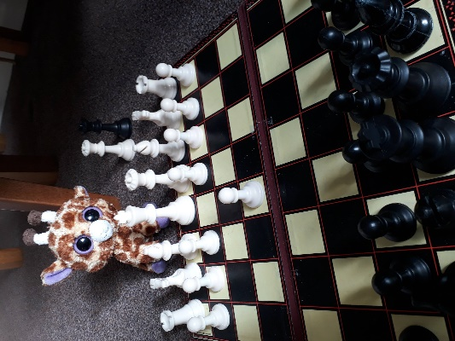
Miss Brearey has started growing avocado stones! She’s put cocktail sticks into the stone and is balancing the stones in glasses on the kitchen window sill. It looks very odd but she’s told me they’ll start growing roots out of the bottom and a stem out of the top. Eventually, it’ll be an avocado tree and we can pick avocadoes from it! I’m not sure how long that’ll take though…
Tuesday
After dinner, Miss Brearey decided to start teaching me chess. It’s quite a complicated game for a giraffe to play! I think it’s quite a good thing to learn because it takes lots of brain power to focus on the game and by the end of my training, I might be good enough to join chess club at school!
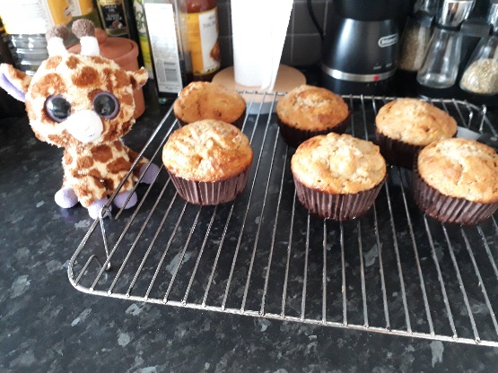
Wednesday
We’ve done lots of baking today. Flapjack, pear and apricot crumble and banana muffins! Miss Brearey said I wasn’t allowed to put Nutella icing on the top…
I’ve been writing a grateful journal since school closed, and it’s making me think of different things that I’m grateful or thankful for each day. Today, it asked me to think of something beginning with the letters of THANKFUL that I’m thankful for. This is what I’ve got so far:
T
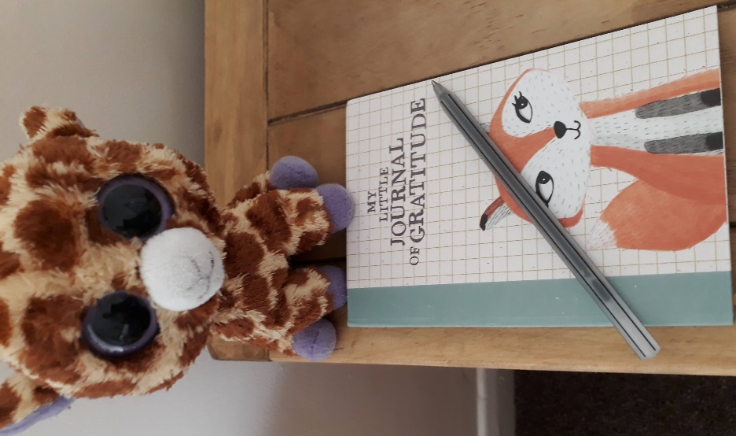
H
Avocado plants
Nutella!
K
Fluffy muffins
U
Learning chess
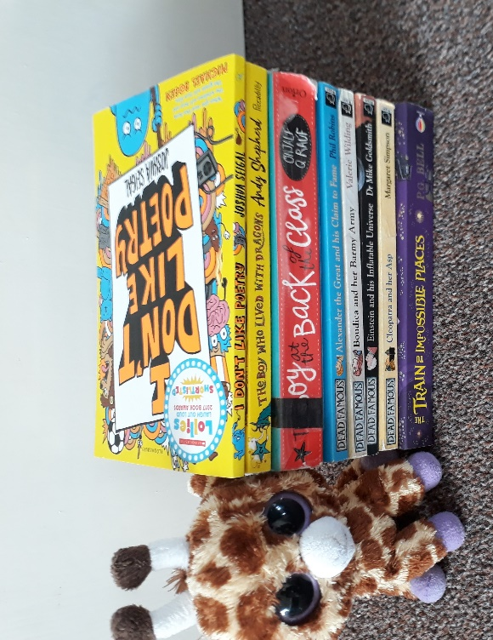
I’m a bit stuck on T, H, K and U so I’ll have a think before bedtime.
Thursday
Mr Postman brought us lots of new books today- when they were piled up, they were taller than me! I’ve already read The Boy At the Back of the Class (I brought this one back from Class 3’s library shelf because I realised I’d never actually read it!) and finished The Boy Who Grew Dragons. I’ve started reading some of the poems in I Don’t Like Poems and they’ve made me giggle lots!
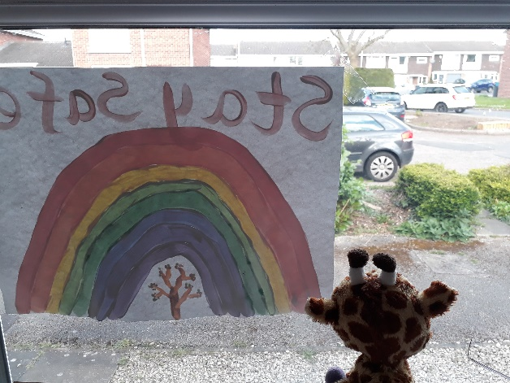
Friday
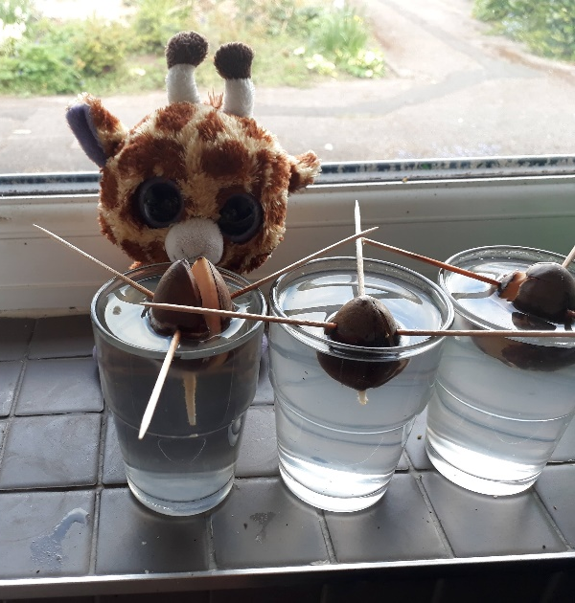
Friday is always our day for art at school so we did some painting today! On our walks around Miss Brearey’s house, we’ve seen lots of rainbows so I fancied doing one too. I think it’s because life is a bit stormy and unpredictable at the moment but we know that everything will be alright in the end when we’re back together. Just like there’s always a rainbow after a nasty storm, but you have to have the nasty storm before you can see the beautiful rainbow!
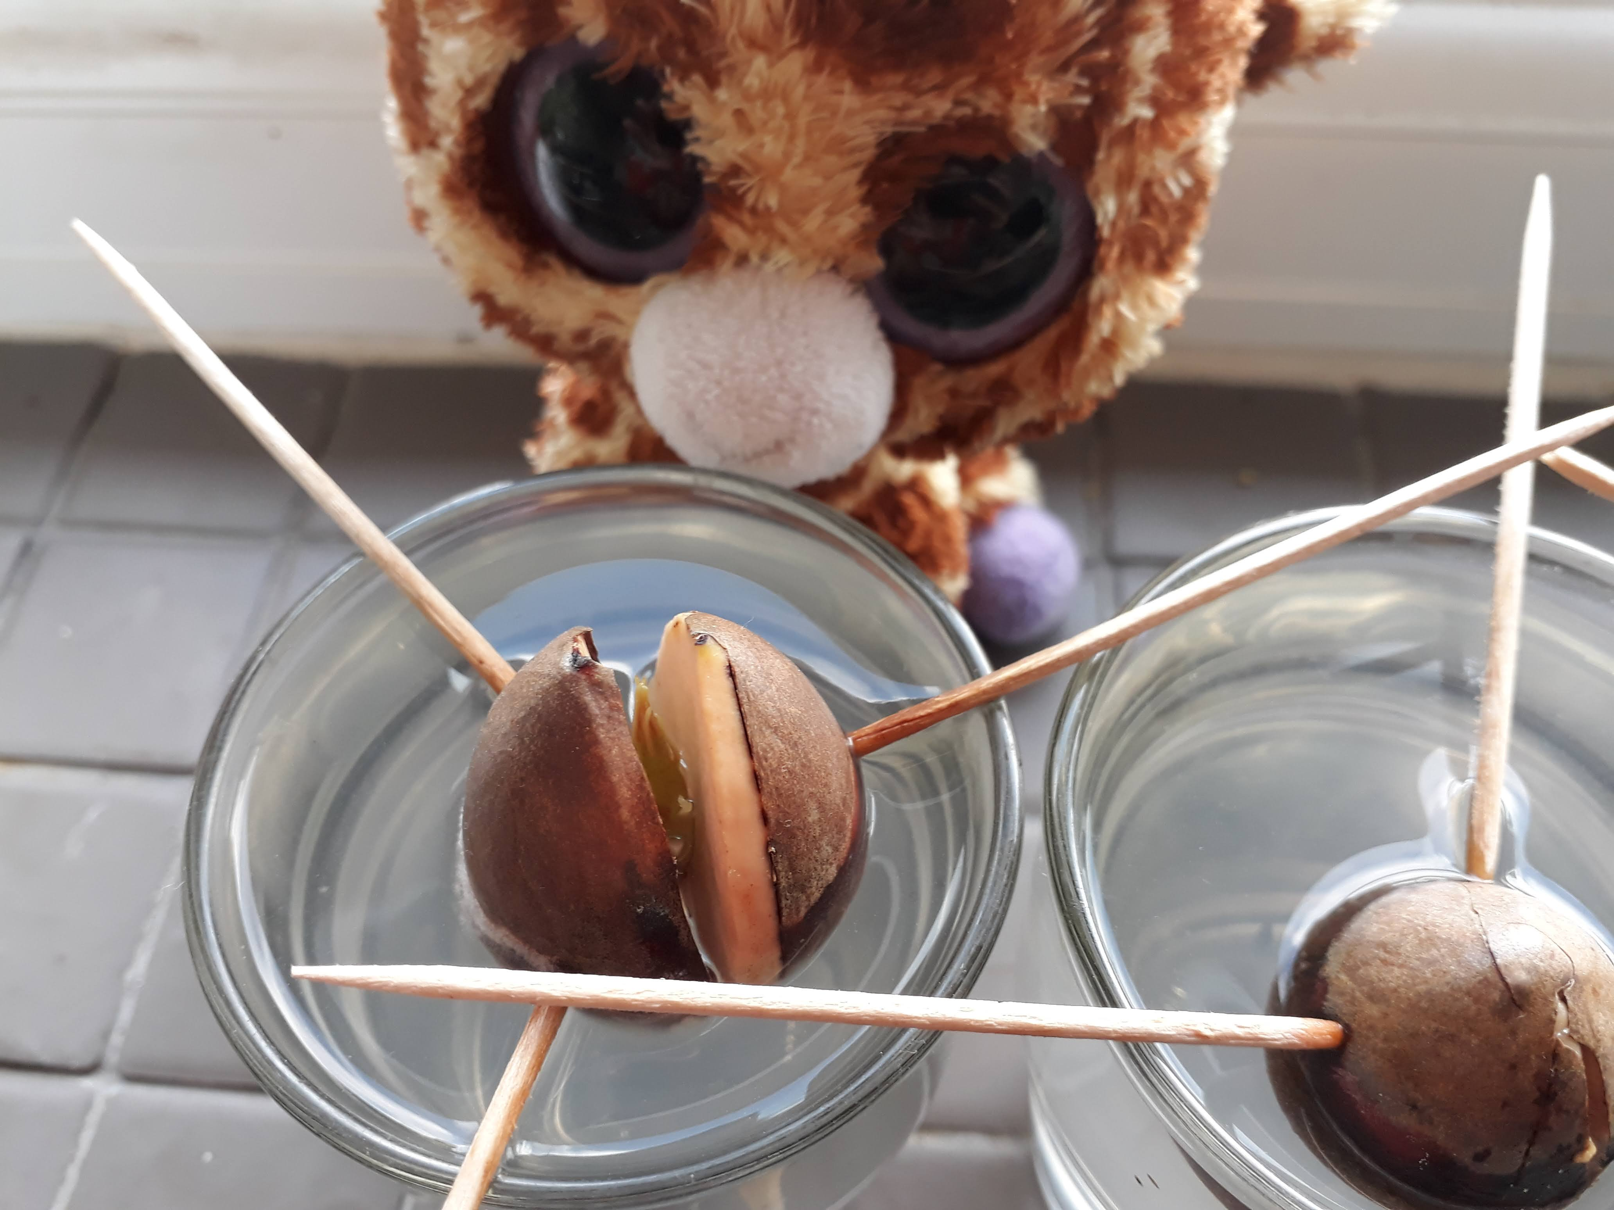Fantastic news for today is Miss Brearey’s experiment (which I have to admit, I thought was a little bit mad!) has worked and her avocado plants are starting to grow little roots out of the bottom. If you peek really carefully in the top, you can see the stem starting to come through too!

Answer the questions below using Gillian’s diary to help you. The questions are in the same order as the text (for example, you won’t find any questions about Friday first!)
What did Gillian have for breakfast on Monday?

Who’s workout is Gillian doing every day?

Why are Gillian and Miss Brearey doing the workout every day?

What sort of stone is Miss Brearey growing?

Find and copy one word that means “unusual”

What game is Miss Brearey teaching Gillian?

Why do you think it is it particularly difficult for a giraffe to play chess?

Find and copy one word that means difficult.

What club does Gillian want to join at school?

Name one thing Gillian made when she did baking.

Why do you think Gillian wasn’t allowed to put Nutella icing on the banana muffins?

Name one thing Gillian is grateful for.

Gillian is stuck on some of the letters of her grateful journal. Have a think and suggest 3 different things she could say beginning with the missing letters (you could have more than one for each letter!).

What did the postman bring Gillian?

Why did Gillian take The Boy at the Back of the Class home?

What made Gillian giggle lots on Thursday?

Why did Gillian do art on Friday?

What did Gillian use to do her picture?

Why do you think Gillian thought Miss Brearey’s avocado experiment was “a bit mad”?

How do we know Miss Brearey’s avocado experiment is working?

