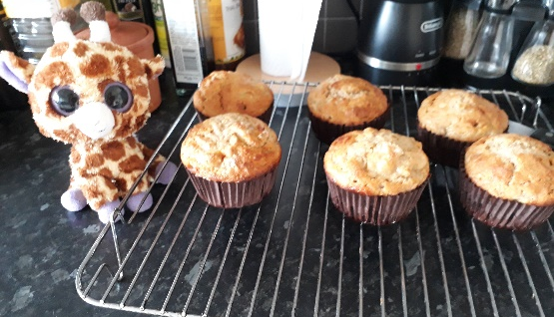
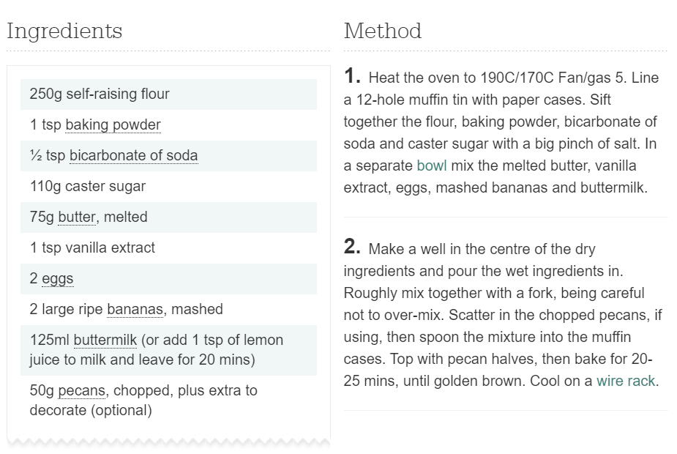
This is the exact recipe that Gillian used to make her banana muffins with Miss Brearey!
It made 10 delicious muffins in total.

When you’re baking or cooking, sometimes you have more ingredients and want to make more muffins, sometimes you have less ingredients and have to make less muffins…chefs and bakers alike have to be very quick and accurate mathematicians, not just with the weighing out! They use adding, multiplying and dividing to work out how much they need of different ingredients.
Use your maths skills to work out the quantities of ingredients for Gillian…
Some might need written workings out of column addition or multiplication and bus stop method, some might be more useful to draw a diagram to show how you could change the quantities (e.g. ½ of a banana).
And (if your baking cupboards are full!) enjoy making your own!
- Next time Gillian makes it, she has 4 ripe bananas. How much of everything else will she need?

- Gillian only wants to make 5 muffins. How much of each ingredient will she need (you will need to do approximates for the butter and buttermilk!)

- Geoffrey gets hold of the recipe and decides he wants to make enough for all of the juniors at Willow Brook! He will need 80 muffins! How much of each ingredient will he need?

- After Geoffrey has raided Miss Brearey’s cupboards, she only has enough ingredients left for 2 muffins! How much of each ingredient will she need (she just has a pinch of bicarbonate of soda!)? How could she workout how much egg she needs (it’s quite tricky to split your egg into 5 equal parts…!)?

