Set W/C 20th April 2020
‘Light’ - Maths

1) Choose a sunny day (this week’s forecast is supposed to be bright sunshine for most of the week).
2) Set up an object outside (the middle of your garden would be best) that will cast a shadow from the sun. You may already have something that will work (for example, a birth bath/feeder stand, or a flower tub, or a garden ornament/statue).
3) Measure the length of the shadow that it casts regularly (measure from the object itself right up to where the shadow stops). You could do it every hour, or every 2 hours. It may help to set an alarm to remind you (a phone alarm, a cooking alarm, a watch or ask Alexa).
4) Record the measurements of the shadow in a results table each time you measure. Part of this task is for you to design your own results table so that it shows what information you need it to. It would be all too easy if I were just to create one and pop it in here for you!
5) Because it involves data that is continuous (in time), a line graph would best represent this data. Draw a line graph from your results after day 1. We did a little bit of work on this in class at the beginning of March. I have included an example of a line graph below for you to remember the general idea:

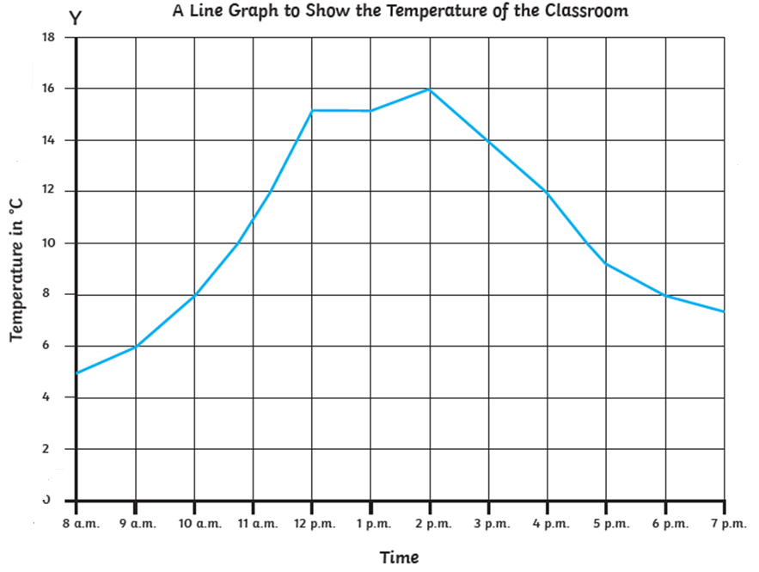

Hayes’ Handy Hints:
- Ensure you have a title to show exactly what the data shows. Start with ‘a line graph to show…’
- Label both axes to show what data it represents. Here, it’s ‘time’ and ‘temperature’. Decide what labels we’d need to use for our data.
- Try to use squared paper. If you don’t have any, you can either print some (type in ‘printable squared paper’ on Google and you should be able to find something), or draw some for yourself (you’d need to measure it accurately and draw with a ruler).
- Put your labels ON LINES (e.g. see how the times along the X axis are on actual lines in the example above – 10am, 11am etc).
- Plot your shadow lengths from your data table and then join the dots up with a ruler and a pencil.

6) Repeat steps 1-4 above for a second and a third day (so that you have data for 3 days). They don’t have to be consecutive days (e.g. they could be Tuesday, Thursday and Sunday). Notice that you don’t have to draw a line graph for all 3 days’ worth of data – just record in a table for days 2 and 3.

7) Is the length of the shadow the same on all 3 days at the same time? (i.e. compare the length at 9am on all 3 days, and the length at 10am on all 3 days etc).

8) Work out a mean shadow length for each of the of the measured times across the three days.
For example, if my results were as below:

 | Day 1 | Day 2 | Day 3
10am | 12.3cm | 11.9cm | 11.6cm
11am | 10.4am | 10.1cm | 9.9cm

I could work out a mean shadow length for 10am by adding all three amounts together and then dividing it by three.
(Don’t forget to line up your columns accurately when adding, and go into decimals when dividing – don’t have a ‘remainder’).

