Set W/C 27th April 2020
‘Light’ - Maths

This is a practice and revision of ratio. We worked on this area a little bit earlier this year.

We can take the idea of the ratio between an object and its shadow length to be able to estimate how tall something else is.
Imagine this scenario:

In my horses’ field, I have a water trough that is 1m tall. Its shadow at 2pm is 0.5m tall. We can see that this is HALF/50% of the length of the actual object.
We can use this fact to work out the height of other objects that we may otherwise struggle to measure the height of – for example, tall objects like trees. This is because the ratio between the object and its shadow that we measured (the water trough and its shadow) is THE SAME for all objects. If the ratio between the object and its shadow is 50%/half, then this will be the same ratio for ALL objects and their shadows.
If a tree casts a shadow on the ground of 6m long (still at 2pm), we can use the ratio between the water trough and its shadow to work out that the height of the tree will be approximately 12m.

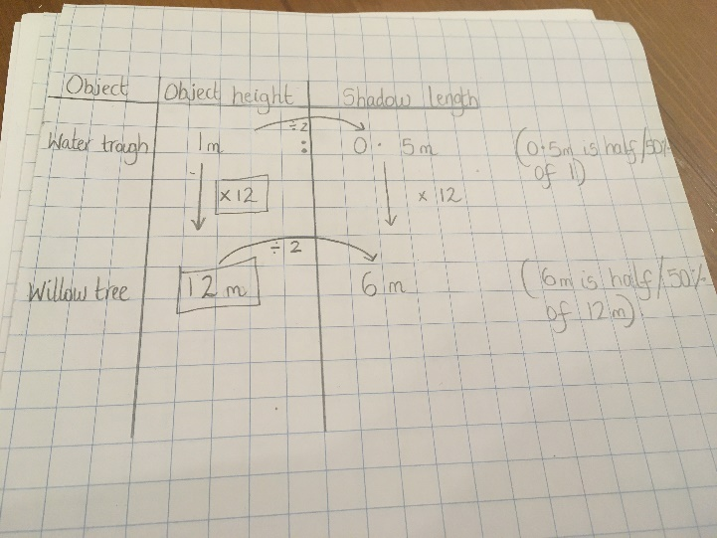
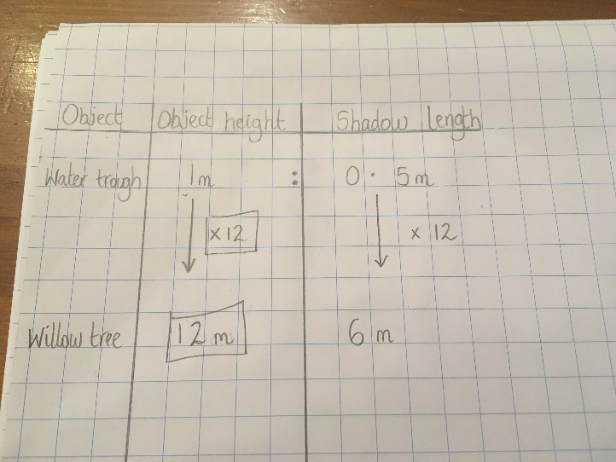
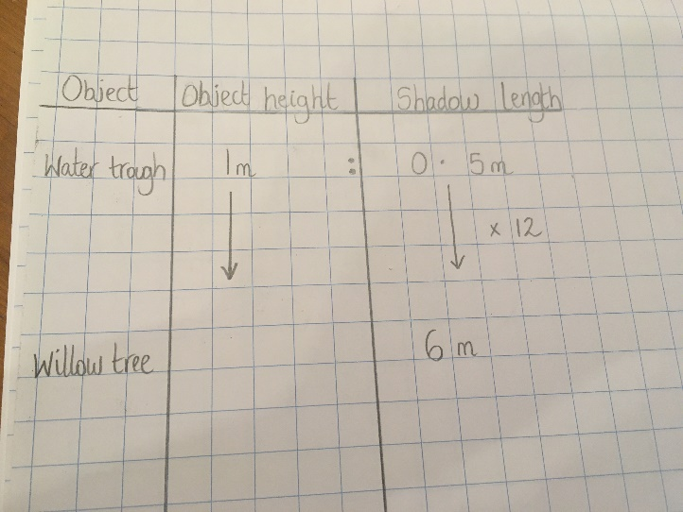
We can represent this like so in these photos:
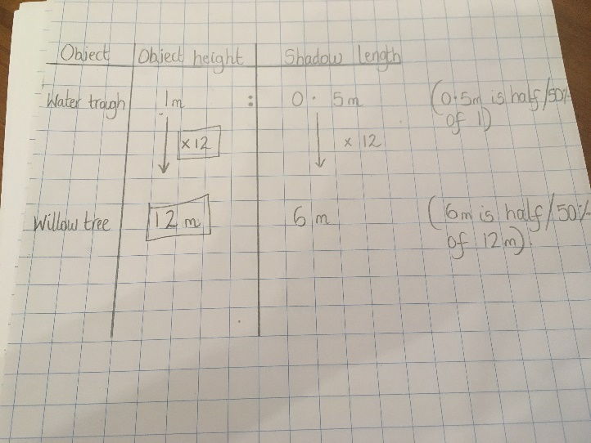
The ratios between an object and its shadow will differ depending on what time of day you measure it, because, as we learnt last week, the length of the shadow depends upon whereabouts in the sky the sun is (what time of day it is).

Q1) Can you complete the table below to fill in the light blue blanks? You will need to work out the ratio between the garden table and its shadow first (by doing 1.2 ÷ 0.4), before you will be able to apply that ratio to the other objects and shadows. You can write the multiplier like I did in my photos (where I wrote x12 on the photos in the example).

You can use a calculator if necessary.

Object | Object height | Shadow length | Percentage/fraction ratio
Garden table | 1.20m | 0.40m
Street light |  | 3m
Oak tree | 25.2m
Electricity pylon |  | 12m

Q2) Complete the table below to fill in the light pink blanks. You will need to work out the ratio between the bird bath and its shadow first (by doing 4.5 ÷ 1.5), before you will be able to apply that ratio to the other objects and shadows. You can write the multiplier like I did in my photos (where I wrote x12 on the photos in the example).

You can use a calculator if necessary.

Object | Object height | Shadow length | Percentage/fraction ratio
Bird bath | 1.5m | 4.5m
Sunflower |  | 1.5m
Silver birch tree | 16.5m
House/flat block |  | 99m

SCIENCE DISCUSSION: What time of day is it likely to be for garden in Q2? How do you know?

PRACTICAL ACTIVITY:
Why not replicate the above table with one of your own? Follow the steps below:
1) Go out into your garden on a sunny day.
2) Measure the height of an object that is relatively easy to measure such as a washing line pole, a bird feeder, a garden table/chair, a statue or plant pot. (Don’t go trying to measure the height of your house!).
3) Now, measure its shadow. Record both of these in a table like the one above.
4) Work out the ratio between the object and its shadow by dividing the biggest one by the smallest one.
5) Next, measure the shadow of a different object in your garden. ENSURE TO DO THIS AT AROUND THE SAME TIME OF DAY AS YOU DID THE MEASUREMENT ON THE FIRST OBJECT AND ITS SHADOW IN NUMBERS 2 AND 3 ABOVE, within about 10 minutes.
6) Use the ratio that you worked out in number 4 to work out what you think the height of the second object will be.
7) Measure the second object’s height to see if your calculation was roughly correct.
8) Repeat.

You will almost definitely need a calculator to work with the numbers in the practical activity where you take your own measurements.

