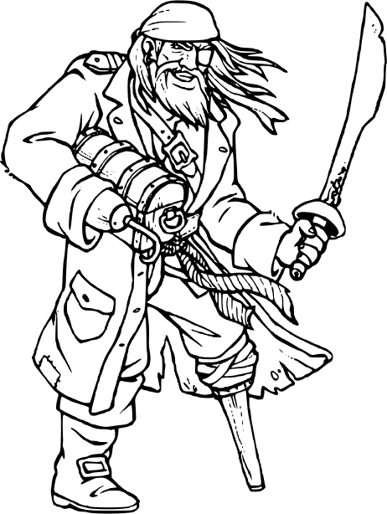

I am afraid it’s mutiny

Your crew have decided that they don’t want you to be their captain anymore. They give you a small piece of paper and as you open it, you see that it has a black spot on it. The black spot is a pirates way of saying that we are going to take control of the ship and that you are going to be marooned (left behind) on a small island (sorry about that).

Your crew takes you to an island and leaves you there to fend for yourself. You take a look around and thankfully see a small house. Inside the house is everything you need to survive… except for food (that is rather important). You look out into the garden and see that it is a bit overgrown but has lots of plants. Surely you can just eat those plants. Sadly, you don’t know what all the plants are and some might not be good to eat. Thankfully, you find on the bookcase a book of plants to help you with your survival.

[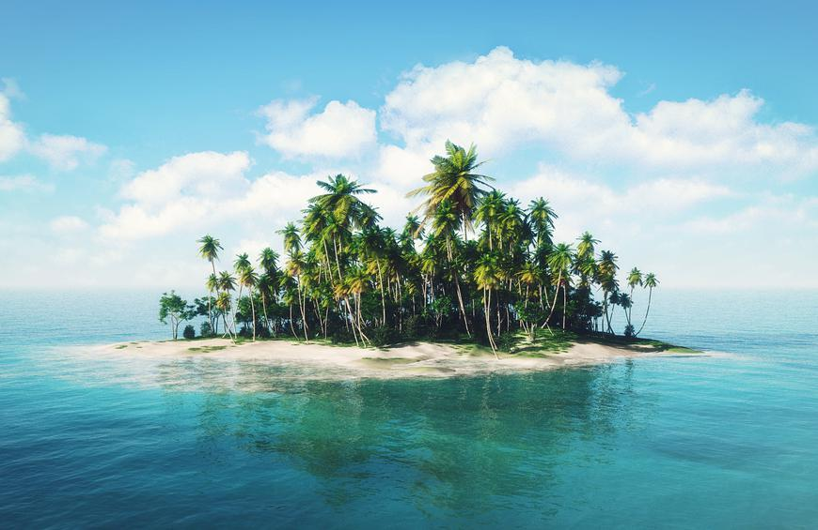](https://www.google.com/url?sa=i&url=https%3A%2F%2Fwww.theactivetimes.com%2Ftravel%2Fmost-stunning-remote-islands-world&psig=AOvVaw2x6VKgGENZY1z7vrCyOkGe&ust=1587898911985000&source=images&cd=vfe&ved=0CAIQjRxqFwoTCND2-aW3g-kCFQAAAAAdAAAAABAD)[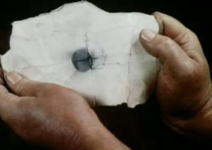](https://www.google.com/url?sa=i&url=https%3A%2F%2Fwww.pinterest.co.kr%2Fpin%2F293648838181531418%2F&psig=AOvVaw1c6NYc52E6tvaLCuKU90fw&ust=1587898832797000&source=images&cd=vfe&ved=0CAIQjRxqFwoTCJjjgZW3g-kCFQAAAAAdAAAAABAD)

[](https://www.google.com/url?sa=i&url=https%3A%2F%2Fwww.wpclipart.com%2Fflags%2Fpirate_flags%2Fpirate_logo_flag.png.html&psig=AOvVaw0nf5frY4FnLz_uqAnpnkxD&ust=1587473808191000&source=images&cd=vfe&ved=0CAIQjRxqFwoTCICHmNKH9-gCFQAAAAAdAAAAABAL)[](https://www.google.com/url?sa=i&url=https%3A%2F%2Fwww.pinterest.com%2Fpin%2F334321972327739787%2F&psig=AOvVaw3Ku-xoYTCxK4uYZTcvqyr0&ust=1587899104720000&source=images&cd=vfe&ved=0CAIQjRxqFwoTCOCumv-3g-kCFQAAAAAdAAAAABAD)

**Pirate Plants**

Inside the book, you notice that it has lots of amazing information to help you understand more about plants.

All you have to do now, is take this book outside and find out as much as you can about the plants in your garden and the areas around your garden.

It’s time to get going.

**For beginners**

|  |  |  |  |  |
| --- | --- | --- | --- | --- |
| **A Pirate Plant Treasure Hunt** |  | Your first task is to see what plants live in your garden or nearby areas. Venture outside and see how many of these plants you can find. Good luck. |  |  |
| Dandelion | Daisy | Buttercup | Nettle | Bramble |
|  |  |  |  |  |
| Ivy | Clover | Thistle | Cow Parsley | Poppy |

[](https://www.google.com/url?sa=i&url=https%3A%2F%2Fdepositphotos.com%2F14004549%2Fstock-illustration-vector-of-a-cartoon-pirate.html&psig=AOvVaw0zzrU3fsogXquVd7yUMk0q&ust=1587900676920000&source=images&cd=vfe&ved=0CAIQjRxqFwoTCOi10fq9g-kCFQAAAAAdAAAAABAD)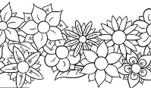



Draw your favourite plant

**A Pirate Plant Treasure Hunt**

Which plant did you see the most?

_________________________________________________

__________________________________________________

__________________________________________________

__________________________________________________

__________________________________________________

__________________________________________________

__________________________________________________

This was my favourite plant because _________________________________________________

__________________________________________________________________________________________________

__________________________________________________________________________________________________

__________________________________________________________________________________________________