Set w/c 20th April 2020
By the end of this, you should be able to describe how the shape and size of a shadow are determined.
‘Light’ - Science

1) First of all, start with some scientific ‘play’ and observe what happens. Get a torch, a book and a piece of paper. Shine the torch towards the book so that it casts a shadow on the piece of paper. You could shade in on the paper where the shadow casts.
Play around with it. Can you change the size and shape of the shadow?

2) During my recent trip to Pluto, I recently acquired a family of shadimals for classroom pets. They live in the shadows and have an intense dislike for direct light. I need your help in working out the best classroom set up for them. They need to live in shadows and have the most amount of room in their cage possible. Below, you will find diagrams that show different plans for the classroom. First, estimate the width of the shadow that will be cast.
Then, actually calculate the width of the shadow. Place your ruler so that it lines up the centre of the light with one of the edges of the partition. Draw a line from the edge of the partition to the wall. Repeat for the other edge of the partition.
Use a pencil to shade in the shadow that you have formed.
Use your ruler to measure the length of the shadow cast on the wall. Record this in the space provided.
See the example below before trying your own.
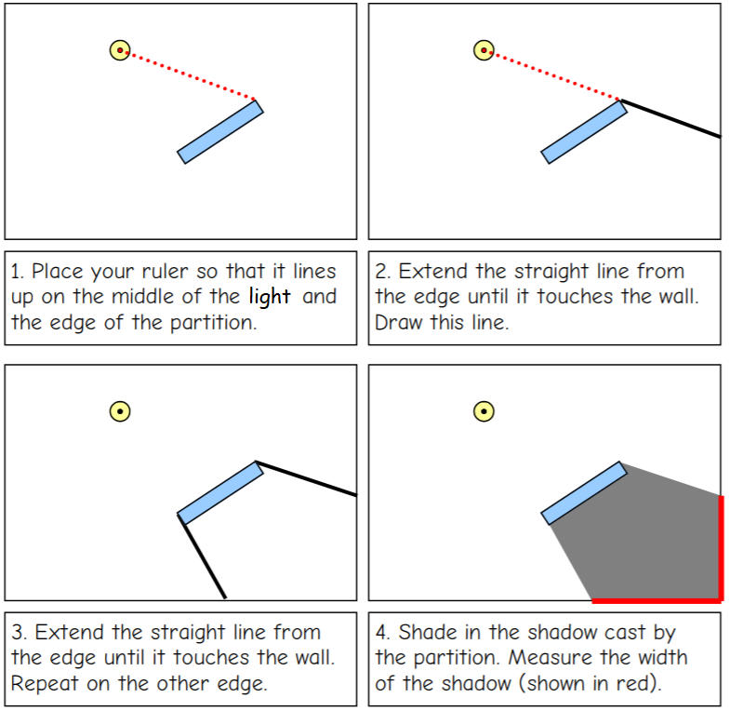
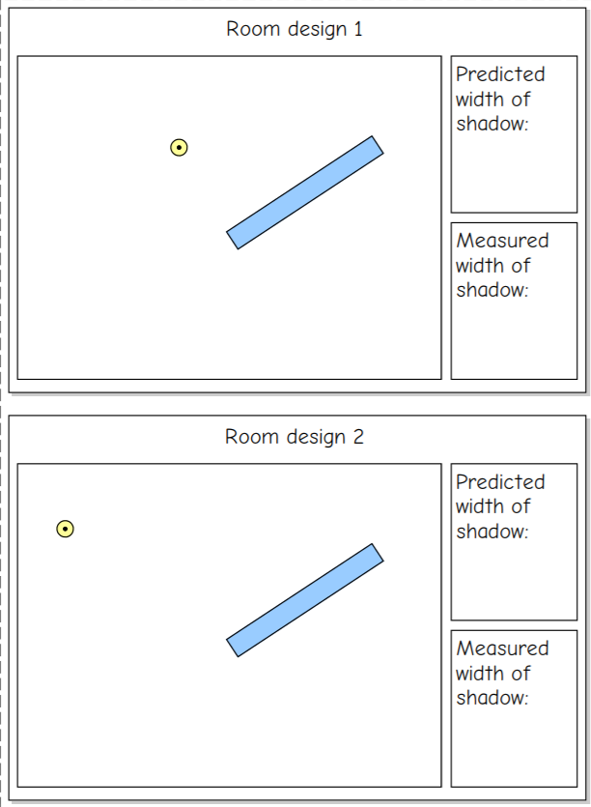

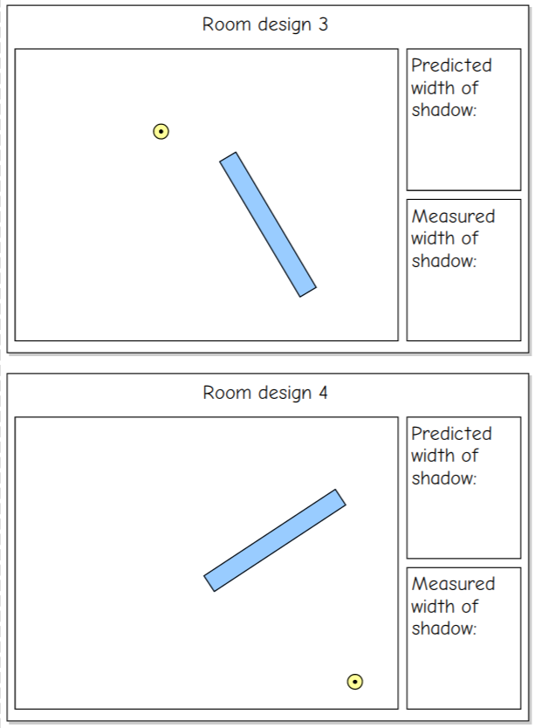

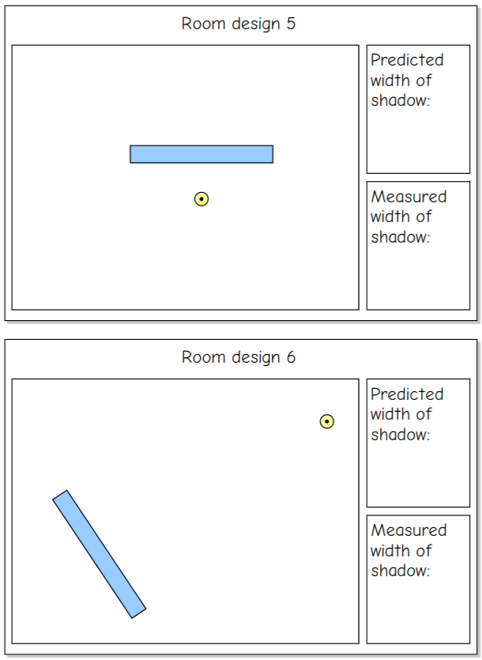

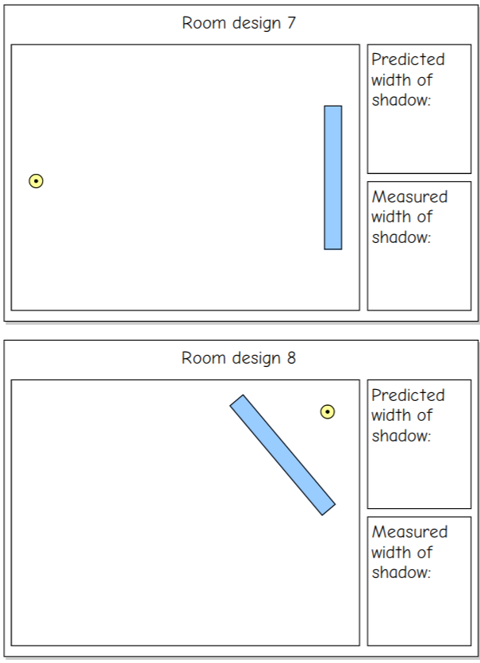
The best classroom design for keeping the shadimals is:

Discussion:
How accurate were your predictions?
Which room has the widest shadow? Why?
Which room design has the narrowest shadow? Why?

