Set w/c 27th April 2020
By the end of this, you should be able to recognise that light appears to travel in straight lines.
‘Light’ - Science

A periscope is a really useful device that enables the user to see around obstacles. They are often used by the military and Navy to help with seeing above the water’s surface in submarines. They were used in World War 1 to see what was above ground from the safety of the trenches.

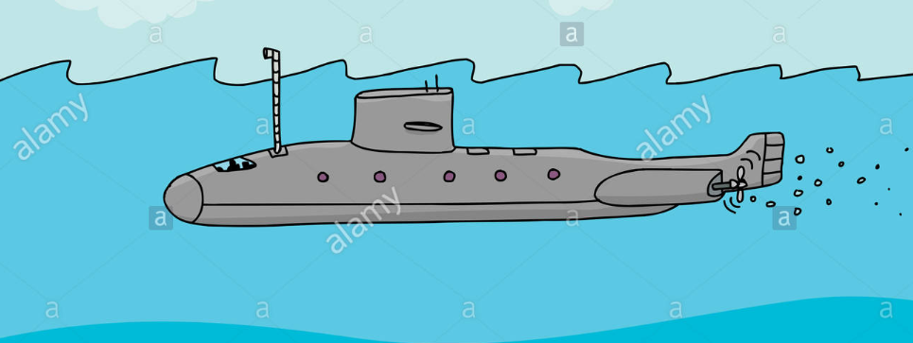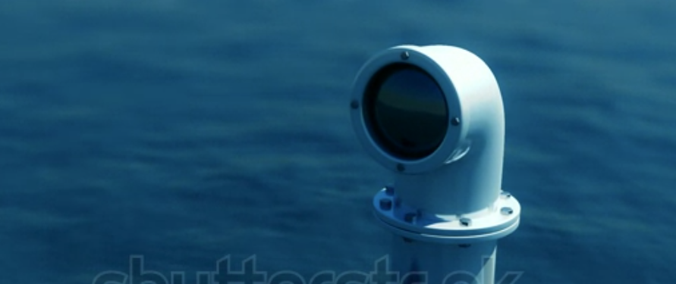

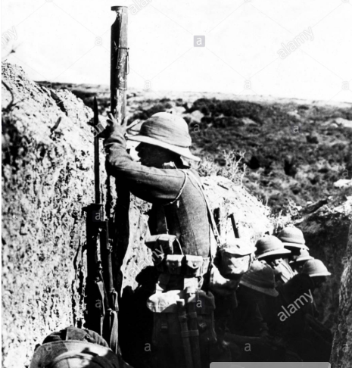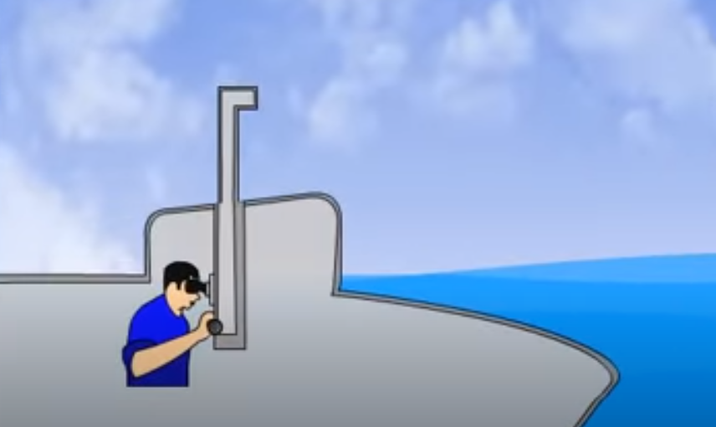

You are going to attempt to make your own periscope! For this, you will need:

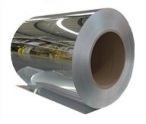
- Blue Tac
- 2 small mirrors (small cosmetic mirrors would work for this. Small mirrors aren’t always very easy to come across in the house but some people may have a ‘mirror on a roll’ type thing in their shed/garage that would work. If you type ‘mirror roll’ in to google, you’ll see what I mean.
- Thick paper or card (you can always stick 2 or 3 sheets of A4 paper on top of each other to make it thicker) with the template on the next page printed on to it. Or, if you don’t have a printer, you can copy it by hand-drawing it on.
- Glue
- Scissors
Find the instructions and template below.
Once you have made it, test it by using it to see around corners in your house and garden, and other objects such as over the back of a sofa.
I’d love to see some photos of finished periscopes! Great designs may even get posted in pride of place on the school website!

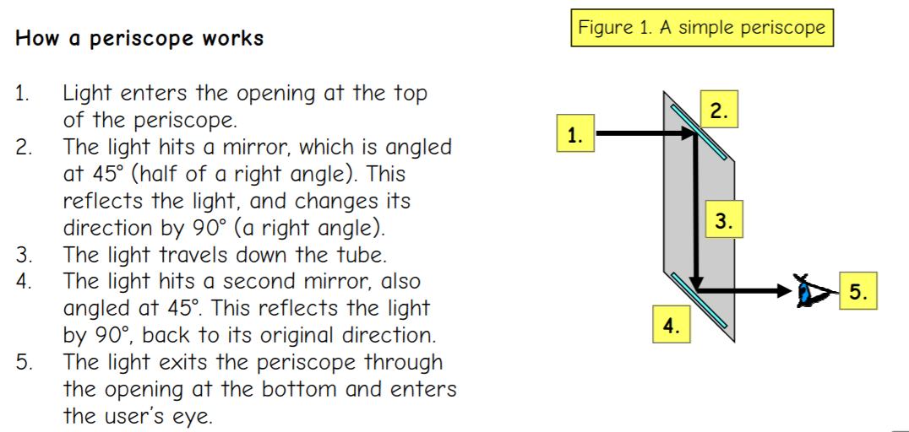

Instructions: How to make a periscope:

