Set W/C 4th May 2020
‘Light’ – Art

Our light and shadow art theme continues this week. For the last 2 weeks, you have been practising your shading skills with the ‘crumpled paper’ and ‘apple’ tasks.
This week, we are going to learn how to draw a shadow accurately in perspective. We did perspective drawings at the start of this year, sometime in January. We learnt that if we draw something in perspective, we make our work look as though it is 3D and takes on uses size to show how far away or close something is.

I based the instructions on the following tutorial: (but please get permission from an adult before clicking the link to the video)

https://www.youtube.com/watch?v=8XLgmiExAbw

This is the kind of shadow we will be aiming to create. We are going to just focus on the simple cuboid, but you can go further and try the house afterwards too, if you wish. As always, draw with a sharp pencil and use LIGHT lines so that you can rub them out if and when needed.
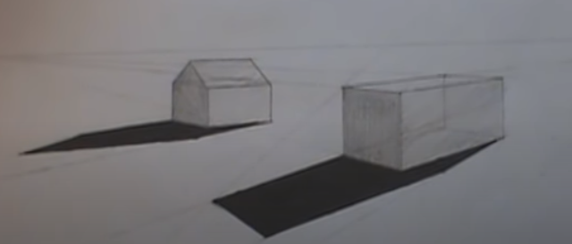

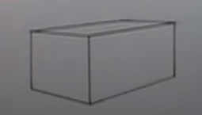
1) Draw or print a cuboid. So that you aren’t focused too much on how to draw a cuboid, I would suggest printing one or seeing if an adult at home will sketch you a quick one. Alternatively, if you’d like to learn how to do this for yourself, you can find many tutorials online to instruct you.

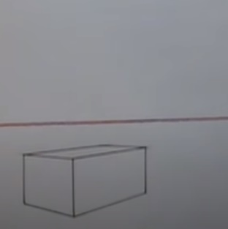
2) Draw a ‘horizon line’ above it; a horizontal line running from one side of your paper to the other. Try to ensure it is straight by making it parallel with the top and bottom of your paper.

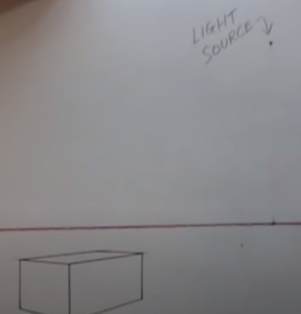
3) Identify where your ‘light source’ (think of this as ‘the sun’) will be in the sky. Put a dot and label it as ‘sun’ or ‘light source’.

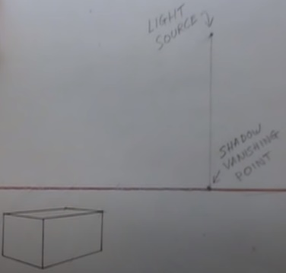
4) Identify the ‘shadow vanishing point’. This is DIRECTLY below the light source on the horizon line. Using a ruler, LIGHTLY draw a vertical line (parallel with the edge of your paper so that you know it’s straight) downwards until it meets the horizon line. The point where they meet is your shadow vanishing point. It is necessary so that your shadow will be in perspective. Label it.

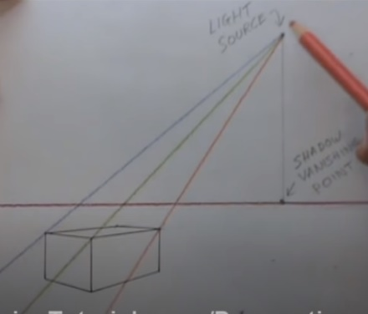
5) Determine how long your shadow will be. Do this by drawing lines from the light source through each of the 3 top corners of the cuboid right to the edges of your paper. It will help to use different-coloured pencil crayons (ensure they’re sharp).
We don’t draw a line through the other top corner because the shadow that the cuboid casts from that 4th corner will be hidden by the shape itself.

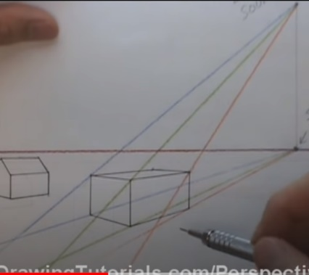
6) To determine the exact shape of the shadow, first you will draw lines from the shadow vanishing point through each of the 3 lower corners. Again, use the coloured pencil crayons. Use the same colours for each corresponding corner – on this example, you’ll see the blue crayon was used for the corners on the edge of the shape furthest to the left, the green one for the middle edge corners and the orange one for the furthest corners on the right edge of the shape.

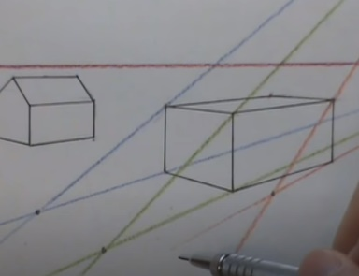

7) Now, put a dot at the point where the 2 blue lines meet, where the 2 green lines meet and where the 2 orange lines meet. You’ll end up with 3 dots.

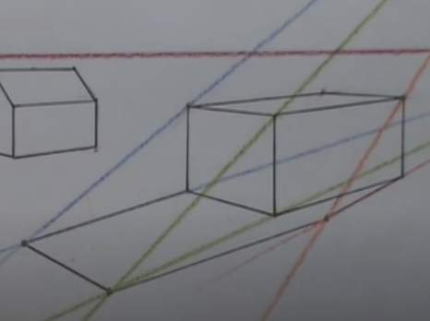

8) Connect the 3 dots together and then join them up with the bottom front left corner of the shape and the bottom back right corner of the shape.

9) Colour the shadow in using dark pencil lines, or a black pencil crayon.

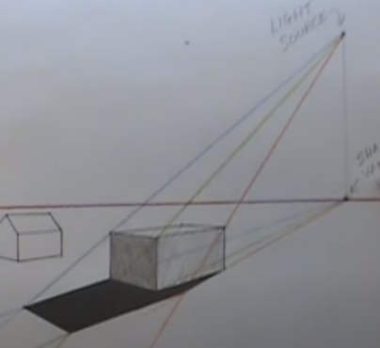
10) If you wish, you can shade the cuboid itself now too. The darkest face will be the nearest one to you (as that’s completely in shadow from the light source). The one on the right hand side will be slightly lighter, and the face on the top of the cube will be pretty light, as the light source is shining on it. You can also rub out the coloured lines and the labels of the light source and the shadow vanishing points if you wish, and if you pressed lightly enough to be able to do so.
You can practise this as many times as you like.

