Set W/C 4th May 2020
‘Light’ – Design Technology

Many garden bugs like to be away from direct sunlight. A great project to undertake is to make them a ‘bug hotel’ in your garden. This could be made from a huge variety of things, from a wooden structure specially built for the purpose, to reusing many things that you have lying around your garden. For example, old drainpipes/drainpipe covers, bricks, old pieces of wood, pallets, garden canes, old plant pots etc.

There is no correct or incorrect way to build a bug hotel, but it’s good to bear these things in mind:

- It’s good to try to place your bug hotel in a sunny place in your garden so that, even though the inside of it will be in shade, the outside of it still benefits from the warmth. It could also be placed in a spot that’s in light shade, but avoid anywhere in heavy shade.
- It does not matter on the size of your bug hotel – it could be huge, medium-sized or small.
- You do not really need to buy new materials to make one – I’m sure that you have old things lying around that could be used to make it.
- Include items inside it such as twigs, leaves, pinecones, bark etc. The more ‘natural’ the better, as of course, bugs like nature and are used to living in such materials.
- Try to make ‘nooks and crannies’ – small spaces that the bugs can crawl into and feel safe in.

I love this diagram showing what types of materials different creatures will like:

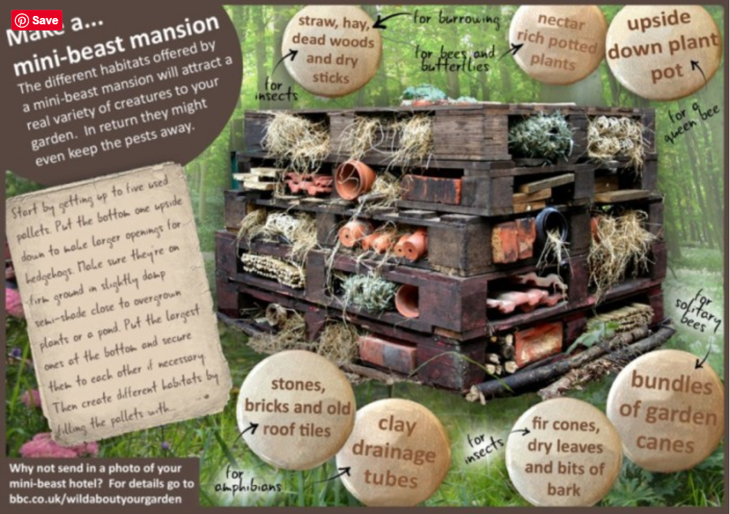

There are many different ideas on the Internet (check with an adult before you look). Here are a few photos to get your creative ideas started!

Happy bug-hotel-building
