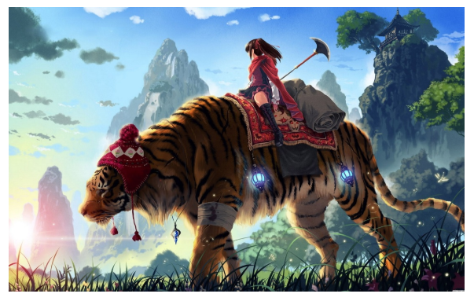
English Task 6
In A Wrinkle in Time we are about to begin an exciting adventure into the unknown…
I would like you to write a short mystery story inspired by the picture above.
Does your story starter here?
Where is she? It doesn’t look like our planet.
Does your story end with this scene?
Is this scene in the middle of your story?
Who is the girl?
Is she on a quest into the terrible? Is she escaping something terrible?

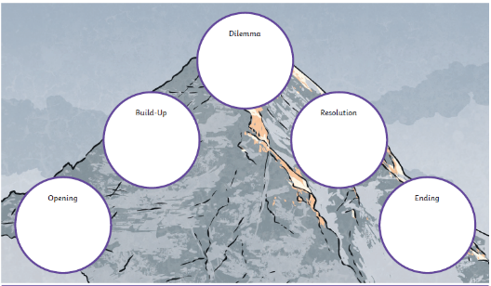
You may want to draw and use a story mountain to help guide your writing and keep it structured.

I have included a mystery story writing checklist to help keep you on the right track. How many features on the checklist can you tick off?

Mystery checklist
I have…
A title
A beginning to introduce the characters
An original setting
A tense build-up
A dramatic dilemma or problem
A brief resolution that solves the mystery/problem
Short, snappy sentences for effect
Correctly punctuated dialogue
Exciting vocabulary
Sophisticated punctuation

Don’t forget to draft, polish and do a neat write-up with illustrations. I can’t wait to read them!

Challenge: Can you compare your final piece to another mystery story? How is it similar? How is it different?

