Top Secret! Gillian’s Self Isolation Diary
Monday
On our daily afternoon walk, we went along the canal in Gamston. There weren’t too many people but there were lots of ducks! Some of them even had ducklings and they were ever so cute.
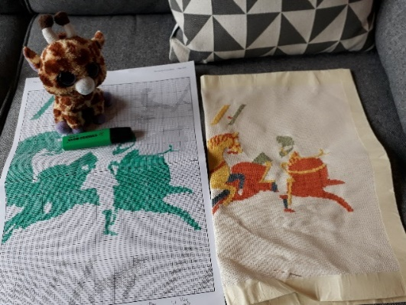
Tuesday
Miss Brearey has started her new cross stich project. It’s an extract from a very famous piece of sewing called the Bayeux Tapestry. It tells the story of a very famous battle that happened in 1066 and the real one is kept in a museum in a place called Bayeux in France. It is over 70 m long and 50 cm wide! Miss Brearey’s is much smaller than that, about 40 cm long and 30 cm wide so it shouldn’t take her very long. It’s not a very colourful cross stitch (it only has 6 colours!) because the real one was made a long time ago when it would have been expensive to make some colours.
As you can see, I’m in charge of the highlighting. I highlight the parts we’ve done so we know where we are. There’s lots of counting involved! I’ve only got it wrong once but Miss Brearey wasn’t very impressed when she had to pull out the stitches and put them in the right place…
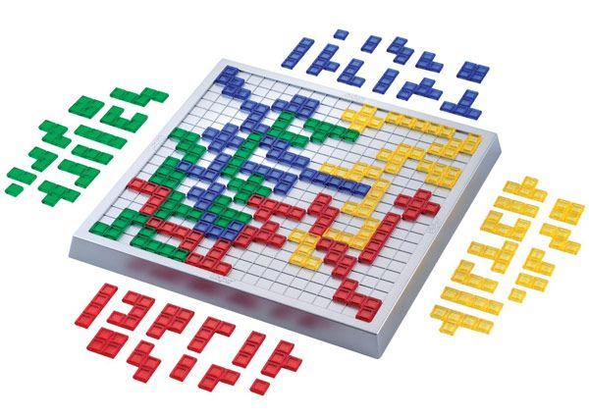
Wednesday
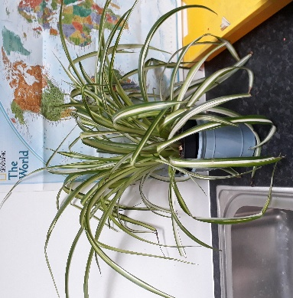
Miss Brearey was in school today so I was left twiddling my thumbs (and keeping an eye on Geoffrey!) at home by myself. When she came back, she tried to explain a new game that she played called Blokus. It sounds a little confusing but it can’t be harder than chess! Hopefully I’ll be able to have a go at it soon.
Miss Brearey said that whilst she was in school, she went into Class 3 and realised that she’d forgotten all about the spider plant next to the sink! Luckily, it had been growing remarkably well by itself, despite not being watered in about 5 weeks…
Thursday
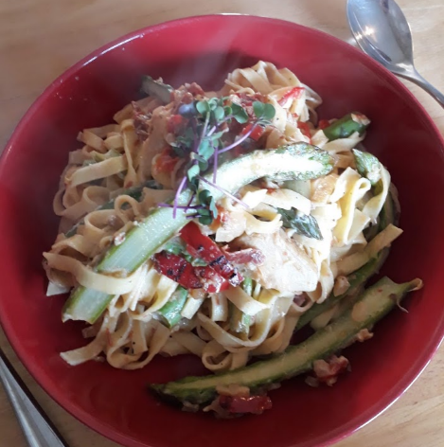
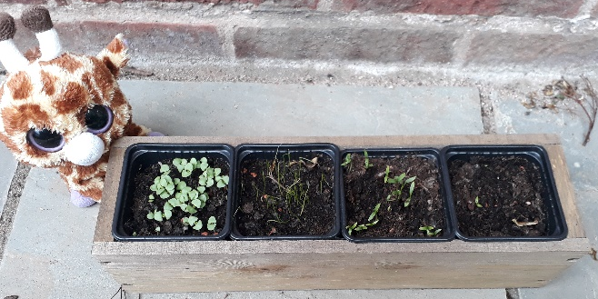
A plant update today! Miss Brearey’s avocado stone had to be put into a new glass because the root was growing so quickly! The kitchen herb garden that she planted with Geoffrey last week is starting to grow but not very quickly. It’s a bit colder and cloudier this week so I think they might be finding it tricky to grow. We’ve been eating the fancy microherbs on our sandwiches and dinners this week. Geoffrey was right- they do taste just like cress! Here it is on our pasta dinner.
Friday
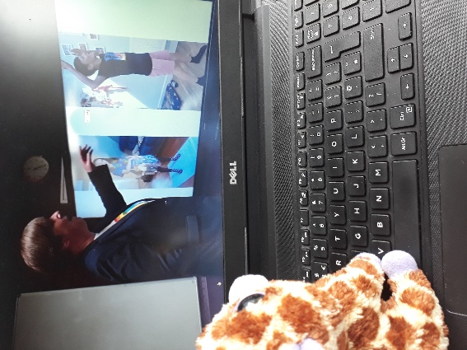
Miss Brearey was in school AGAIN today so I felt a bit lonely. Luckily, I had lots of activities from Mrs Ballard to keep me busy. I absolutely loved doing the Harry Potter yoga although it was a little tricky (giraffes aren’t very flexible you see). It was lovely to see all the work everyone has been doing in Mrs Ballard’s Bench of Glory special. It felt a bit different seeing an assembly on the screen but I enjoyed it still

Answer the questions below using Gillian’s diary to help you. The questions are in the same order as the text (for example, you won’t find any questions about Friday first!)
Where did Gillian go for her walk on Monday?
Find and copy the word that means baby duck.
Tick True or False:
Statement | True | False
Gillian and Miss Brearey walked along the canal.
They walked at 10am.
There were lots of other people walking along the canal.
Miss Brearey thought the ducklings were cute.

Where is the Bayeux tapestry kept?
How long is the real Bayeux tapestry?
Why does Geoffrey think Miss Brearey will be quick with her sewing?
How many colours does Miss Brearey’s new cross stitch have?
How does Gillian help Miss Brearey with the cross stitch?
How many times has Gillian got her cross stich counting wrong?
Why was Miss Brearey not very impressed about Gillian counting wrong?
Where did Miss Brearey go on Wednesday?
What was Gillian doing whilst Miss Brearey was at school?
Does Gillian want to play the new game Blokus? How do you know?
What had Miss Brearey forgotten about in Class 3?
Find an copy a word that means “extraordinarily”.
Why was Miss Brearey surprised that the spider plant was growing well?
Why do you think this plant is called a spider plant (use the picture to help you)?
Why did the avocado stone have to be moved into a different glass?
Which of Miss Brearey’s plants aren’t growing very quickly?
Why would the weather being cloudier mean Miss Brearey’s plants are struggling to grow?
What have they been eating on their lunches and dinners this week?
Who was right about the microherbs tasting like cress?
How did Gillian feel on Friday?
Who sent Gillian things to keep her busy on Friday?
What did Gillian love doing?
Why was the yoga tricky for Gillian to do?

