Set W/C 4th May 2020
Maths – Missing Angles

Not necessarily linked to ‘light’ but more of a follow-on from the Science/Maths activity that I’ve set this week all to do with mirrors and reflection of light.

We covered some ‘angles’ work earlier this year so this is some consolidation and practice of those skills.

1. Name the angles below.
____________________ ____________________ ___________________ ___________________

2. Find the missing (lettered) angles in the questions on the next page.
Remember… Angles on a straight line add up to 180°
Angles around a point add up to 360°

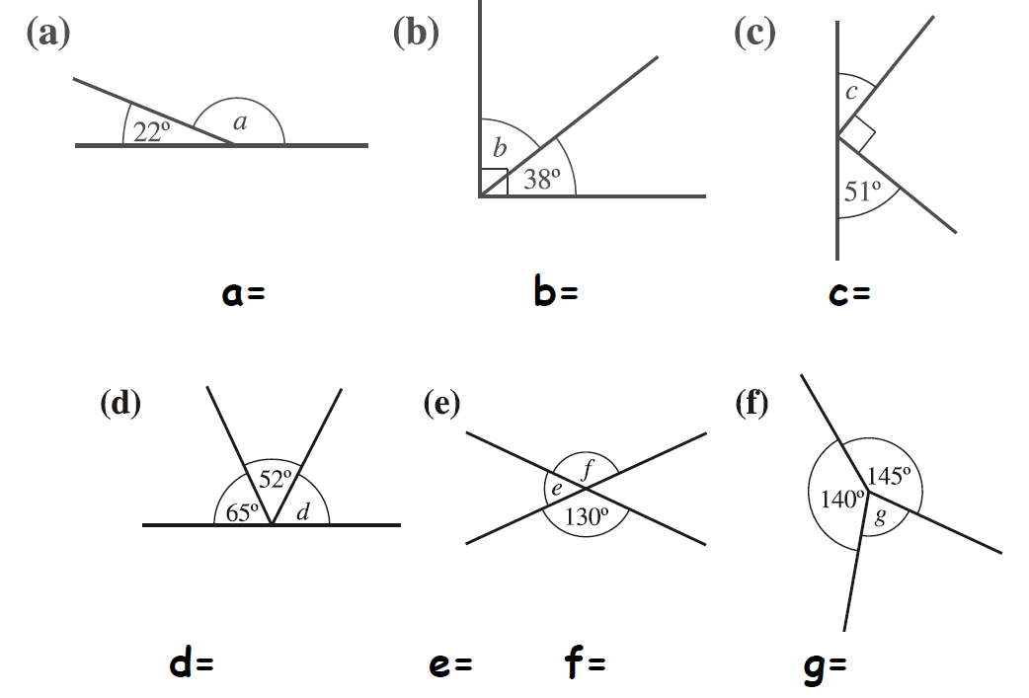

2EXT) Here is an extension to do if you think you are able:

3) Find the missing (unlabelled) angles below.
Remember… Angles in a triangle add up to 180°
Angles in a quadrilateral add up to 360°
Opposite angles are equal

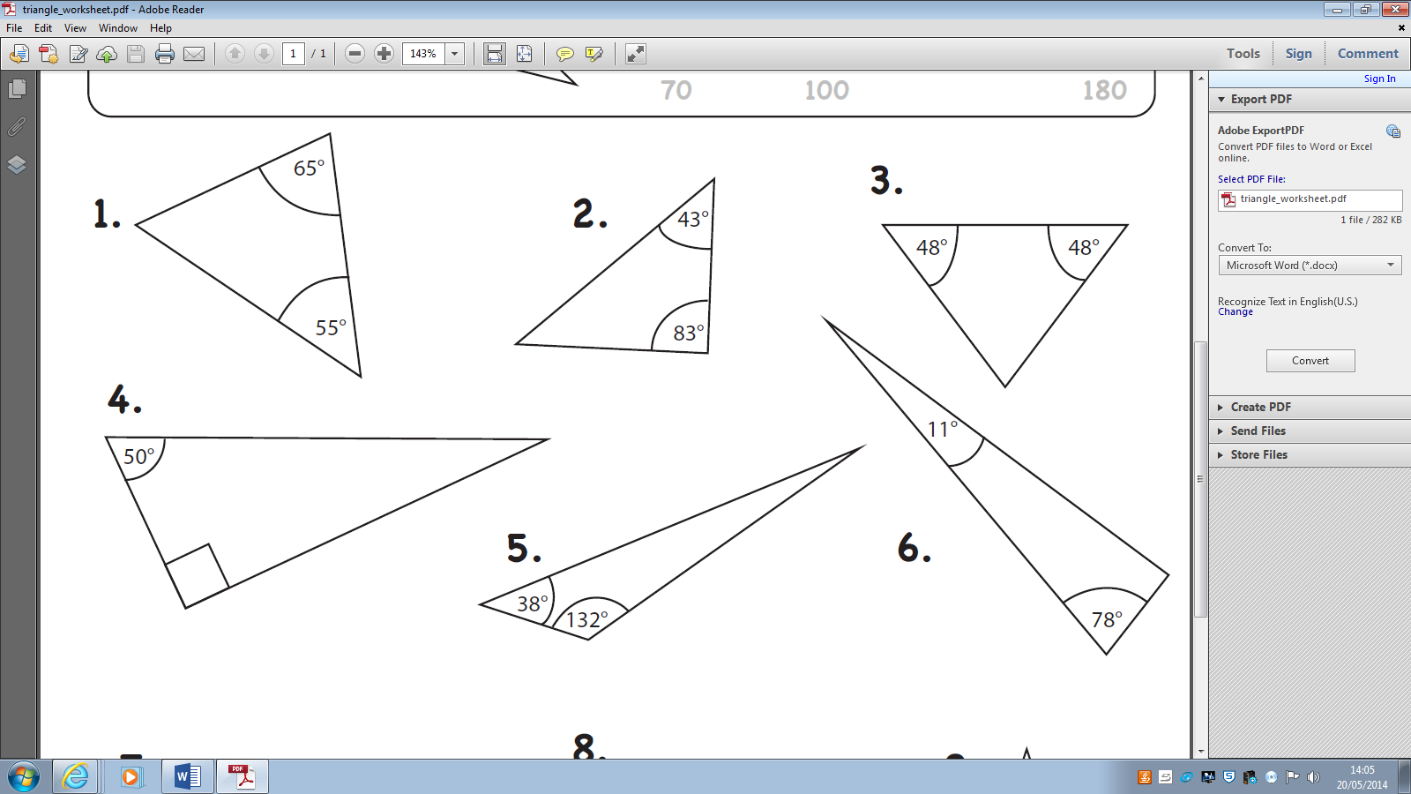

4. Find the missing (lettered) angles below:

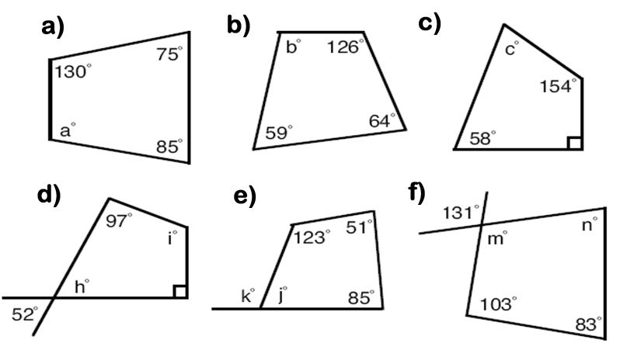

EXTRA CHALLENGE:
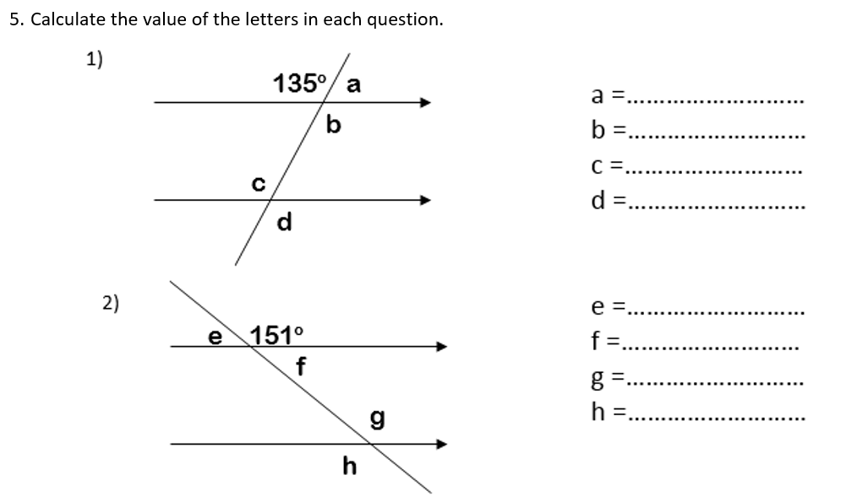
Remember: Opposite angles of 2 lines crossing are equal.
Angles around a point add up to 360˚.

Answers: (don’t look at these until you’re done!)
Answers
- A) Reflex B) Right Angle C) Acute D) Obtuse
- (a) 158° (b) 52° (c) 39° (d) 63° (e) 50° (f) 130°
2EXT. (g) 75° (h) 69° (i) 67° (j) 115°
- (a) 60° (b) 54° (c) 84° (d) 40° (e) 10° (f) 91° (g) 60° (h) 45° (i) 30° and 75°
- (a) 70° (b) 111° (c) 58° (d) 52° and 121° (e) 79° and 101° (f) 131° and 43°
- (a) 45° (b) 135° (c) 135° (d) 135° (e) 29° (f) 29° (g) 151° (h) 151°

