[](https://www.google.com/url?sa=i&url=https%3A%2F%2Fwww.facebook.com%2Fletsgetquizzicaltees%2F&psig=AOvVaw1pYJvM8UhZ2kfwl2SjhMBg&ust=1588588821681000&source=images&cd=vfe&ved=0CAIQjRxqFwoTCPDdvLDBl-kCFQAAAAAdAAAAABAD)

I have got a challenge for you this week to see how active you have been keeping your brains. I’m sure they are all fired up and ready to go.

I am going to ask you Maths questions. I have no doubt that you are all going to be able to answer these questions. I will also give you some help along the way.

After you complete this test, check your answers on the answer sheet document.



Good luck

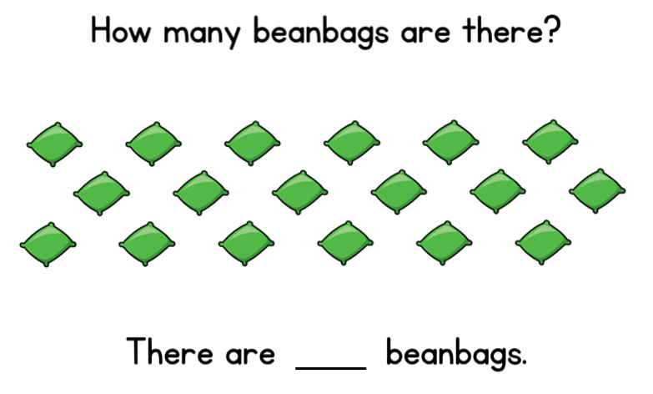

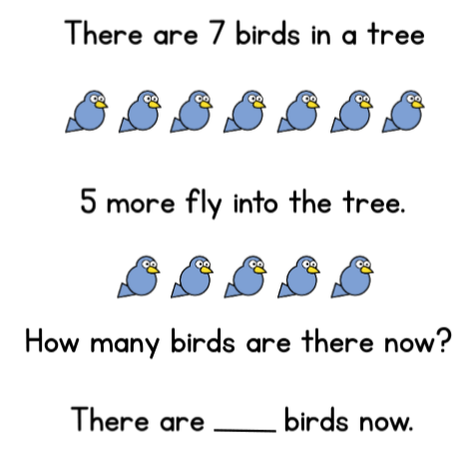

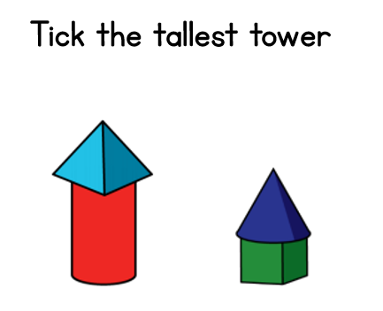

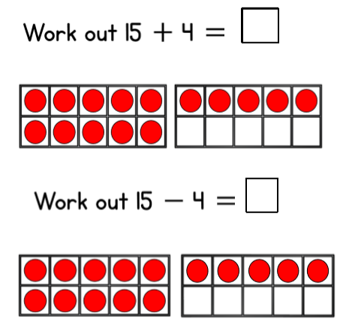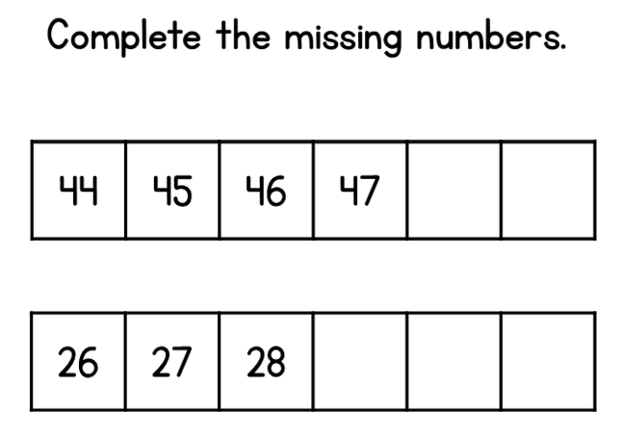

Remember to look if it is:

add +

or

take away –

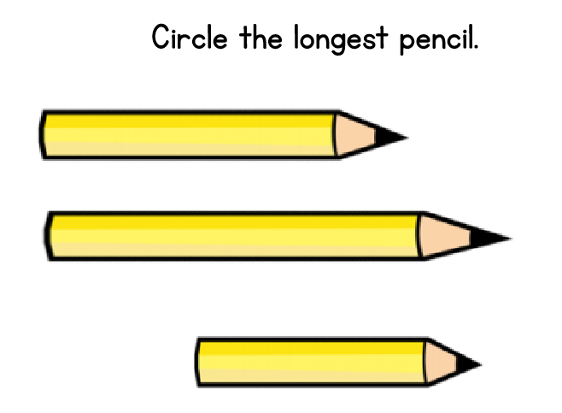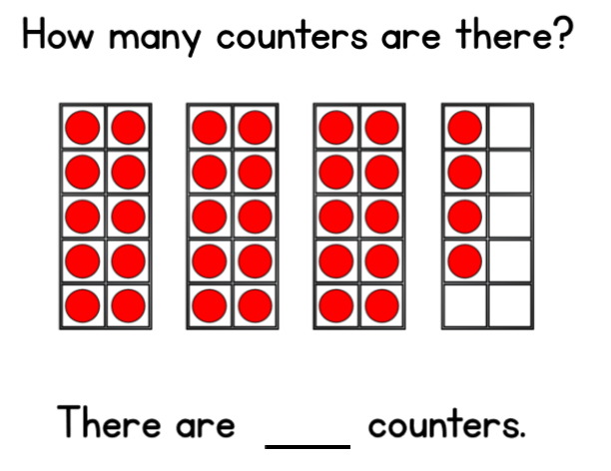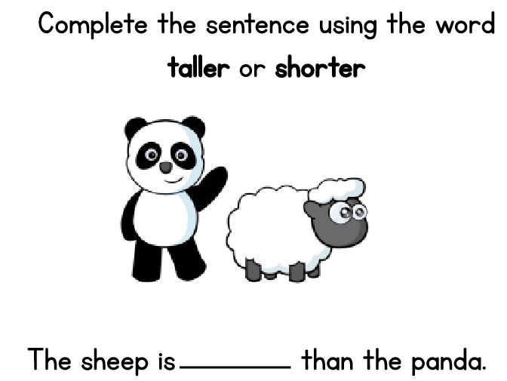

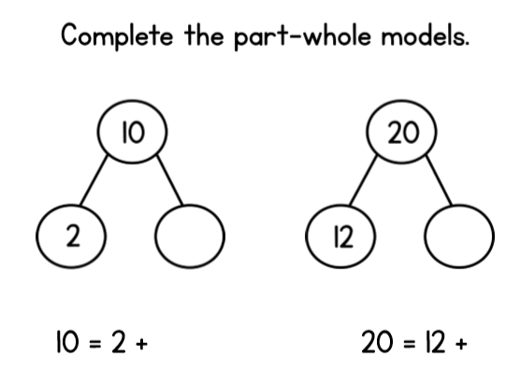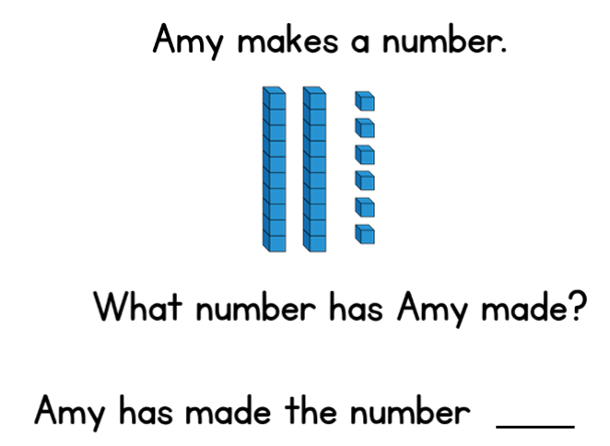

Remember.

There are two parts and when they add together they make the whole.

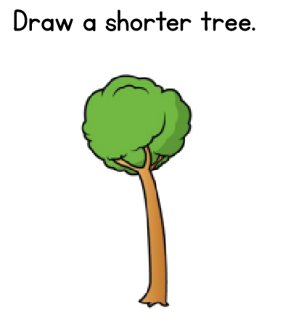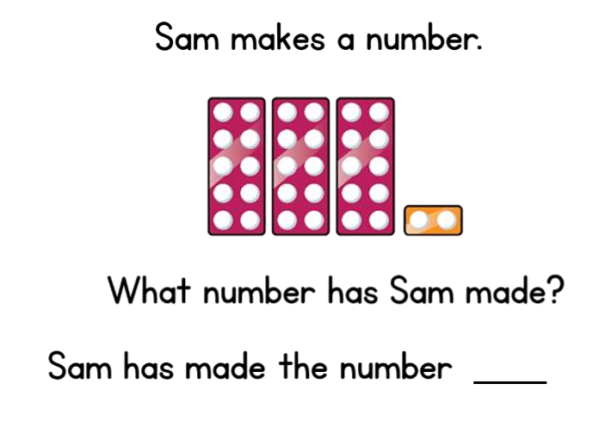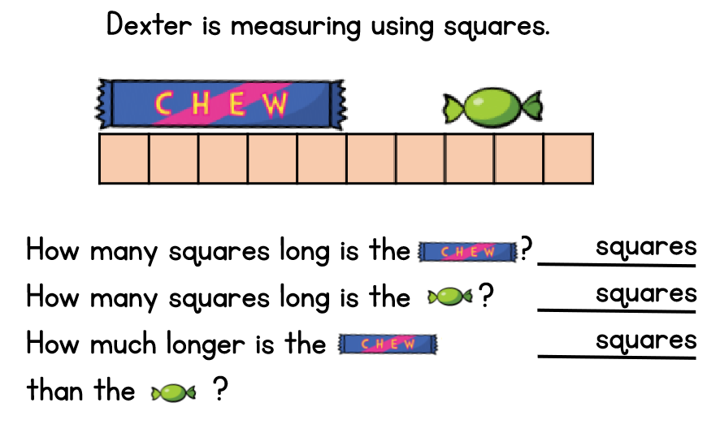

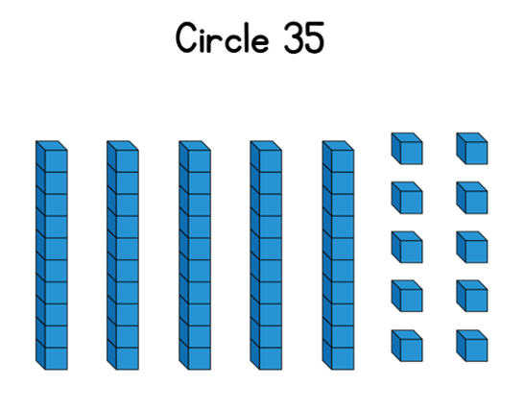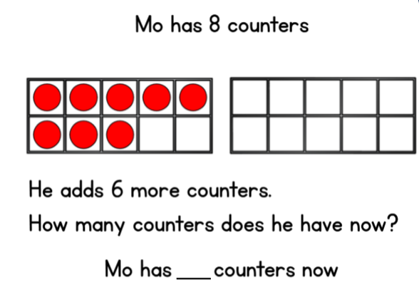

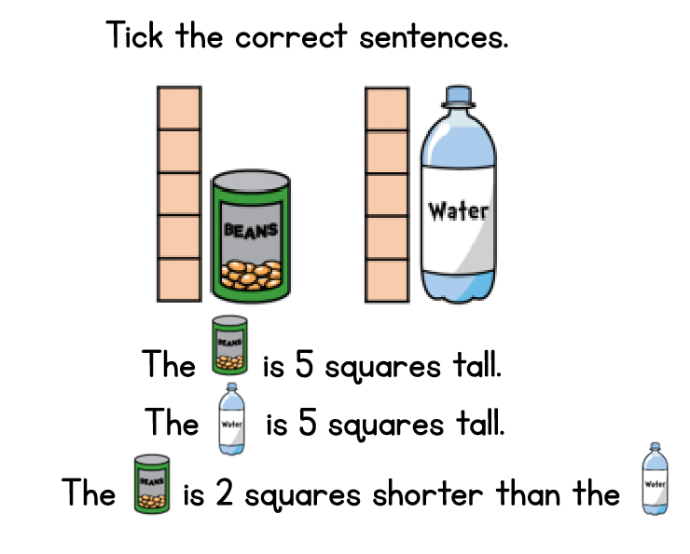

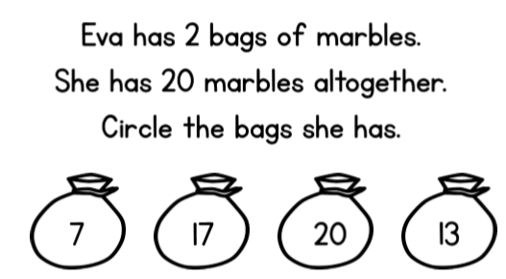

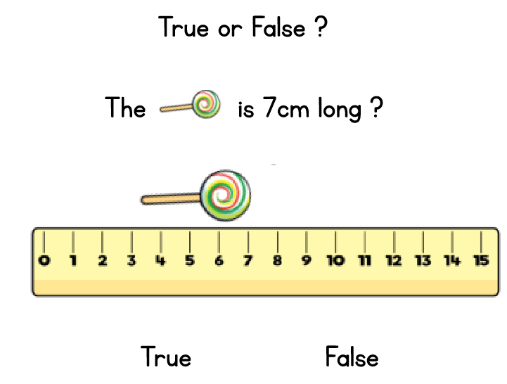

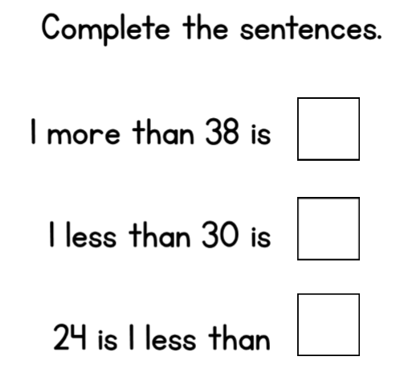

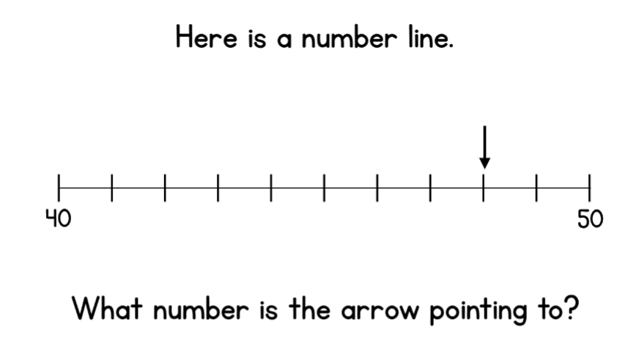

**Extra Challenge-**

**Times tables**

1 x 2 =

1 x 5 =

2 x 5 =

3 x 5 =

4 x 5 =

5 x 5 =

6 x 5 =

7 x 5 =

8 x 5 =

9 x 5 =

10 x 5 =

11 x 5 =

12 x 5 =

2 x 2 =

3 x 2 =

4 x 2 =

5 x 2 =

6 x 2 =

7 x 2 =

8 x 2 =

9 x 2 =

10 x 2 =

11 x 2 =

[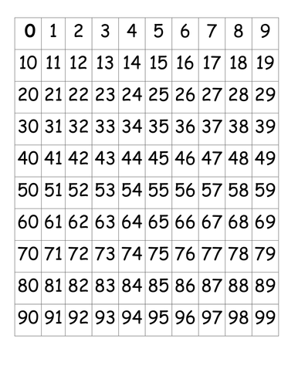](https://www.google.com/url?sa=i&url=https%3A%2F%2Fwww.tes.com%2Fteaching-resource%2F0-99-square-7108921&psig=AOvVaw3avhIScLp8Xdvq3QITQPdG&ust=1588590444566000&source=images&cd=vfe&ved=0CAIQjRxqFwoTCLi99LbHl-kCFQAAAAAdAAAAABAD)12 x 2 =

Use the number square to help you.

Colour in the numbers as you count.

Use a different colour for 2’s and 5’s.

See if you can see a pattern.

Your turn to be the quiz master

Can you write some maths questions for me?

See if you can challenge my amazing mathematical mind.