|  |  |  |  |
| --- | --- | --- | --- |
| Day | Time | Activity | Location |
| Wednesday | 11.00 | Leave for Camp Brearey | Home |
| 11.01 | Arrive at Camp Brearey, unpack | Camp Brearey |
| 11.30 | Lunch prep, eating and clearing up (cheese toastie) | Kitchen/outdoor patio |
| 12.30 | Nature walk, collect leaves/take pictures | Local area |
| 14.00 | Arrive back at Camp Brearey, identify the tree species using leaves | Indoor seating |
| 15.00 | Make camp (blanket fort) | Camp Brearey |
| 15.50 | Snack and cup of tea break | Grass Area (watch out for cats) |
| 16.00 | Knot learning! | Grass Area (watch out for cats) |
| 17.00 | Dinner prep, eating and clearing up (Fish and chips) | Kitchen/Outdoor patio |
| 18.30 | Campfire singing (no s’mores ☹ ) | Outdoor patio |
| 19.25 | Hot chocolate | Miss Brearey blanket fort |
| 19.40 | Zoom call Mrs Mullen to see how she’s getting on | Miss Brearey blanket fort |
| 20.25 | Get ready for bed, brush teeth | Bathroom |
| 20.40 | Reading in bed | Miss Brearey blanket fort |
| 21.20 | Lights out! |  |
| Thursday | 7.20 | Up, shower, dressed | Miss Brearey blanket fort/bathroom |
| 8.15 | Breakfast al fresco (cereal and cup of tea), wash up | Outdoor patio |
| 8.40 | Tidy blanket fort ready for tidiness inspection | Miss Brearey blanket fort |
| 9.00 | Plan route of daily walk | Seating area |
| 9.20 | Nature art using materials collected yesterday and those found in garden, take picture (and make sure cats don’t disrupt) (or birds, they might try to use the twigs for their nests) | Outdoor patio |
| 10.00 | Tea and snack break | Outdoor patio |
| 10.15 | Daily walk, taking pictures of birds to identify | Local area |
| 11.45 | Use pictures to identify birds | Seating area |
| 12.15 | Lunch prep, eating and cleaning up (cheese sandwich) | Kitchen/outdoor patio |
| 13.20 | Set up and run assault course | Outdoor patio/grass area (watch out for cats) |
| 14.15 | Dismantle blanket fort, pack up camp | Camp Brearey |
| 15.00 | Leave Camp Brearey | Camp Brearey |
| 15.01 | Arrive home | Home |
| 15.02 | Write up review of Camp Brearey to send to Class 3 | Home |

How long did Miss Brearey spend travelling to Camp Brearey?

How long did Miss Brearey spend singing around the campfire?

What was Miss Brearey doing at 3pm on Thursday?

What was Miss Brearey doing at 10 minutes to 4 in the afternoon on Wednesday?

How long did Miss Brearey plan to spend making her blanket fort?

Miss Brearey actually spent 1 hour and 15 minutes making her blanket fort. What time did she finish making it?

How long did it take Miss Brearey to get up, showered and dressed on Thursday morning?

How long did Miss Brearey have to enjoy her breakfast?

How long did Miss Brearey spend on her walk each day?

How long was Miss Brearey allowed to read before bed time?

Miss Brearey actually only took 25 minutes to pack up her blanket fort! What time would she have been able to leave Camp Brearey?

If Miss Brearey went to sleep at lights out and woke up at 7.20 (as planned), how much sleep did she get?

How long did Miss Brearey spend on Camp Brearey in total (11.01 on Wednesday until 15.01 on Thursday)?

On the clocks, draw the analogue times on the clock face for when each event started. Write the digital time underneath using the 12 hour clock (e.g. 7:00pm instead of 19:00).

Reading in bed

Set up and run assault course

Knot Learning

Leave Camp Brearey

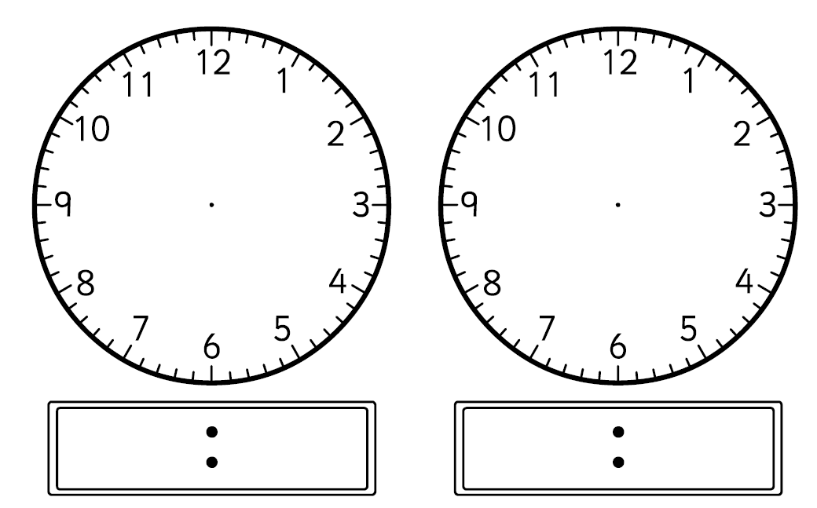

Snack and cup of tea break, Wednesday

Hot chocolate!

Nature art

Zoom call Mrs Mullen