Phonics
Just a reminder, that the BBC Bitesize pages provide a great base of resources to help you build up your child’s knowledge of letters and sounds. Alphablocks, too, is a thorough but speedy recap of early phase sounds, along with a reminder of the alphabet. At school, we follow the Letters and Sounds programme. Their website has a wealth of online games and printable activities to reinforce your learning. (letters-and-sounds.com)
This week I have given you two new digraphs to master - ‘ai’ (e.g. rain, sail, train etc.) as can be heard on the BBC website:
www.bbc.co.uk/bitesize/topics/zvq9bdm/articles/z4xsxyc
The second sound is ‘oa’ (e.g. goat, boat, oat etc. ) see this website for a clear audio definition:
https://www.bbc.co.uk/bitesize/topics/zvq9bdm/articles/zh4j47h

Along with these two sounds I’ve also included a few tricky words. Tricky words don’t follow a normal sound pattern and cannot be sounded out phonetically, they simply just have to be learnt.
https://www.bbc.co.uk/bitesize/topics/zvq9bdm/articles/zr728xs
‘he’ ‘she’ ‘we’ ‘me’ ‘be’ ‘they’ ‘I’ (from two weeks ago, do you remember them?)
New words:
‘you’, ‘are’, ‘her’, ‘was’, ‘all’, ‘my’

As always, it’s always a good idea to encourage your child to read the words sounding out each sound. After sounding out each word, try and write the word again, encouraging your child to sound out each grapheme at a time. Then when you are reading stories together, see if you can pick out these words. Maybe use them in a sentence, if you’re feeling brave. Along with these ideas, if you fancy having a bit more fun or getting active with these sounds instead, have a go at one of my activities:
- Picture and word mats: cut them out and jumble them up. Can you match the words and pictures? Remove the pictures and read the word. Can you draw the picture? Remove the word. Can you now write the word that matches the picture? Trace over the words and practice your handwriting. Turn them over and take it in turns to choose a card, can you name it, can you write the word, if you get it right have another go. Pick a word and picture and write a sentence about it, e.g. ‘The snail on the wall’, ‘The loaf cut for toast’.
- Writing: its always a good idea to practice writing these words, sounding them out carefully. Don’t always feel you have to write them on paper. Try writing them in sand, moon dust (a mix of coco, flour and olive oil), play dough, in water, chalk outside or even in some alphabet spaghetti! You can always take a photo and show me.
- Tricky words. If you’re a fan of hopscotch, and enjoyed this game last time, why don’t you draw a game and place the words in the squares instead of numbers? If it’s wet outside, print off my paper tabletop version and play inside. A Lego person or button works just as well to move up and down the hopscotch board. Alternatively, cut them out, mix them up, if you have a net or sieve at home go fishing for your words, sit on the carpet and see which words you can name and catch. Who can collect the most? You could always play teacher to action man and teddy? Teach them and read to them these words, I’m sure they will enjoy this time with you.
- Spider web game: You could play this with any words/ sounds previously set and can be used in counting too. Take it in turns to move a shape around the web, say the word (or sound) correctly and you can move your piece on to the next word. It is someone else’s turn when you get it wrong. Have fun. You will need a counter/ object for each person. (buttons, pasta, lego bricks et

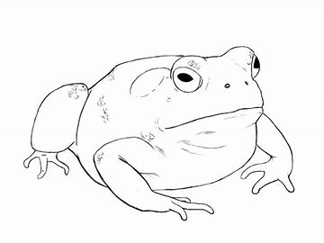 | 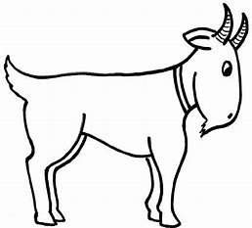 | 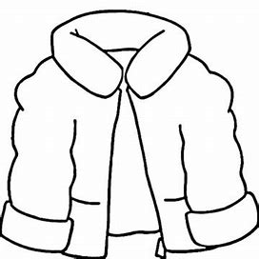 | 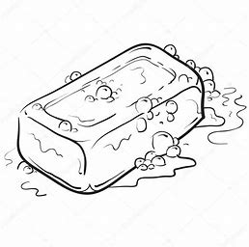
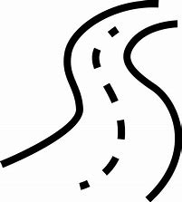 | 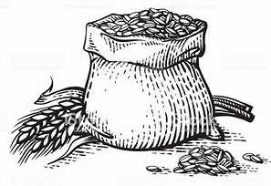 | 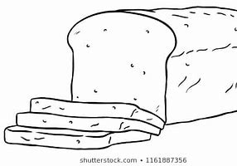 | 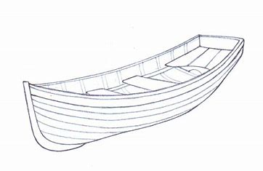

boat | toad | loaf | coat
road | soap | goat | oats

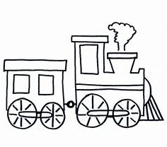 | 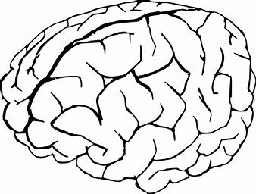 | 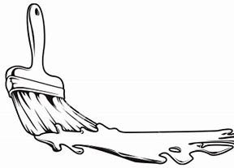
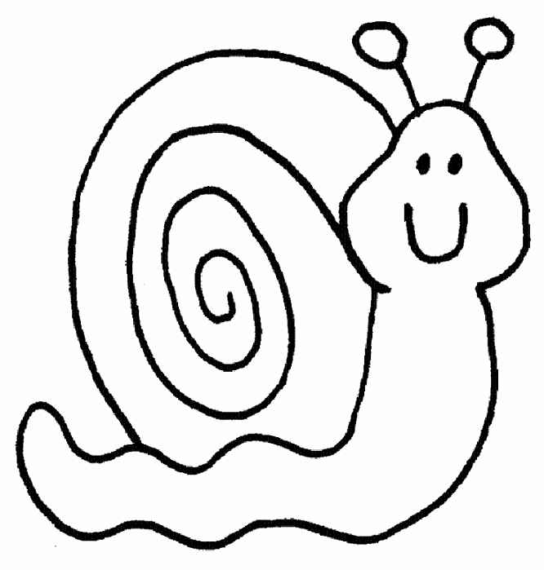 | 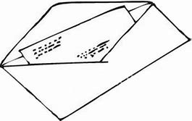 |  | 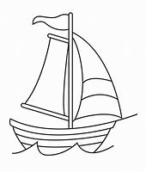

snail | brain | mail | paint
tail | sail | train | nail

