Set w/c 4th May 2020
By the end of this, you should be able to use your knowledge of reflection and how light travels to place mirrors to make light follow a certain path.
‘Light’ – Science/Maths

Mirrors
Mirrors are flat, highly reflective surfaces which can be used to change the path of light in a predictable way. We saw this last week with the periscopes; if you want to make light change direction, you can place a mirror at a certain angle and it will reflect (change the direction of) the light.
Mirrors are often placed around homes so that they reflect the light back to us so that we can see ourselves. When it is completely dark in a room, with no light whatsoever, the mirror will not work, because there is NO light to reflect.
Mirrors are also useful tools for having in cars and other vehicles so that the driver can see behind them without turning their head.
Mirrors are used in many scientific and engineering devices, such as in telescopes, periscopes and cameras.

We can use our maths skills to calculate the path a ray of light will take when it hits a mirror. An example is shown below:

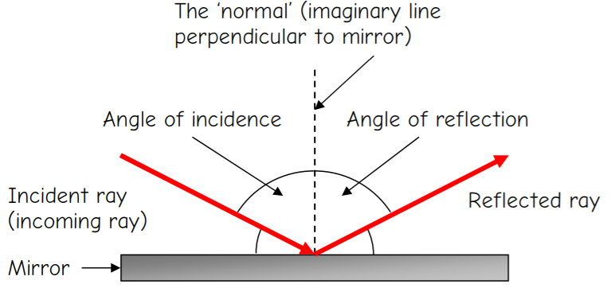

When a ray of light hits a mirror, it is reflected back at EXACTLY THE SAME ANGLE that it entered the mirror. For example, if the incident ray (the original ray of light) hits the mirror at 45˚, then the reflection out of the mirror will be at 45 ˚ too – see the diagram below:

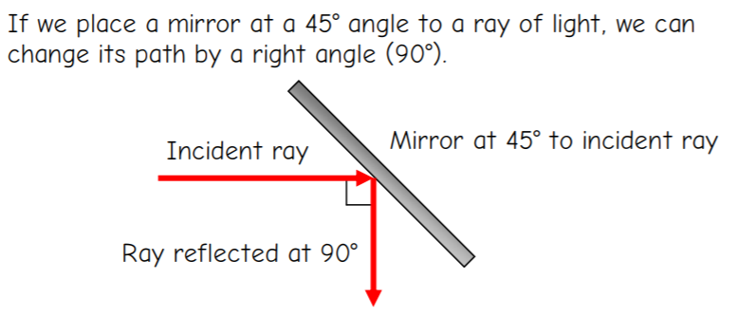

Your Challenge:
My friend is designing a new type of escape room involving laser reflection.
The gamer stands at the entrance to the room (labelled ‘in’ on the diagrams) and must find a way to reflect the beam of the laser torch (which is shining straight ahead from the entrance to the room) in mirrors so that it eventually hits the ‘door release’ sensor (labelled ‘out’ on the diagrams).
In each room, the gamer must decide whereabouts to place the mirrors.
He/she MUST use a set number of mirrors – the amount is different in each room.
All mirrors must be positioned at a 45˚ angle to the laser beam.
There are some walls in the rooms. The positions of these are shown with opaque (grey) squares. The beam of light will NOT travel through these, as they are solid walls. You will have to go around them if they are in your way.

YOU are the first contestant to trial the game! See if you can decide where you will position the mirrors for each of the rooms below. There is an example below.
REMEMBER – all mirrors must be placed at a 45˚ angle to the beam of light. You will not need a protractor to measure this. If the beam of light is travelling along one of the grey lines, then a 45˚ angle will be a diagonal line through the squares (see the positioning of the mirror in the example).
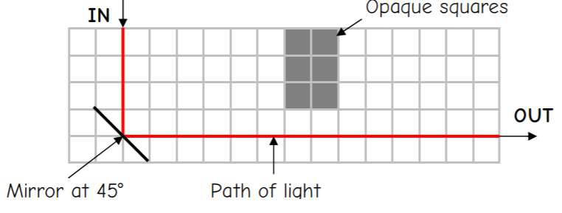

Draw the mirrors on to the room layouts on the next pages, at a 45˚ angle, with a thin, coloured pen (a coloured biro or a thin pencil crayon/felt tip would be ideal).

