I hope that you are feeling confident with using fractions after completing the White Rose Hub Home Learning tasks for Weeks 1-3 (confusingly named Week 1, Week 2 and Summer Term Week 1 on the website…)! If you haven’t yet worked your way through these tasks, I would suggest doing that before completing the below activity. (https://whiterosemaths.com/homelearning/year-3/ )
As some of you will no doubt have noticed, after the first 3 weeks on the website, you unfortunately have to pay for “premium” membership and the content is no longer to do with fractions. You are of course welcome to purchase the White Rose Hub premium membership for yourself but there is no need to. I hope that Weeks 1-3 have been enough to make you feel you have learnt something new and that it was clear for you to work through. Now, a fraction activity for you to complete…
Who has the better deal? For each question, work out which teacher has got the better “deal” when sharing the treats in the staff room... You could use the picture and different coloured pencils to work out who has the most. By the second page, you might be able to work out which teacher has the better deal without using a diagram! If you’re not able to print these pages off, draw your own pictures to colour in- they could be simple “dots” or more life-like but pay attention to the number of equal parts I’ve included otherwise the fractions could get complicated…
Miss Brearey has half of the cakes. Mrs Mullen has one eighth of the cakes. Who has the most?
Mr Jones has three eighths of the pizza. Mrs Ballard has 5 eighths. Who has more?
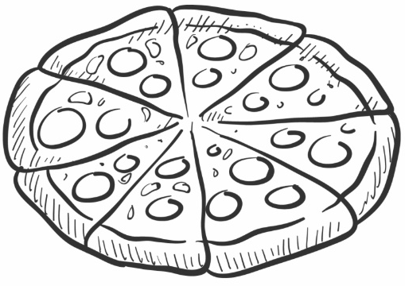
Miss Harris has one sixth of the biscuits. Mr Castledine has one third of the biscuits. Who has more?

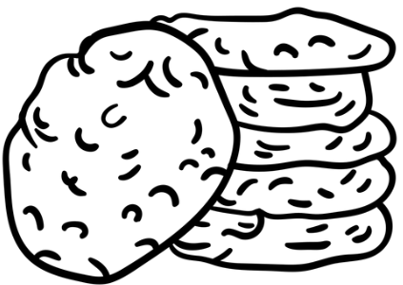
Mrs Sampson has one third of the sweets. Miss Weston has two sixths. Who has more?
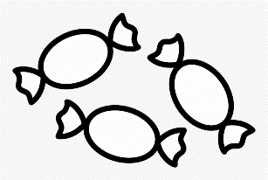
Mr Boyd has one fifth of the chocolate bar. Miss Hayes has 3 fifths of the chocolate bar. Who has more? 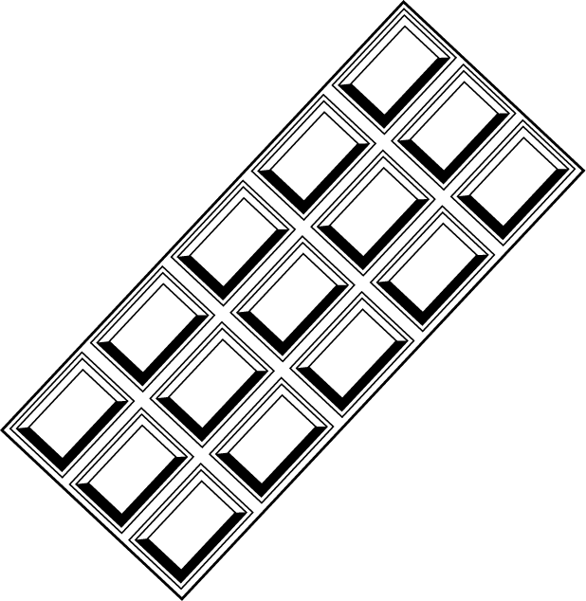
Mrs Hollingshead has one half of the jellybeans. Mrs Hallsworth has 4 eighths. Who has more? 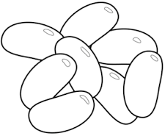
Mrs Bloomfield is appalled at all these unhealthy snacks in the staff room! She tucks into two thirds of the cherries. Mr Castledine eats the rest. Who has the most?
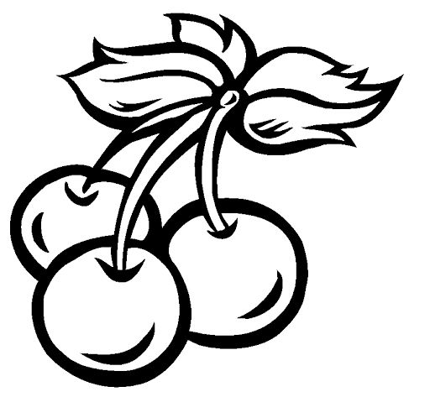
CHALLENGE Generous Mrs Zawodniak brings in everyone’s favourite…crumpets! She brings in a total of 20. Mrs Ballard butters half of them, Mr Jones smothers 2 fifths of them with jam and Miss Brearey puts huge dollops of Nutella on the one tenth left. How many crumpets are there with each topping? Are there more crumpets with butter, jam or Nutella?

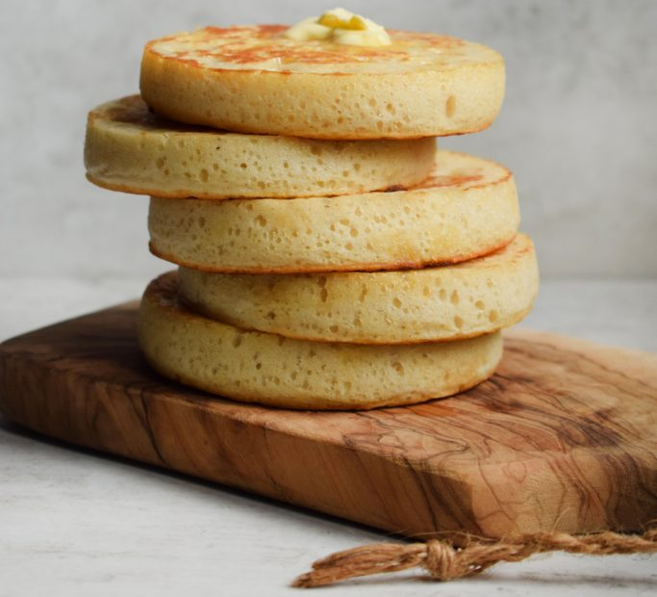
Use < > or = in the gap to compare the fractions on this page.
Note to grown ups: there’s lots of discussion that can be made with “greater than” “less than” or “equal to” (equivalent when you’re talking fractions!). You can also talk about, when looking at unit fractions (fractions with a 1 as the numerator/number on top), the bigger the denominator (number on bottom), the smaller the “part”. When you have 2 fractions with the same denominator, the size of the equal parts is the same so the bigger the numerator, the more of those equal parts you have and the bigger the fraction!
The best way to think of it (or the way my food-themed brain always looks at it…) is to think what fraction of cake would you rather? Remember the bottom number (denominator) is how many equal parts the whole cake is split into, and the top number is how many of those equal parts you have.
Those eagle eyed amongst you may have noticed that these are using the same fractions as the previous pages. This page is simply showing them as fractions instead of written words!
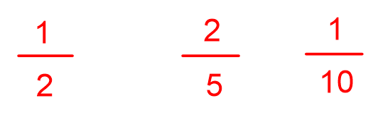
You could have a go at writing your own comparisons, using grown ups, sister/brother, packets of biscuits, counters…Or just choosing 2 fractions at random and seeing if you can tell which one is bigger!

Here is a chocolate based fraction game (or you could make it any object you like, food works best…) which would work very well if you were able to “act it out”. I’m envisaging some lucky teddy bears being roped in but adults and siblings could of course be used if they are willing…
https://nrich.maths.org/34&part=

