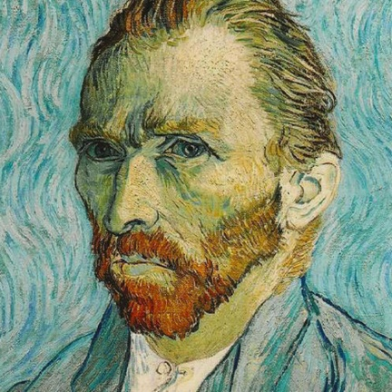
What is Miss Brearey’s favourite Van Gogh painting?
Vincent Van Gogh was a very famous painter and painted over 900 pieces of art!
Here is a description of my favourite painting of his:
Van Gogh was probably most famous for painting the sunflowers but my favourite is a different plant. It hasn’t got any flowers but it’s different sized leaves are fiery red, sunset orange and golden. The edges of the leaves are trimmed with a golden border. It is stood in what looks like a clay pot and is planted in a deep, dark soil. In the background, it looks as though there is a deep blue painted wall. I think the plant has been placed on a wooden desk.
Use my description and see if you can find my favourite using https://www.vangoghgallery.com/catalog/gallery.html (all of the paintings are named which is very helpful!)
Now, choose your favourite (there’s plenty to choose from!), write a short description (be careful because some of them look very similar…so be specific!) and see if someone in your house can guess which painting it is. You could also/in stead send your description to me to see if I could guess it right!
abrearey@willowbrook.notts.sch.uk
Potential follow up work:
- Recreate your favourite painting using crayons, paints, pencil…whatever you can get your hands on!
- Do some more research on your painting. If it’s a plant, could you find one in your local area? Could you find a picture of it in real life? If it’s a landscape, could you find out where it was painted? If it’s a person, can you find out how Van Gogh knew them? If it’s Van Gogh, can you find out how old he was when he painted it?
- How did Van Gogh paint? What materials did he use? What colours did he use?
- If he only sold one painting in his life time, how did he have enough money to buy food, painting materials and clothes?
- One of his paintings sold for over £65 MILLION! Can you find out which painting this was? Do you think it was worth that much money? (If you’re interested in incredibly expensive art, this article is worth a look…some eye watering sums of money! https://www.invaluable.com/blog/most-expensive-painting/ )
- Write a biography of Vincent Van Gogh. This website is a good place to start for some key facts: https://www.ducksters.com/biography/artists/vincent_van_gogh.php

