Year 3 and 4 Not Quite A Residential!
As I’m sure you’re aware, we will not be able to attend our Year 3 and 4 residential trip to Walesby Forest as planned on Wednesday 6th- Thursday 7th May. This would have been this week but never fear, Mrs Mullen and Miss Brearey have a cunning plan already prepared to give you some taste of a residential experience!
We would both absolutely love to see pictures, read your diary entries/reviews and see what you’ve made of a rather unique residential experience so please drop us an email:
cmullen@willowbrook.notts.sch.uk
abrearey@willowbrook.notts.sch.uk
The main thing that would be exciting going on a residential would be a night away from home with all of your best friends from school. This clearly cannot happen in the literal sense but there are some things you could do to give yourself a different night’s sleep…
*Please check with mum or dad before doing any of these!*

Sleep somewhere different- a blanket fort, outside in a tent/under tarpaulin, in the shed or garage, the sofa, a blow up mattress on the floor in a different room of the house.
Create a poster for your residential site- let people know where you are staying, you could still call it Walesby Forest but by all means use your imagination…you could go to Lapland, Sahara Desert…
Create a brochure- let people know what activities/facilities are available at your residential site. This normally includes a map of the site- where are the dormitories? The different activities? The toilets? Campfire…?!
Plan your activities and schedule- on the next page are a list of potential activities. These are by no means exhaustive and feel free to add your own. The only rule, as is on a residential, is no watching tv programs, films or going on ipads unless it’s part of an activity listed on the next page- you simply wouldn’t be able to on residential!

Lots of these activities can be completed independently but, of course, residential is not about working all by yourself, you’re normally part of a group! If you have any siblings or mums and dads around, get them involved too!

Potential Activities
Meal times
Have your breakfast “al fresco”, this is a staple of residential experiences! A bowl of cereal sat outside somehow tastes better…
Cook a s’more…this requires either a fire or a tea light works surprisingly well! Toast a marshmallow on a stick (carefully!!), prepare rich tea/digestive biscuit with chocolate button on top, squash your marshmallow between the biscuits and devour!
Have a hot chocolate before bed time
If you haven’t been already, help make dinner and do the washing up.
Lunch on residential often consists of a sandwich (often made by yourselves), crisps, piece of fruit and a biscuit/cake. Again, outdoors tastes better!
Outdoors
Plan your family walk for the day using a paper map or electronic (such as https://gb.mapometer.com/ )
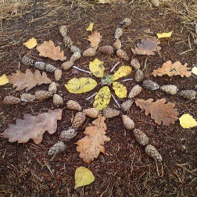
Create your own “natural” art using twigs, leaves, flowers (although ask mum/dad before digging up their prized marigolds…!). See if you can arrange them into an animal, face, building, scene…
Create your own assault course using what materials you have available! Map out the route and think about going under/over/through things…
Identify any plants/flowers you have in the garden or in your local area. Do you know your apple blossom from your cherry blossom? A daisy from a dandelion? Take pictures and compare to pictures you can find online/from a nature expert family member!
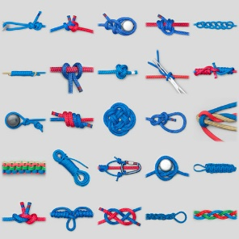
Indoors
Call/video call a school friend or 2 and ask how their residential trip is going!
On a residential experience, the teachers always make sure to take lots of pictures and often use these to do some writing activities the following week. Take some photos or draw pictures of what you have been doing and write up a diary or review of your residential experience!
Sing campfire songs! If you are lucky enough to have some sort of bonfire/fire pit at home then of course use this, if not, be inventive and sing around a “campfire” made up of what you can find- red, orange, yellow and brown pieces of fabric or shoes piled together! Miss Brearey has sung lots of silly songs with both Class 3 and 4 in the past…personal highlights include “Bungalow”, “3 blind jellyfish”, “40 days on an iceberg”, “Alert, alive, awake and concentrating”, “Polish Banana Boat”. It’s also a great time to play silly games such as Granny’s Shopping List (take it in turns to go through a shopping list for Granny, each time adding onto her list. A good way to do this is alphabetically), 20 questions (think of a person or animal and everyone has to guess what you are by your yes or no answers), I Spy etc.
Learn how to create a knot…(https://www.youtube.com/watch?v=5c5xI-3SnUU Knot tying for kids).
On residential, it’s important to keep your dormitory nice and tidy. Teachers might organise a competition for the tidiest space…parents feel free to hand out prizes (a high five or a homemade certificate would work!) for the tidiest dormitory- either their sleeping space for the night or their bedrooms!

