Q | J | Q | P | P | V | X | N | L | U
D | U | A | J | A | X | W | T | E | W
Y | R | O | T | L | J | R | X | S | X
W | G | Y | O | C | S | O | M | Z | O
U | R | U | B | L | G | J | P | P | W
S | Y | C | Y | H | J | N | R | A | D
J | S | P | U | Z | O | E | Z | B | T
S | I | I | Z | T | F | K | X | K | F
A | O | A | M | E | S | S | O | R | C
D | J | T | R | X | M | Y | F | E | C
The word search only contains the root word from your spelling (I’ve taken off the suffixes!)
- rubbed
- missed
- cutting
- saddest
- clapped
- wrapping
- preferred
- jogging
- wetter
- crossed

Put each of your spelling words into a sentence:
________________________________________________________________________________________________________________________________________________________________________________________________________________________________________________________________________________________________________________________________________________________________________________________________________________________________________________________________________________________________________

Week 2 Summer 1: doubled consonants

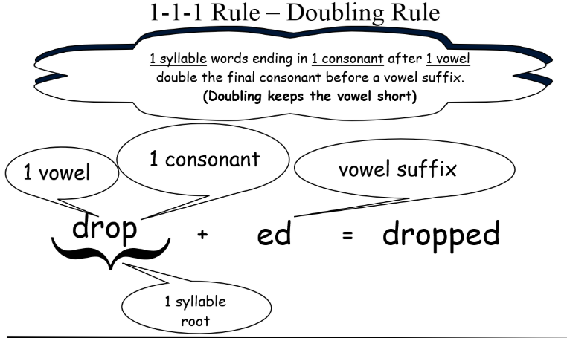
- rubbed
- missed
- cutting
- saddest
- clapped
- wrapping
- preferred
- jogging
- wetter
- crossed

Monday- reading task
Listen to the first chapter of PG Bell’s The Train to Impossible Places: https://www.youtube.com/watch?v=g7GT_WwtHMw (and/or read it on the next page. You could even
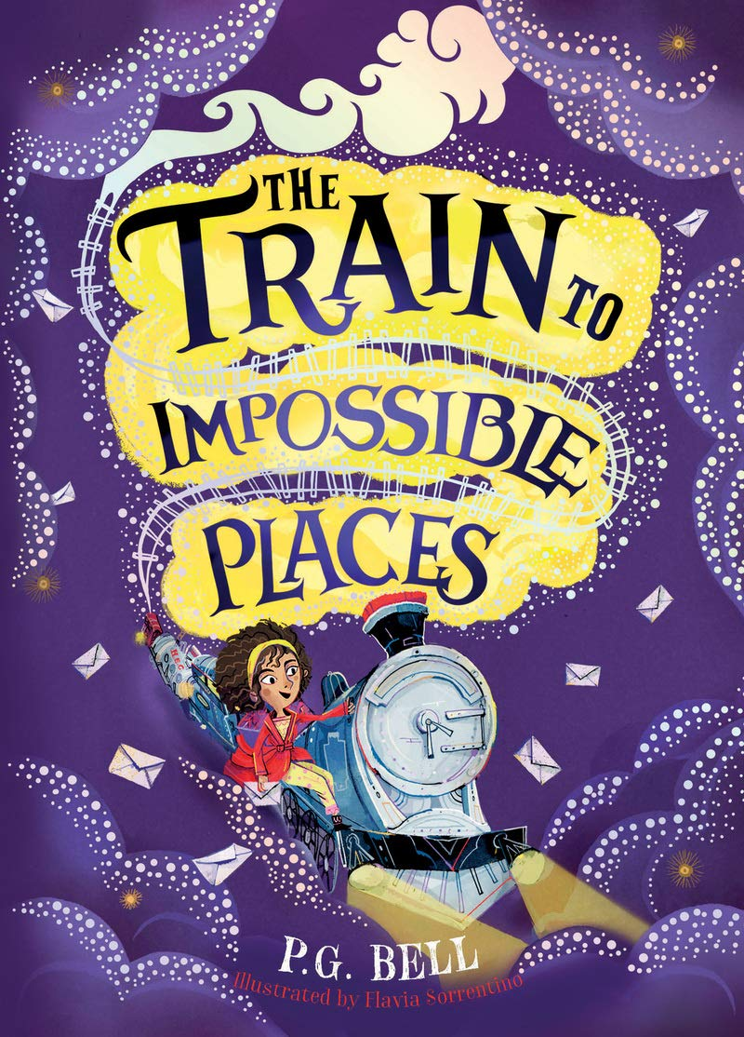
Have a think about these statements which are themed around making predictions/inferences. For each one, decide whether you agree or disagree. It’s up to you whether you write your response (in full sentences!) or have a discussion with an adult about your ideas.
(Note to adults: it might be interesting to play “devil’s advocate” to children’s suggestions/answers to get them to think really carefully about their reasoning, e.g. “Why do you think that?” “What evidence have you seen to make you think that?”)
Suzy must be a train driver.

Suzy’s parents won’t go on the adventure with Suzy.
Suzy isn’t expecting anything strange to happen.
The green light is magic.
I think Suzy will be woken up by a train noise.
I think that Suzy is clever!

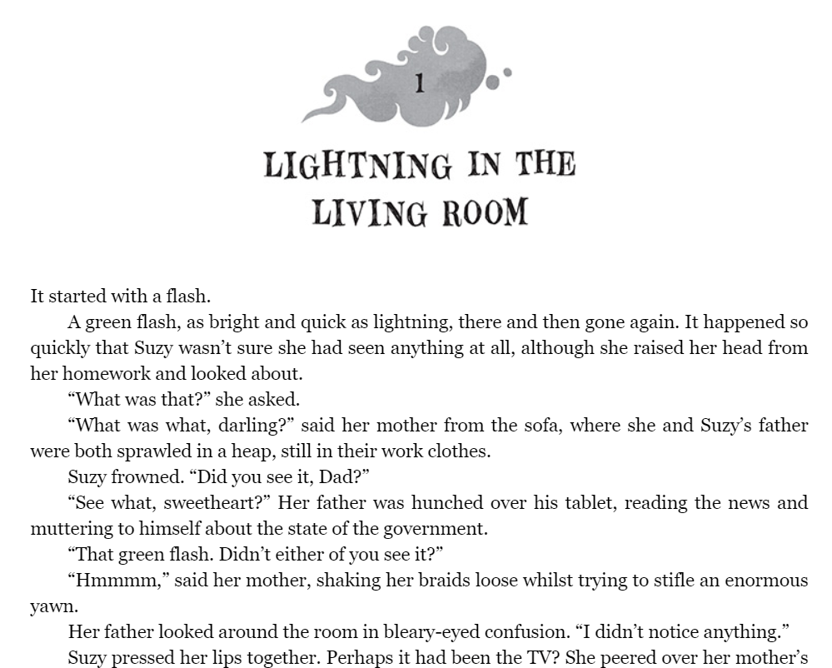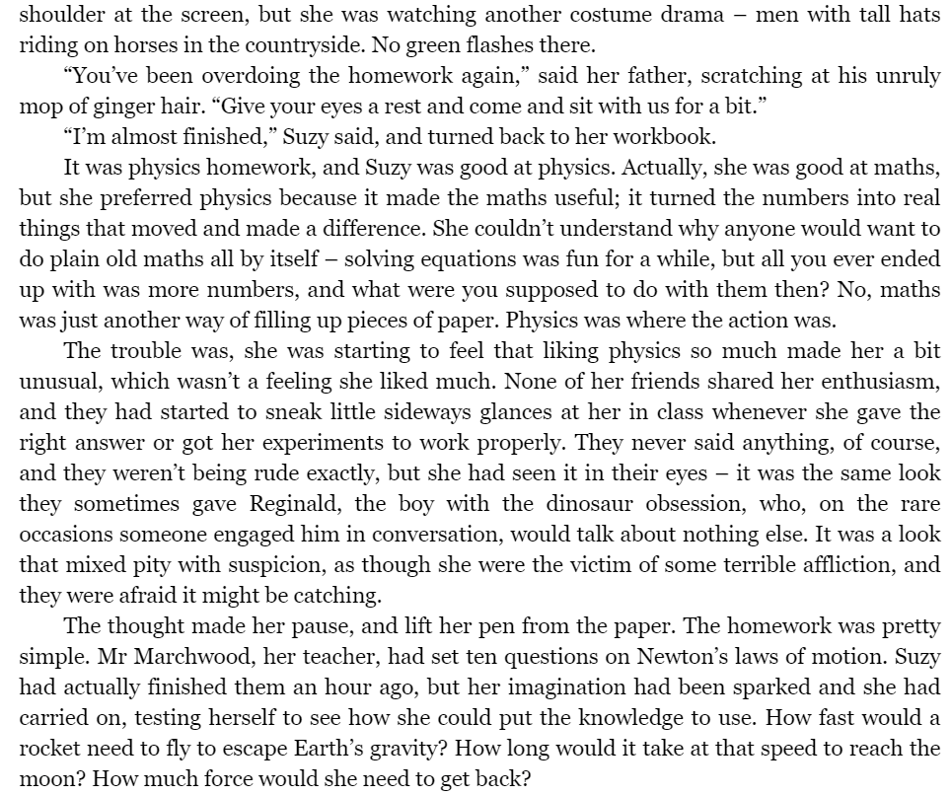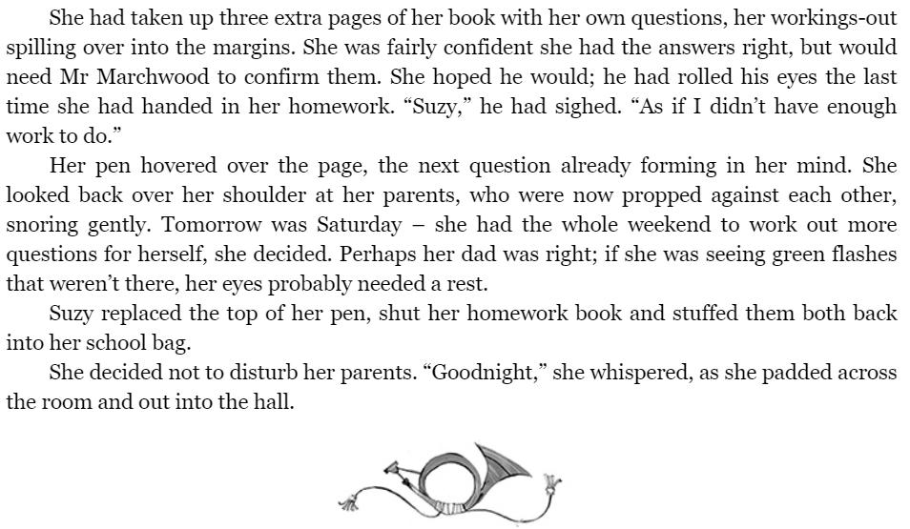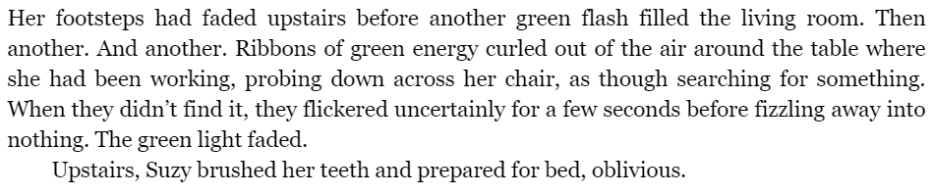
Tuesday – planning your writing
You’ve heard the first part of the story from PG Bell himself …now what happens next?

Is the green light because of something green?
Perhaps an alien?
A plant?
A monster?

Is the green light because of some sort of machinery?
A spaceship?
A car?
A computer?

The second chapter starts with Suzy waking up. Does a noise wake her up? Is the “thing” still just in the living room? What are her parents doing?
Is Suzy scared? Does she go to explore or wait for the “thing” to find her…?
Lots of things to think about…let your imagination take Suzy wherever you want!
Send your finished exciting story to Miss Brearey (either as a photo or typed up, with illustrations would be super too!) to put on the school website! abrearey@willowbrook.notts.sch.uk
I suggest that you start by planning what is going to happen, who your other characters might be and how the story is going to come to an ending…happy or otherwise!
On the next page, is a simple grid that you may want to use to plan through the different stages of your story (you might want to simplify it further and do 3 boxes as beginning, middle and end instead). Label it with key words (description, sentence starters for example), speech/thought bubbles you might want to use…
**If you have read the story before then try to go down a different route…Alternatively, take Suzy on a different adventure with the same characters! Just try not to retell the same story!**

Wednesday- writing up in rough and editing!
Oh look…a familiar looking bookmark for things to check when you say “I’ve finished!” or to have alongside you as you go!
I can’t wait to read them all and good luck!
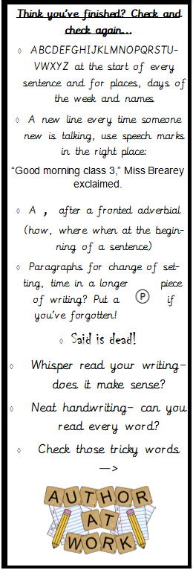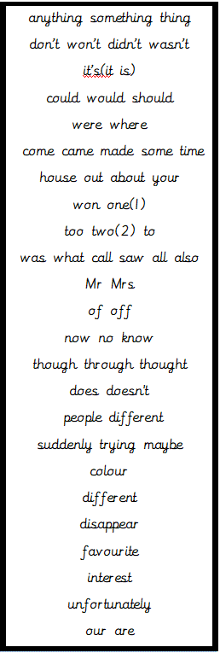

Thursday – write up in neat and send to Miss Brearey!

