Monday- Spelling Task
Fill in the missing letters (they are the same order as on the list!)

o ___ ___ osite opp___ s___ te oppos ___ ___ e __ pposit __

l___ ___ guage lang ___ ___ ge l ___ ngu ___ ge

m ___ ___ tion me ___ ___ ion ment ___ ___ n __ entio___

su ___ ___ ose s ___ pp ___ se supp ___ s ___ ___uppos ___

b ___ ___ ieve bel ___ ___ ve b ___ li ___ ve ___eliev ___

c ___ ___ tre cent ___ ___ ce ___ ___ re ___ entr ___

s___ ___ mach stoma ___ ___ st ___ m ___ ch ___tomac___

c ___ ___ tain cert ___ ___ n c ___ rt ___ in ___ ertai ___

temp ___ ___ ature tempera ___ u ___ e ___emperatur ___
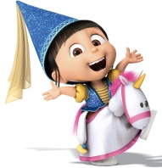
Week 3 Summer 2: Year 3 tricky words

- opposite
- language
- mention
- suppose
- believe
- centre
- stomach
- certain
- natural
- temperature

Score: ___________

________________________________________________________________________________________________________________________________________________________________________________________________________________________________________________________________________________________________________________________________________________________________________________________________________________________________________________________________________________________________________________________________________________________________________________________________________________________________________________________________________________________________________________________________________________________________________________________________________________________________________________________________________________________________________________________________________________________________________________________________________________________________________________________

Monday- Apostrophes!
Read the below text and insert the apostrophes in the correct place. Remember this means you only need an apostrophe if it is something belonging to somebody or if a letter is missing (e.g. it is shortened to it’s)!

If it’s belonging to more than one person so there is an s already (such as for parents) then the apostrophe goes after the s (such as my parents’ house)…NOT FOR PLURALS (more than one)!!!!

- Miss Breareys bubble has 8 year 1 children in it.
- Lots of Class 3 children have been sending their work to Miss Breareys email address.
- Mr Castledines been grump because the teachers mugs aren’t in the dishwasher!
- We have been watching Mrs Ballards assemblies with our families.
- I have been doing my work on Daddys computer.
- My handwritings got much neater since school closed!
- I loved looking at my friends poems on the website.
- My tummys rumbling because I’m ready for my lunch.
- I can hear the sheeps lambs from my classroom.
- My hairs in need of a haircut because its getting very long.

Tuesday-Wednesday- Malala Yousafzai’s story

This week’s learning for English is with a slightly different structure as the topic is one that (I hope!) will lend itself to lots of discussion, extra research and wonderings…

Saturday 20th June is National Refugee day and this is going to be the basis for your English tasks. We’re going to be focussing on the remarkable story of Malala Yousafzai.

Have a look at these pictures of Pakistan, where Malala was born. On the person outline (next page) note down any words you’d use to describe somebody who lived in this country (Note to parents: allow any misconceptions/assumptions, e.g. “poor, can’t read, can’t speak English, sad, scared” as these will be addressed/challenged later on in the activity!)

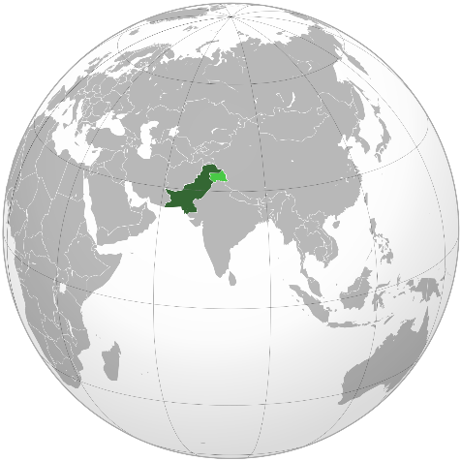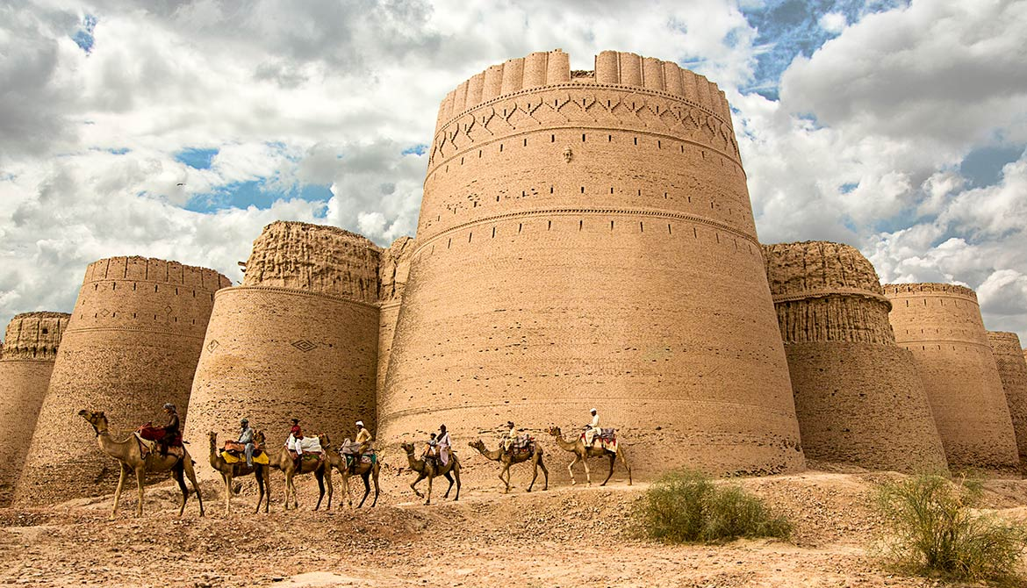
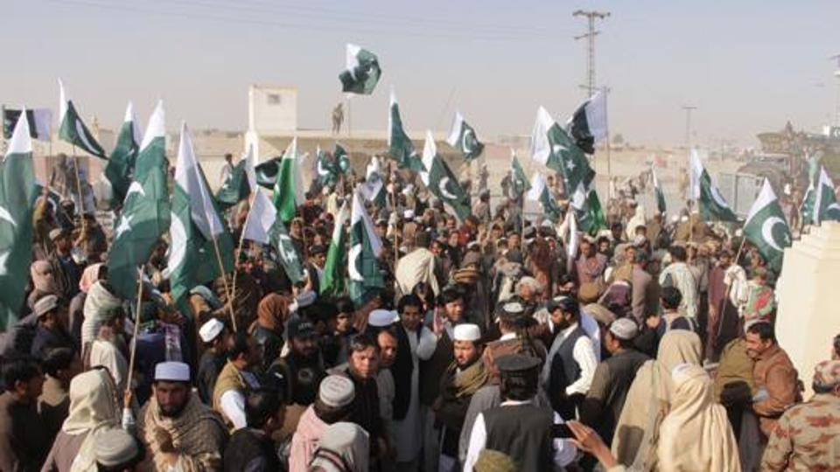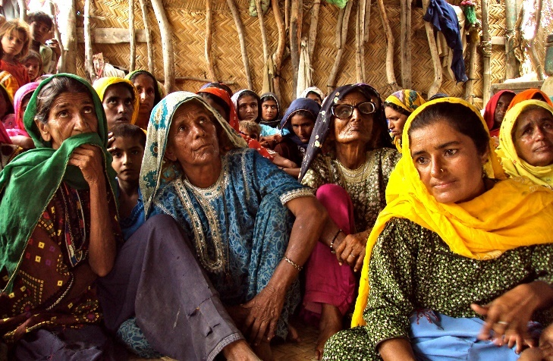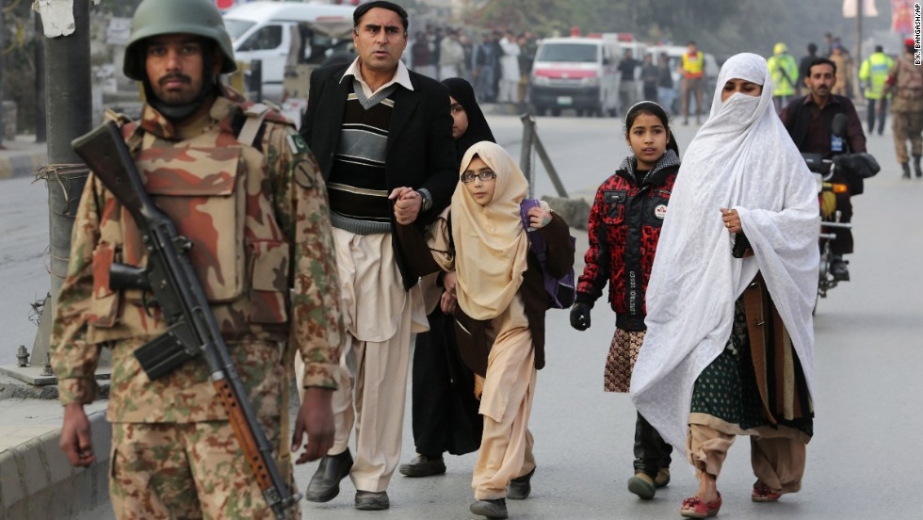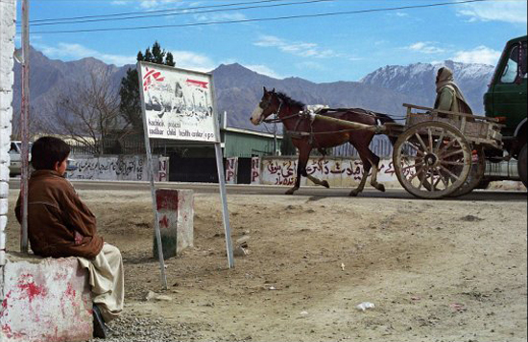
Now have a look at these pictures of Malala’s school and family in Pakistan. Add some more words to your person using a different colour. Are there any words that you’d written last time that you think are wrong now (don’t cross them out because the different colours are there to show how your opinion is changing!)?
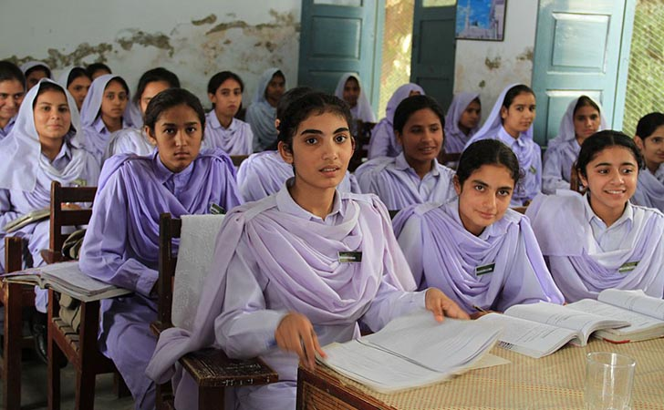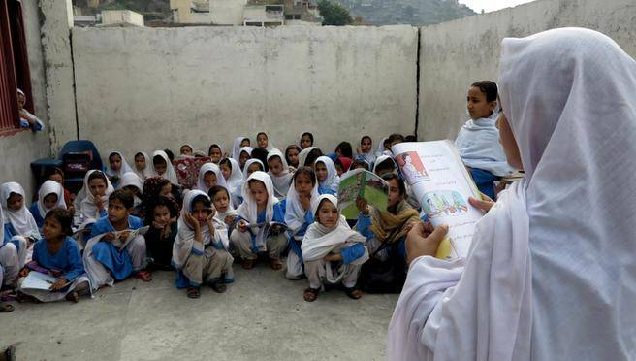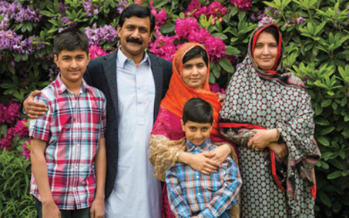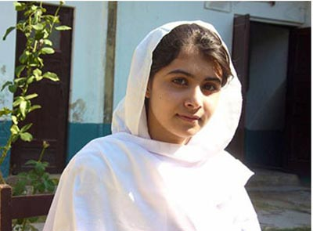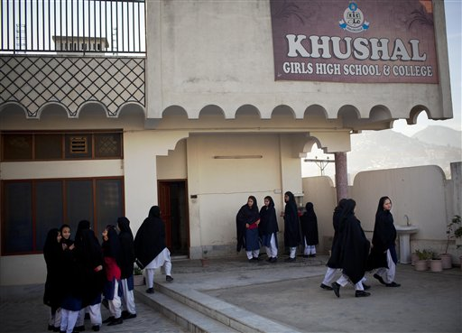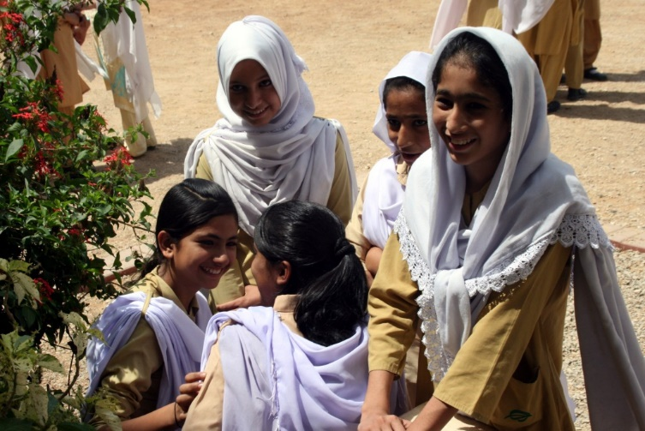
Finally, watch and listen this video: https://www.youtube.com/watch?v=rJZc3T8SIhg (if you search “for the right to learn malala yousafzai's story” on youtube, it is the first result). You may want to pause the video at some points to discuss any unfamiliar language or ask questions. It would be lovely to jot these questions down as they will be good to reflect on later on this week!
Note down your thoughts on Malala after hearing her story in another different colour pen/pencil.

Below are some questions that would be a good starting point for discussion. The CBBC newsround website also has lots of child appropriate videos/articles about Malala: https://www.bbc.co.uk/newsround/24440653
Last year for World Refugee Day, they created a super article and video: https://www.bbc.co.uk/newsround/48660079
There are also lots of profound quotes from Malala (one of which I’ve mentioned below!) which are, again, good points for discussion and can be found simply by googling “Malala quotes”!
Why couldn’t Malala stay in Pakistan?

Why is Malala famous? Why do lots of people want to meet her?

Why didn’t Malala just stop going to school when she knew it was dangerous?

What would you want to ask Malala if you met her?

What does it mean if you’re a refugee? Do all refugees have a story similar to Malala?
One of Malala’s quotes is “One child, one teacher, one book and one pen can change the world.” Do you agree? Why? Why not? How could that change the world?

Thursday- writing task
For you writing task this week, I’d like to give you a bit more freedom and choice with how you present your learning. It might be that you…
- write a paragraph or 2 about what you’ve learnt, whether your thoughts have changed on refugees, what discussions you’ve had
- write a newspaper report on Malala
- write a character description of Malala (perhaps using the words from your person outline on Tuesday)
- write a poem based on one of her quotes
- re-write Malala’s story in your own words
These are just suggestions so there may be another way of writing about your learning that I haven’t covered here. I’d love to hear what you’ve found out and what you think of Malala and/or refugees so please email your work (or just a sentence describing how you’ve got on with this topic!) to me at abrearey@willowbrook.notts.sch.uk

Extra reading if you fancy!
I know that some of you have already enjoyed reading The Boy at the Back of the Class, but for those of you who haven’t (or for those of you who want to read it again!), here are the first 10 chapters as a pdf document:
https://www.barhamprimary.co.uk/attachments/download.asp?file=800&type=pdf

Although this is a fictional story about a refugee boy attending a school in England, it includes lots of real thoughts, feelings and points of view (that are based on real ones!) to consider.

