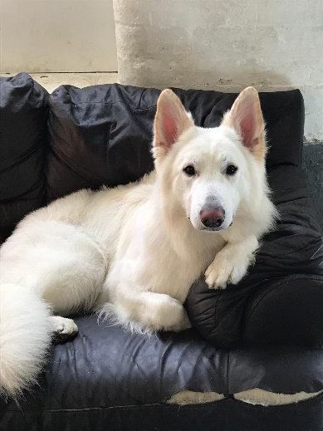
My Pet
Our pets are amazing creatures.
They can come in many different sizes.
They can be as big as a horse or as small as a mouse.
But I want to know what you or your relatives’ pets are like.
I wonder if you can make a little fact sheet about your pet:
- What they like to do
- What they like to eat
- Where do they sleep?
- Where do they come from?
Lastly, I want you to write some questions to your pet. What would you ask them if you could?
Name of pet
Type of pet

What do they like to do?
______________________________________________________________________
______________________________________________________________________
What do they eat?
______________________________________________________________________
______________________________________________________________________
Where do they sleep?
______________________________________________________________________
______________________________________________________________________
Where do they come from?
______________________________________________________________________
______________________________________________________________________
What questions would you ask your pet?
______________________________________________________________________
______________________________________________________________________
______________________________________________________________________
______________________________________________________________________
______________________________________________________________________
______________________________________________________________________

