Tuesday and Wednesday – Telling the time

As mentioned on the suggested timetable, the best way to teach telling the time is to do it in “real time”! Practice using analogue clocks, digital clocks (24 and 12 hour!), using vocabulary such as a.m., pm., noon…

There are also some good telling the time games on the Top Marks website: <https://www.topmarks.co.uk/Search.aspx?q=telling+time>

Write the time in words (e.g. 10 minutes past 2).

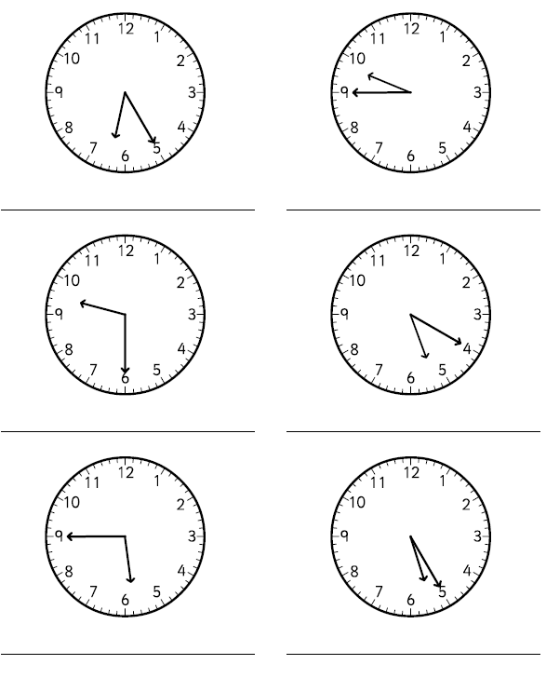

Draw the clock hands on these clocks. Be careful to make the minute hand longer than the hour hand (you could even use 2 different coloured pencils!).

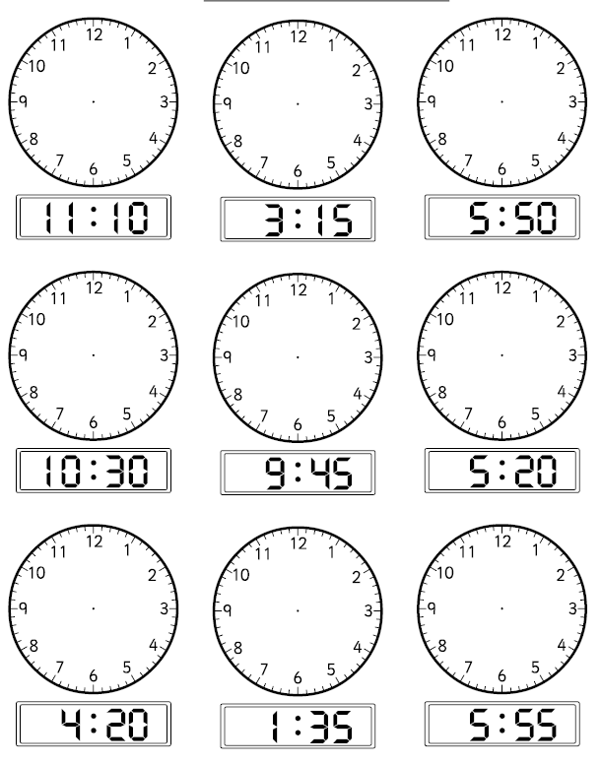

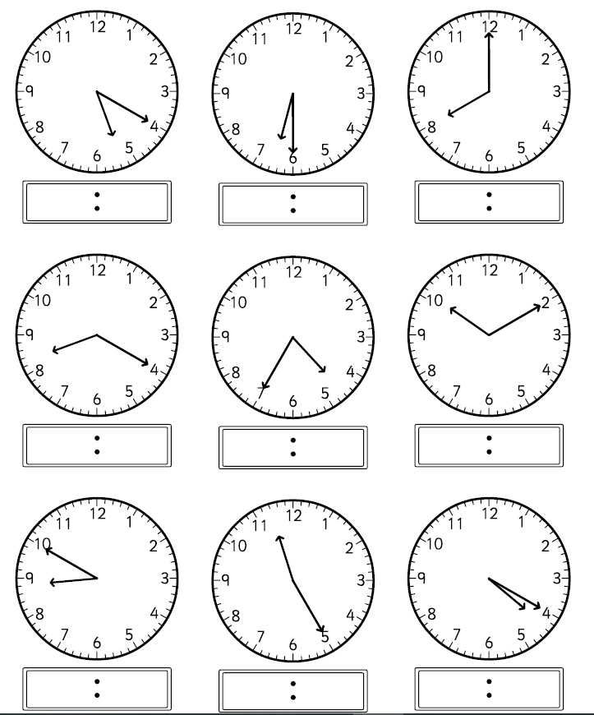Write the time using the 12 hour digital clock.

Write these times on the clock (with roman numerals!). I always find that if you know the position of numbers on a clock, you don’t need to “learn” roman numerals on their own because you recognise where the hands are pointing. Having said this, if you wanted to learn roman numerals I – XII on their own then of course feel free to!

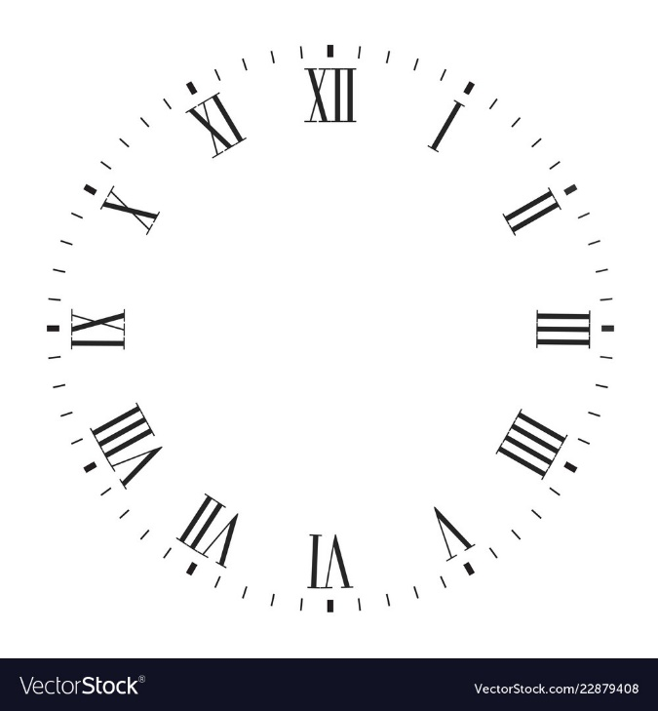



20 minutes past 4

Quarter to 12

25 minutes to 3

Seven o’clock

5 minutes past 10

10 minutes to 5

Have a go at writing your own timetable for the day. It might be that you do this retrospectively (after you’ve done the activity) or ahead of time (and then maybe go a bit under/over your planned times!), it’s up to you. For each event, state the start time (using digital 24 hour or written time), end time and duration (how long you’ve spent doing the activity). Then draw a picture of you doing the activity! Feel free to carry on onto another sheet of paper if you get carried away! Here is my example:

