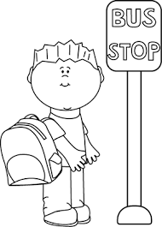
Is my bus here yet?!
Monday- arithmetic task bus stop division
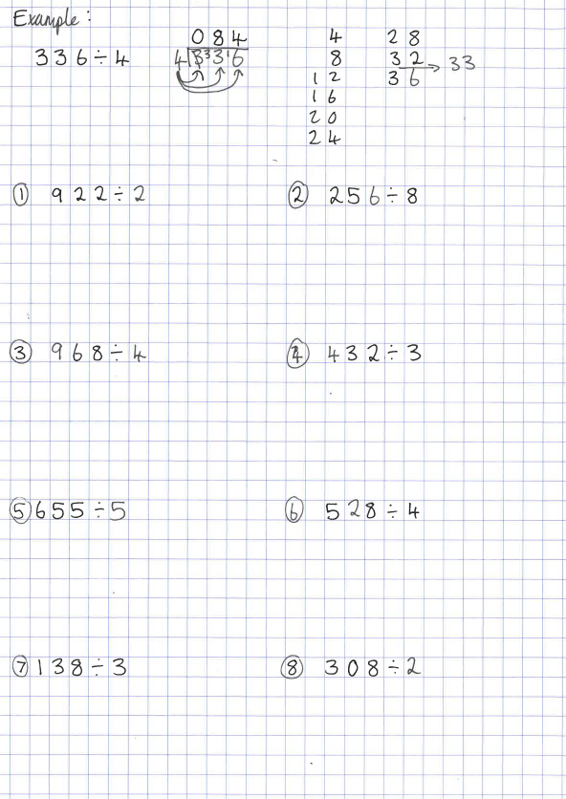
Not that kind of bus stop!! Have a look at the example to help you remember this tricky method and use this thought process …“how many 4s go into 3? Can’t do that, so I carry it over…how many 4s go into 33? 33 is between 32 and 36 so I’ve counted 8 times in 4s and I have 1 leftover to get from 32 to 33. I carry that 1 leftover over…how many 4s go into 16? I’ve counted 4 times in my 4s so it’s 4. My final answer is 84.”

Tuesday- Measuring mass
If you have weighing scales at home…Choose 6 objects of various size/shape (that aren’t going to break the weighing scales!). Draw a picture of your first object, predict how much it weighs (grams or kilograms!), measure it on your weighing scale. Using the actual mass, make your predictions (and draw the picture) for the next one and so on. For example, my first object might be a pencil with an estimated weight of 50g. Once you’ve recorded that actually, it’s much lighter than that, use the pencil to compare with your next object…is it lighter/heavier than the pencil? How much so?
If you don’t have weighing scales at home…Get an adult to choose 6 objects from the kitchen cupboards that have the weight written on them (eg. cans of beans, boxes of cereal, bags of flour, cartons of juice would all work well, don’t forget that 1ml weighs 1g!). Don’t peek at the label as you make your prediction…once you’ve made your prediction, have a look at the label. Using the actual mass, make your predictions (and draw the picture) for the next one and so on. For example, my first object might be a can of beans with an estimated weight of 1kg. Once you’ve recorded that actually, it’s much lighter than that, use the can to compare with your next object…is it lighter/heavier than the beans? How much so?
Object | Picture | Prediction | Actual Mass

What mass are these scales showing? 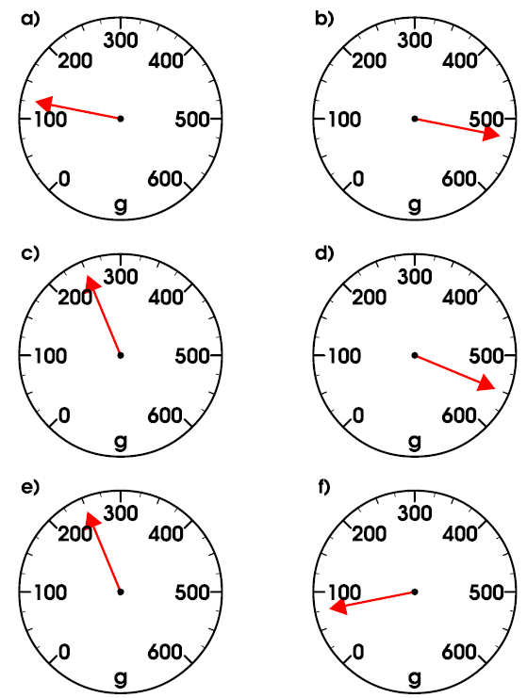

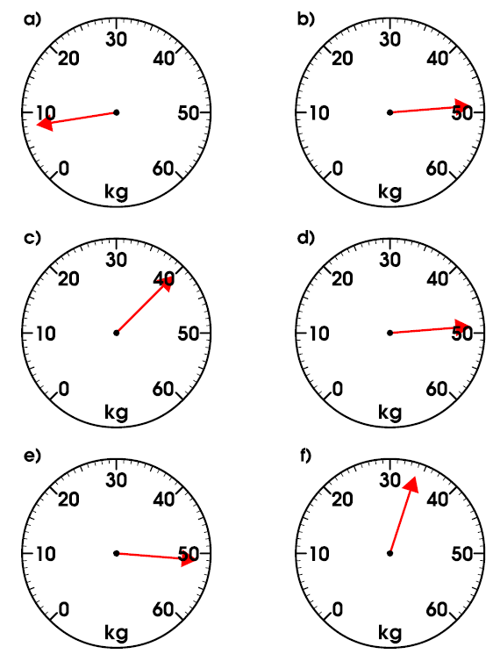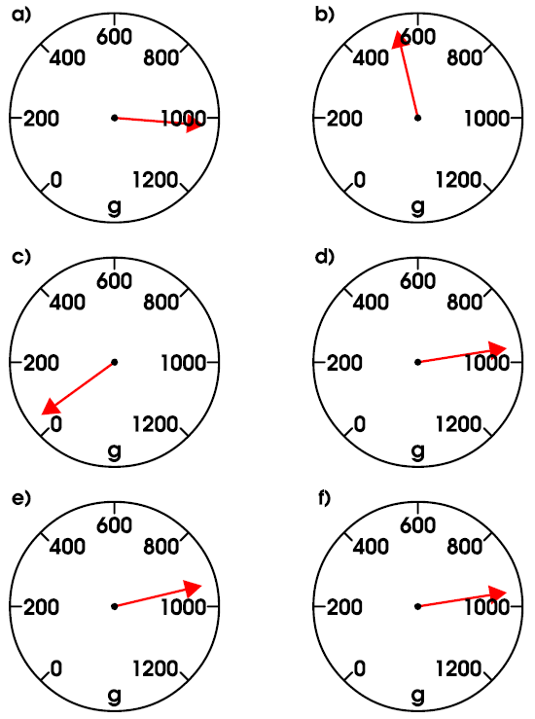

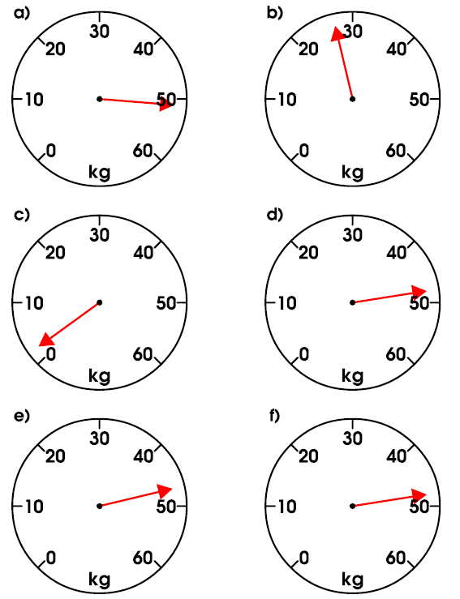

Wednesday- Converting and problem solving with mass
Remember…1kg is the same as 1000g so…1000g is the same as 1kg
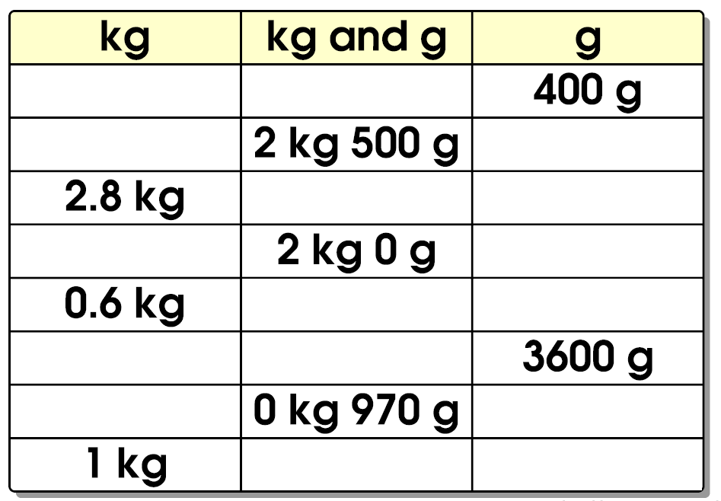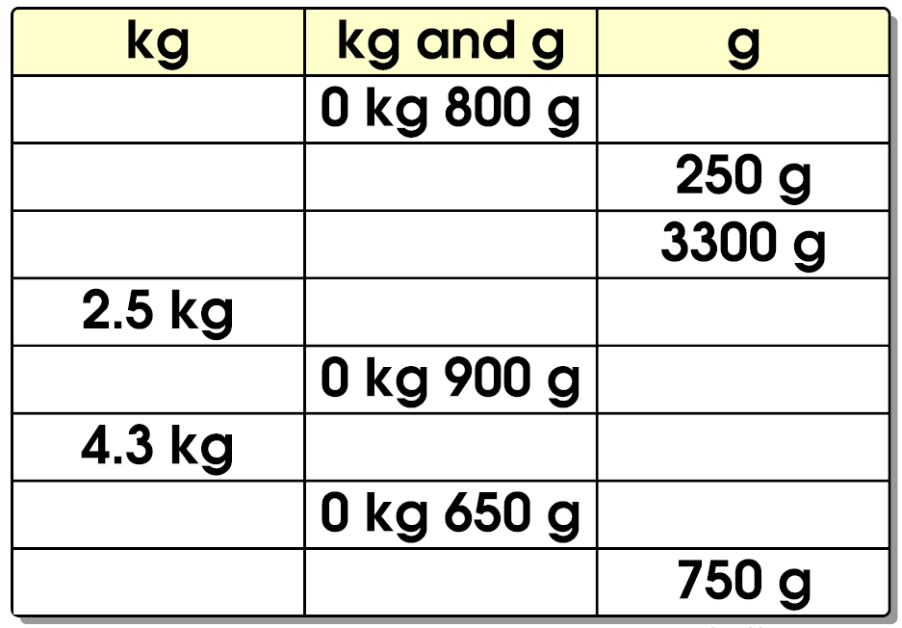
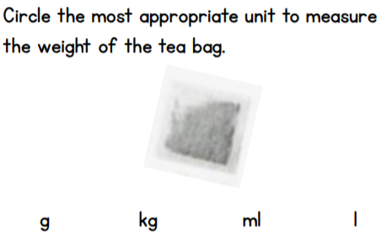

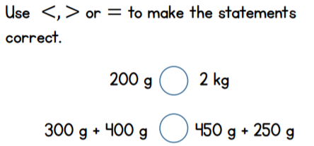

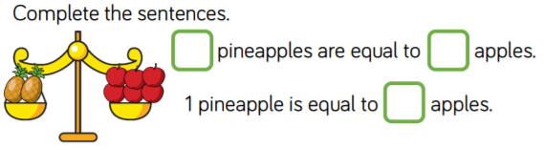

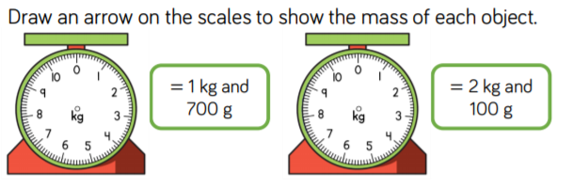

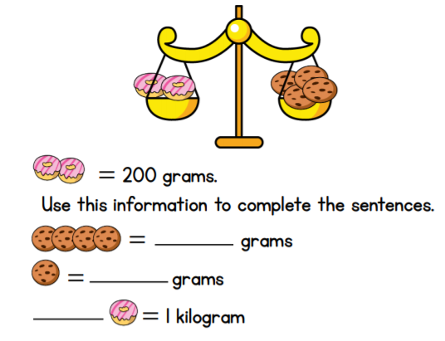
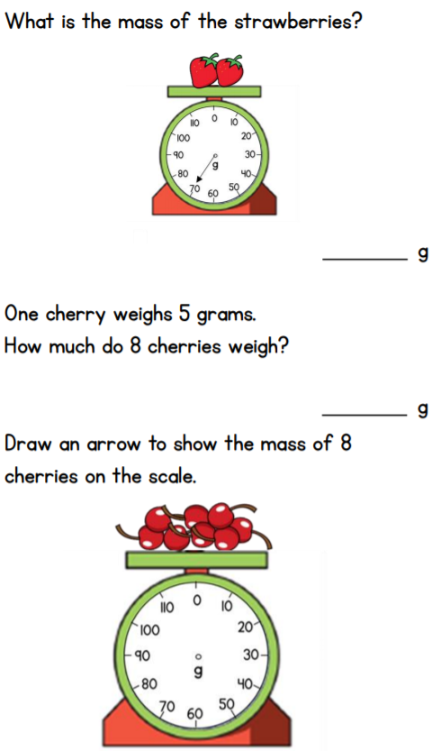

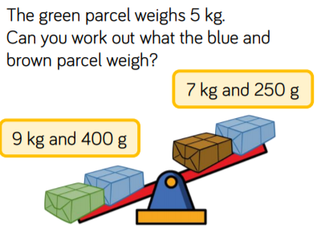

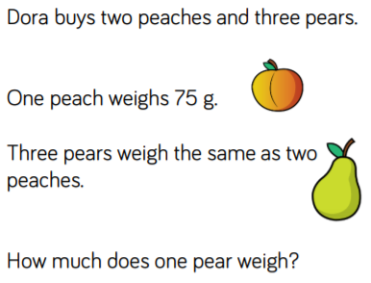
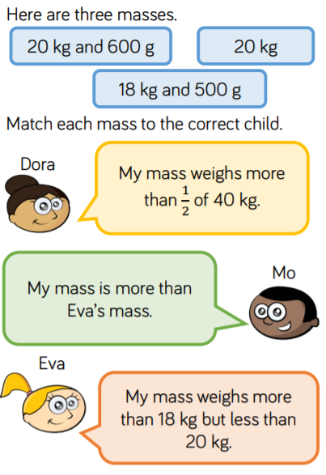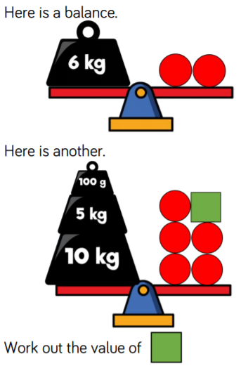

Thursday- times table challenge...eggs on legs! 