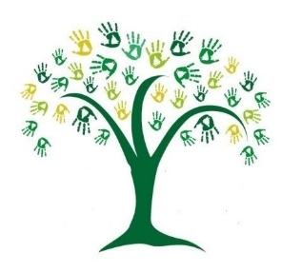
Learning for your year group for the week beginning: 18th January

Day 1 | Task 1  Our learning objective: Rehearse and apply times tables knowledge.  Your task: Complete several ‘Daily 10’ timed exercises of your choice on the TopMarks website. | Task 2  Our learning objective: Learning about the Antarctic Circle.  Your task: Draw and label maps of the Antarctic and learn about the territorial claim and protected status. | Task 3  Our learning objective: To read and understand text (Part 1).  Your task: To read (and enjoy!) the story of Ernest Shackleton and answer the questions as you go.
Additional resources/activities that might help you achieve your tasks:

Day 2 | Task 1  Our learning objective: To read and understand text (Part 2).  Your task: To read the text and answer the true or false at the end. | Task 2  Our objective: To convert decimals and fractions Part 1.  Your task: To work through a choice of tasks. | Task 3  Our objective: To learn the vocabulary for the unit En Famille.  Your task: To watch and listen to the slides in Lessons 1-5.
Additional resources/activities that might help you achieve your tasks:

Day 3 | Task 1  Our learning objective: To learn about adverbs of time and place.  Your task: To watch a short video and complete sentence writing activities. | Task 2  Our learning objective: To compare and classify geometric shapes based on properties.  Your task: To distinguish between irregular and regular polygons. Classify other polygons. | Task 3  Our learning objective: To learn about the lifecycle of flowers.  Your task: To draw a diagram illustrating the lifecycle of a flower.
Additional resources/activities that might help you achieve your tasks:

Day 4 | Task 1  Our learning objective: Applying adverbs of time and place to Shackleton’s story.  Your task: Write sentences and use adverbs correctly inspired by our Survivor story. | Task 2  Our objective: To convert decimals and fractions Part 2.  Your task: Choose from a selection of tasks. | Task 3  Our objective: Learning about the Arctic Circle.  Your task: To draw and label and map of the Arctic and learn about the countries that lie within the Arctic Circle.
Additional resources/activities that might help you achieve your tasks:

Day 5 | Task 1  Our learning objective: Learning how to spell words with the omitted apostrophe.  Your task: To tell a story using the words on the spelling list. | Task 2  Our objective: To express your opinion on the learning over the last two weeks.  Your task: We’ve recently learnt about the desert (the Kalahari) and the Antarctic. Choose one place and tell me why you would most like to visit there (and not the other). | Task 3  Our objective: To create a piece of art inspired by the indigenous people of the Arctic.  Your task: Create a piece of art from one of three options provided.
Additional resources/activities that might help you achieve your tasks:

