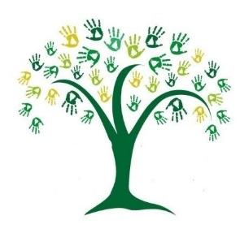
Learning for your year group for the week beginning:
Please return all finished tasks for marking. Return completed documents or photos of work via email. These will be added to your books.
Day 1 | Task 1 English  Our learning objective:  Reading for understanding  Your task:  Reading the first half of a survival story. Answer questions as we go through the text. | Task 2 Maths  Our learning objective:  Recapping multiply and divide by 10, 100, 1000  Your task:  Study the example | Task 3 Geography  Our learning objective:  Understanding desert biomes  Your task:  Label the deserts on the world map and answer the questions on desert biomes.
Additional resources/activities that might help you achieve your tasks:

Day 2 | Task 1 English  Our learning objective:  Reading for understanding  Your task:  Reading the second half of a survival story. Answer questions as we go through the text. | Task 2 Maths  Our objective:  Converting units, metres, cm, mm and km.  Your task:  Study the example and work through the questions. | Task 3 French  Our objective:  Speaking about myself in French  Your task:  Using Language Angels, login information is in Teams, click on the 'sound' icon enables you to listen to the pronunciation. Watch and pause the video/slides so you can write the French for the attached exercise. There is an example on the sheet.  Practise your pronunciation - when you are ready, read your written script to an adult and ask them to score you out of 10.
Additional resources/activities that might help you achieve your tasks:
Microsoft Teams, Microsoft OneNote, Google searches, any sort of Atlas,

