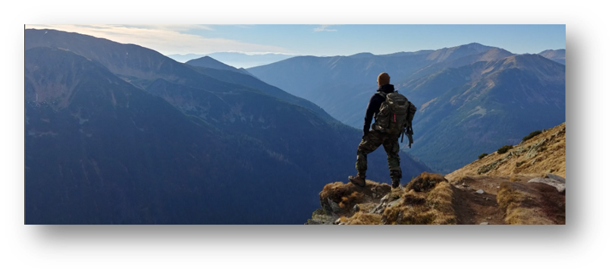

**The Big Idea…**

The world is a beautiful and wondrous place. With travel being restricted due to covid wanderlust is taking over. Our focus this half term will look at the amazing planet we live on. The diversity of landscapes and the beauty and adventure that awaits us in our future.

As mathematicians we will …

be gaining a deeper understanding of decimals to provide a basis for our work with money and time. With money becoming more and more a matter of decimal numbers rather than concrete coins we will be consolidating our learning, incorporating negative numbers and solving real life problems.

We will also improve our understanding of time. Ensuring we can all still recognise and read an analogue clock in a digital time and applying this knowledge to real life situations.

**As language specialists we will…**

be immersing ourselves in the dramatic stories of ‘Survivors’ by David Long. We will be studying the language used to convey excitement and to engage the reader. We will be using our scientific and geographical knowledge to aid the creation of imagery in own written pieces and delving into the language of emotion to convey the thoughts and feelings of our story’s survivors. We will be producing poetry, using linguistic tools to create a visual image, inspired by ‘Survivors’.

**Our Goals as Geographers**

We will be able to locate North and South America. We will use maps, atlases, globes and digital mapping to locate the countries and describe features. We will discover the importance of rainforest, tundra and desert and see change over time.

KS2 Curriculum Aims – ‘*understand the processes that give rise to key physical and human geographical features of the world, how these are interdependent and how they bring about spatial variation and change over time’*

**Our Goals as Historians**

We will look at how significant ecologists have changed the world through their action and ideas.

*KS2 Curriculum Aims - gain historical perspective by placing their growing knowledge into different contexts: understanding the connections between local, regional, national and international history; between, economic, political and social history; and between short- and long-term timescales*

**Our Goals as Scientists**

We will be investigating biomes and habitats around the world and the impact of human behaviour on them. Practical investigations will also help us to consider different forms of generating energy.

*KS2 Curriculum Aims - ‘recognise that living things can be grouped in a variety of ways. To explore and use classification keys to help group, identify and name a variety of living things in their local and wider environment, recognise that environments can change and that this can sometimes pose dangers to living things’*

**Across the curriculum**

**As expressive artists**

Using a wide range of different materials to sculpt and manipulate to represent the different landscapes of the world.

**As computer specialists**

We will make use of the school’s computers in order to prepare a presentation about their ideas for #Earthshot. The children will learn how to scan in their own work, prepare different slides and present their plans to the rest of the class.

**As fitness experts**

We are very lucky to be swimming this term. We will be using the Keyworth Leisure centre facilities progressing our skills with the Keyworth swimming teachers.

**In PSHE**

Very relevant to the current situation, we will be looking at how to maintain good health, both physically and mentally.

**Knowledge of the World and Religion**

Children will understand the rich variety of culture around the world and the many different ways of living. In RE we will explore creation stories from around the world – both religious and scientific.

**Citizenship**

Before we look at the rest of the world, what things do we value about living in Britain? What makes us a British citizen? Are these values found in other countries around the world?

**Ambitious thinking**

What is it about the way that we live our lives that is fundamental to our wellbeing? What can we do without? What sort of a world do we want for the future?

You vs Wild