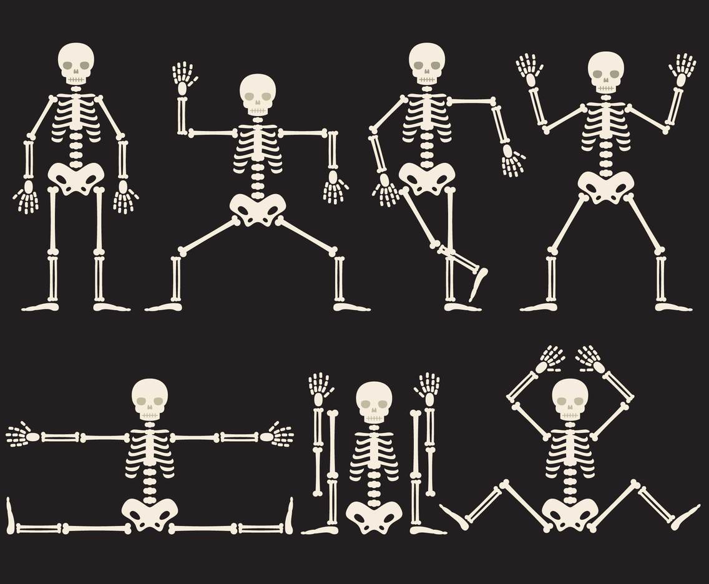

**THE BIG IDEA…**

Human bodies come in all shapes and sizes. They are unique and make us special. They change and grow, but how does all of this happen? Are our bodies like a machine and could we build something like them if we found out how they work? What do our bodies need to keep working well? During this topic we will explore these key ideas and find out just how amazing the human body can be.

**Funny Bones**

**As language experts we will**  
be reading the Funnybones series and starting to understand the authors writing style. We will be spotting similarities and differences between the stories and using what we find out to write out own Funnybones story. We will look at the work of Nick Park and the famous animation of Wallace and Gromit before bringing our Funny Bones stories to life through the art of stop motion animation and story boarding. We will be thinking about cloning ourselves into robots through the text, ‘Can I build another me?’ by Shinsuke Yoshitake. An instruction manual into how to work the robot will showcase all the special features of ourselves and what makes us unique. To link with our Design and Technology work we will also be writing recipes for our cooking creations.

**As mathematicians we will**  
be continuing our work on statistics to start the half term. We will be gathering data and presenting this in pictograms and block graphs. We will interpret the date and draw conclusions from the information and compare it with others. Our focus will then turn to shape. We will be learning the names of regular and irregular shapes, using their properties to identify them. We will learn about sides and corners for 2D shapes before moving on to edges, vertices and faces for 3D shapes. We will then have our first look at fractions. Beginning with finding fractions of shapes before moving on to fractions of numbers. Alongside all of this learning we will continue to perfect our 4 calculations and how to solve word problems.

**As historians we will**

be thinking about the jobs of our parents, grandparents and great grandparents and comparing what jobs are available now compared to times gone by. We will be thinking about how robots and invention in the future may change the types of jobs that are available to us.

**Across the curriculum**

**As athletes we will**  
be looking at a range of athletic skills in our PE lessons with different coaches. We will be perfecting our running skills both over short and long distances before mastering the techniques of the relay race to build competitive spirit! Other athletic skills will include throwing the javelin and standing jumps, speed bounce and triple jump.

**As expressive artists we will**

be looking at the art of stop motion animations and creating our own characters and backgrounds. We will explore chiaroscuro and then create our own robot pictures looking at light and shade.

**As computer scientists we will**

be developing our skills using digital devices to create and save work. We will become computer programmers and use our coding skills to create an animation linked to Funny Bones.

**As theologians we will**

be exploring the culture and beliefs of the Sikh faith.

**As scientists we will**

be learning about our amazing bodies. We will explore what our different senses tell us about the world and develop our vocabulary to describe accurately what we find out. We will think about what our bodies need to grow and stay healthy, starting with learning about different types of food, then looking at exercise and hygiene. We will build on our knowledge of what makes a fair test when investigating practically. Finally, we will reflect on what we have found out and present our knowledge about our amazing bodies to the rest of the class.

**As geographers**

we will be looking at how people live in different locations around the world. We will identify the geographical features of different places and how these might change the types of house people live in. We may even discover some places around the world that are more difficult for humans to survive in. We will use an atlas to locate different places and find out about the population.

**Knowledge of the World**

We will be discovering what is similar and different about how people live in around the world. From jobs to pastimes, past and present, how does culture shape us?

**Citizenship (PSHE)**

We will be looking at safe relationships and how to respect ourselves and others. We will look at ways to play and work with each other cooperatively.

**Ambitious thinking**

We will be using the text ‘Can I Build Another Me?’ to think philosophically about what makes us who we are and what it means to be uniquely human.